Oceania: “The Other 1/3 of the World”
- Watch the video I created on Oceania. Take notes on key points I make and enjoy the two minutes of rugby bliss. https://youtu.be/-FNhPAFBQYI

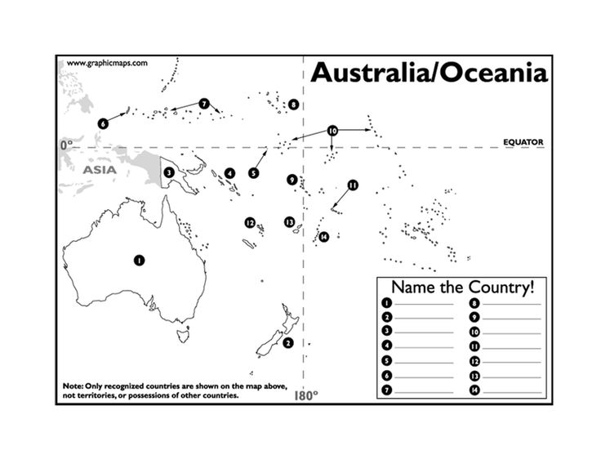
- Fill in the map:
- Easter Island Mystery Solved? New Theory Says Giant Statues Rocked

Potbellies might help explain how the Moai were moved.

By: National Geographic staff, National Geographic News

PUBLISHED June 24, 2012
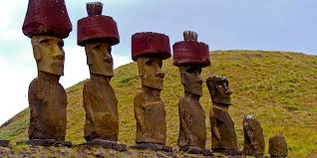
Hypothesize:
- What was the purpose of building these statues?

- How were they constructed?

- What would be required to create such works?

For centuries, scientists have tried to solve the mystery of how the colossal stone statues of Easter Island moved. Now there's a new theory—and it rocks.
The multi-ton behemoths traveled up to 11 miles (18 kilometers) from the quarry where most of them were carved, without the benefit of wheels, cranes, or even large animals.
Scientists have tested many ideas in the past, figuring that the islanders must have used a combination of log rollers, ropes, and wooden sledges. Now a pair of archaeologists have come up with a new theory: Perhaps the statues, known as Moai, were "engineered to move" upright in a rocking motion, using only manpower and rope.
Terry Hunt of the University of Hawaii and Carl Lipo of California State University Long Beach have worked closely with archaeologist Sergio Rapu, who's part of the South Pacific island's population of indigenous Rapanui, to develop their idea. They've observed that fat bellies allowed the statues to be tilted forward easily, and heavy, D-shaped bases could have allowed handlers to roll and rock the Moai side to side.
Last year, in experiments funded by the National Geographic Society's Expeditions Council, Hunt and Lipo showed that as few as 18 people could, with three strong ropes and a bit of practice, easily and relatively quickly maneuver a ten-foot (three-meter), five-ton Moai replica a few hundred yards (a few hundred meters). No logs were required. (National Geographic News is a division of the Society.)
- Write a paragraph synopsis of what you’ve learned about Polynesian culture today.

