Class/Subject: Philosophy | Lesson 11- “Artificial Intelligence”
Objective(s):  SWBAT utilize computers, in particular the Clever Bot, to attempt to define thinking and reflect on whether computers will ever be capable of doing so. | Unit- “EPISTEMOLOGY”
Philosophical Quote of the Day:  "A computer would deserve to be called intelligent if it could deceive a human into believing that it was human,"- Alan Turing- 1950 | Philosophical Song of the Day:  “Mr. Roboto”- Styx (https://www.youtube.com/watch?v=3cShYbLkhBc)
Key Points of the Day:  - What constitutes, “thinking”? How can you refute that a computer will never be able to think? | - Alan Turing’s test has broad implications in the computer age. What are they?
Journal Entry:  “Is it conceivable that in the future, there will be computers capable of, “thinking”? If so, what is your definition of thinking? What separates human thought from that of a computer? | Supplemental reading and featured philosopher:  “The Man Who Knew Too Much: Alan Turing and the Invention of the Computer” David Leavitt  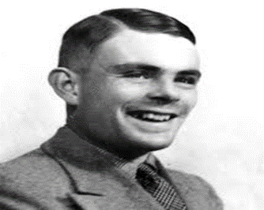  Alan Mathison Turing, OBE, FRS was a British pioneering computer scientist, mathematician, logician, cryptanalyst, philosopher, mathematical biologist, best known for cracking the Enigma Code in World War II and constructing the Turing Test

