Name: ____________

GRAPHING PERIODIC TRENDS
Hour:

PRE-LAB DISCUSSION:
The Periodic Table is arranged according to the Periodic Law. The Periodic Law states that when elements are arranged in order of increasing atomic number, their physical and chemical properties show a periodic pattern. Students can discover these patterns by examining the changes in properties of elements on the Periodic Table. The properties that will be examined in this lesson are: atomic radius, first ionization energy, and electronegativity.
PURPOSE: To determine periodic trends going down a group and across a period such as atomic radius, ionization energy, and electronegativity.

PROCEDURE:
- Use the information in these tables to complete the graph as described below.
- Make a correct scale on each of your graphs. (take your highest value for each graph and divide it by the total number of boxes on the graph to determine the scale, i.e. what each small line is increasing by)
- Plot the points on the graph.
- Draw a line of best fit, do not connect the dots.
- Repeat for graphs 1b-3b+
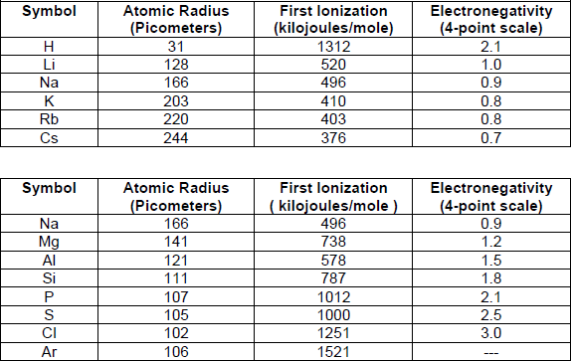
Group 1 (Alkali Metals) data:
Period 3 data:
Graph 1a: Atomic Radius (Group data)
For elements in Group 1 (Alkali metals), make a graph of atomic radius as a function of atomic number. Plot atomic number on the X axis and atomic radius on the Y axis.

Graph 1b Atomic Radius (Period data)
For elements in period 3, make a graph of atomic radius as a
function of atomic number. Plot atomic number on the X axis and atomic radius on the Y axis.

Graph 2a Ionization Energy (Group data)
For elements in Group 1 (Alkali metals), make a graph of the energy required to remove the easiest electron (first ionization energy) as a function of atomic number. Plot atomic number on the X axis and energy required on the Y axis.

Graph 2b Ionization energy (Period data)
For elements of period 3, make a graph of the energy required to remove the easiest electron (first ionization energy) as a function of atomic number. Plot atomic number on the X axis and energy required on the Y axis.

Graph 3a Electronegativity (Group data)
For elements in Group 1 (Alkali metals), make a graph of the electronegativity as a function of atomic number. Plot atomic number on the X axis and electronegativity on the Y axis.

Graph 3b Electronegativity (Period data)
For elements of Period 3, make a graph of the electronegativity as a function of atomic number. Plot atomic number on the X axis and electronegativity on the Y axis.

DATA ANALYSIS AND LAB QUESTIONS:
- Define each of these terms: Atomic radius, First Ionization Energy, and Electronegativity
  - Atomic radius-

  - Ionization energy –

  - Electronegativity -

- Look at your graphs – What happens to the atomic radius as the atomic number increases across a period? What happens to the atomic radius as the atomic number increases Down a group?

- Look at your graphs - What happens to the energy needed to remove an electron (Ionization energy) as the atomic number increases across a period? What happens to the Ionization energy at the atomic number increases Down a group?

- Look at your graphs – What happens to the electronegativity as the atomic number increases across a period? What happens to the electronegativity as the atomic number increases Down a group?

- Research – Look at the trends for atomic radius you wrote about for lab question 2. Do some online research to find out why the atomic radius changes as it does across a period AND down a group.

- Research – Look at the trends for Ionization energy you wrote about for lab question 3. Explain why the energy required to remove an electron (Ionization energy) changes as it does across a period AND down a group.

