Periodic Trends-Station 1 – Atomic radii
Can the properties of an element be predicted using a periodic table?

The periodic table is often considered to be the “best friend” of chemists and chemistry students alike. It includes information about atomic masses and element symbols, but it can also be used to make
predictions about atomic size, electronegativity, ionization energies, bonding, solubility, and reactivity. Mendeleev organized the table by atomic mass while Mosely organized the elements according to the element’s atomic number. In this activity you will look at a few periodic trends that can help you make those predictions. Like most trends, they are not perfect, but useful just the same.
- Look at the data in Model 1 on the following page.
  - Each element has three numbers listed under it. Which number represents the atomic radius?

  - What are the units for the atomic radius?

- In general, what is the trend in atomic radius as you go down a group in Model 1? Support your answer, using examples from two different groups.

3. Use your knowledge of Coulombic attraction (the force of attraction between positive and negative charges) and the structure of the atom to explain the trend in atomic radius that you identified in Question 2. Hint: You should discuss either a change in distance between the nucleus and outer shell of electrons or a change in the number of protons in the nucleus.

4. In general, what is the trend in atomic radius as you go across a period (left to right) in Model 1? Support your answer, using examples from two periods.

5. Using your knowledge of Coulombic attraction and the structure of the atom, explain the trend in atomic radius that you identified in Question 4.

Model 1 – Main Group Elements

1  H |  |  |  |  |  |  | 2  He
37 |  |  |  |  |  |  | 31
1312 |  |  |  |  |  |  | 2372
2.1 |  |  |  |  |  |  | N/A
3  Li | 4  Be | 5  B | 6  C | 7  N | 8  O | 9  F | 10  Ne
152 | 112 | 83 | 77 | 71 | 66 | 71 | 70
520 | 900 | 801 | 1086 | 1402 | 1314 | 1681 | 2081
1.0 | 1.5 | 2.0 | 2.5 | 3.0 | 3.5 | 4.0 | N/A
11  Na  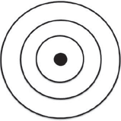 | 12  Mg  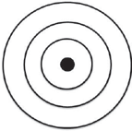 | 13  Al | 14  Si | 15  P | 16  S | 17  Cl | 18  Ar
186 | 160 | 143 | 117 | 115 | 104 | 99 | 98
496 | 738 | 578 | 786 | 1011 | 1000 | 1251 | 1521
0.9 | 1.2 | 1.5 | 1.8 | 2.1 | 2.5 | 3.0 | N/A
19  K  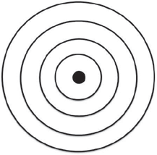 | 20  Ca  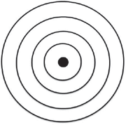 | 31  Ga  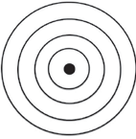 | 32  Ge | 33  As | 34  Se | 35  Br | 36  Kr
227 | 197 | 122 | 123 | 125 | 117 | 114 | 112
404 | 550 | 558 | 709 | 834 | 869 | 1008 | 1170
0.8 | 1.0 | 1.7 | 1.8 | 1.9 | 2.1 | 2.5 | N/A
Note: The transition ele- have been removed from the
Atomic Number Element Symbol Electron Shell Diagram Atomic Radius (pm)
1st Ionization Energy (kJ/mol) Electronegativity
ments and f-block elements
periodic table here to ease the
analysis of the trends.

Periodic Trends-Station 2 – Ionization Energy
Can the properties of an element be predicted using a periodic table?

Locate the numbers in Model 1 that represent the ionization energy. The ionization energy is the amount of energy needed to remove an electron from an atom.

- Using your knowledge of Coulombic attraction (the force of attraction between positive and negative charges), which takes more energy, removing an electron from an atom where the nucleus
has a tight hold on its electrons, or a weak hold on its electrons?

- In general, what is the trend in ionization energy as you go down a group? Support your answer using examples from two different groups.

- Using your knowledge of Coulombic attraction and the structure of the atom, explain the trend in ionization energy that you identified in Question 7.

- In general, what is the trend in ionization energy as you go across a period? Support your answer using examples from two periods.

- Using your knowledge of Coulombic attraction and the structure of the atom, explain the trend in ionization energy that you identified in Question 9.

- Atoms with loosely held electrons are usually classified as metals. They will exhibit high conductivity, ductility, and malleability because of their atomic structure. Would you expect metals to have high ionization energies or low ionization energies? Explain your answer in one to two complete sentences.

Periodic Trends-Station 3 – Electronegativity
Can the properties of an element be predicted using a periodic table

Read This!
Electronegativity is a measure of the ability of an atom’s nucleus to attract electrons from a different atom within a covalent bond. A higher electronegativity value correlates to a stronger pull on the electrons in a bond. This value is only theoretical. It cannot be directly measured in the lab.

- Using the definition stated in the Read This! box above, select the best visual representation for electronegativity. Explain your reasoning.
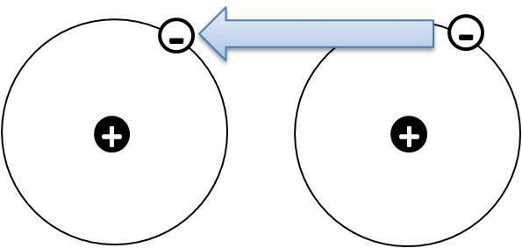
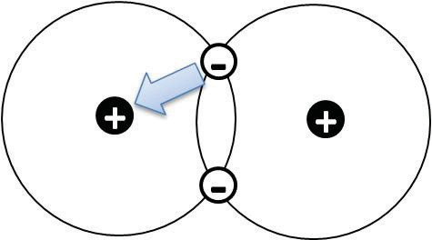
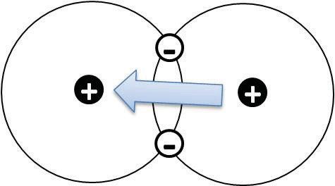
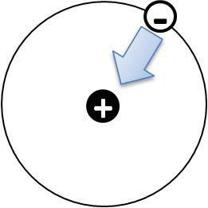
A B C D

- Locate the electronegativity values in Model 1.
  - What is the trend in electronegativity going down a group in Model 1?

  - Explain the existence of the trend described in part a in terms of atomic structure and Coulombic attraction.

  - What is the trend in electronegativity going across a period in Model 1?

  - Explain the existence of the trend described in part c in terms of atomic structure and Coulombic attraction.

Name _________________________________________________________ date ___________________ hour __________

Periodic Trends-Station Activity Answer sheet
As you rotate through the stations and look at the data, write your answers in the appropriate spaces.

Station 1 – Atomic Radii

1a. ___________________________________________________________________________________

1b____________________________________________________________________________________

2. (Group trend)

- Explain-

- (Period Trend)

5. Explain -

6. ___________________________________________________________________________________

7. (Group Trend)

8. Explain –

9. (Period Trend)

10. Explain -

11. Metals and Ionization energy-

12. ________________________________________________________________________________________

13a. (Group Trend)

13b. Explain-

13c. (Period Trend)

13d. Explain –

Let’s put it all together!

14. The two diagrams below can summarize each of the three trends discussed in this activity. Write “atomic radius,” “ionization energy,” and “electronegativity” under the appropriate diagram.

High Low
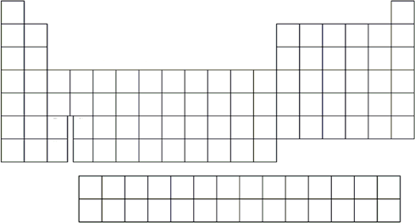
Low
High

Extension Questions
- During this activity you may have noticed that not all of the data provided in the models fol- lowed the trends.
  - Identify two places in Model 1 where the property listed does not fit the trend identified in this activity.

  - Why is it still beneficial for chemists to understand as many periodic trends as they can?

  - Propose an explanation for one of the exceptions you identified in part a. Use your knowledge of atomic structure and Coulombic attraction in your hypothesis.

- Rank the following elements from smallest to largest electronegativity based on the trends you have discovered thus far in the periodic table: barium (atomic number 56), bromine (atomic number 35), and iron (atomic number 26). Explain your reasoning.

