Team 1
Proof 1:
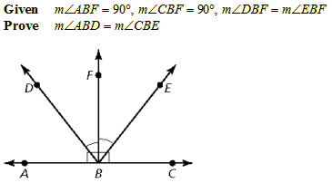

Proof 2:
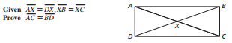

Team 2
Proof 1:
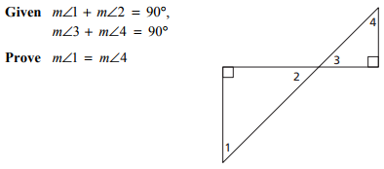
Proof 2:
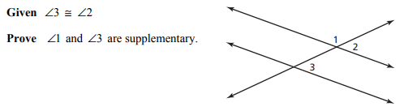

Team 3
Proof 1:
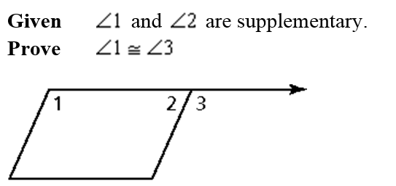
Proof 2:
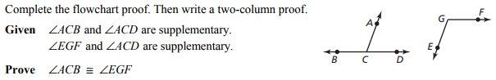

Team 4
Proof 1:
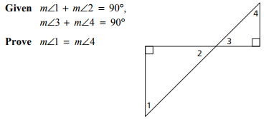
Proof 2:
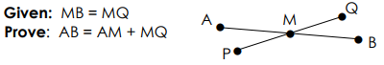

Team 5
Proof 1:
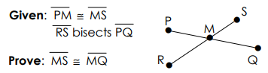

Proof 2:
Team 6
Proof 1:

Proof 2:

Team 7
Proof 1:
Proof 2:

Team 8
Proof 1:
Proof 2:

Team 9
Proof 1:
Proof 2:

Team 10
Proof 1:

Proof 2:

Team 11
Proof 1:

Proof 2:

