Electricity and Circuit Review Questions Name __________________________ Date _______
Physics B

- What causes electrons to flow through a material? What prevents electrons from flowing?
- What is the definition of current? Explain what an Ampere is.
- Why is conventional current shown as going from higher voltage to lower voltage?
- Describe a circuit. (p.630)
- What are the two ways to connect resistors, switches, batteries, or other circuit elements? Explain specifically how to tell the difference between the two ways on a diagram. (p.639)
- Why are houses wired in parallel and not series?
- What is the difference between a fuse and a circuit breaker? What do they have in common? (p.645)

- Draw a circuit with the following: A 2Ω and an 8Ω resistor in series, connected to a 12-Volt car battery, and a closed switch. Draw a voltmeter across each resistor, and an ammeter next to the battery. The battery should be oriented so the current flows counterclockwise.
- Calculate the voltage across each resistor, power used by each resistor, and power supplied by the battery.
- Calculate how much energy the circuit would use in 7 hours. (Remember that a Watt is defined as 1 Joule per second.)
Voltage, or potential difference, pushes electrons. Resistance prevents electrons from flowing.
Current is the flow of charge, usually electrons. 1 Ampere = 1 Coulomb of charge per second.
Ben Franklin guessed (50/50 shot) that the positive charge carriers were moving. He was wrong. All the books for hundreds of years had shown current moving from (+) to (-), so we stuck with it.
Circuit: Complete loop along which electrons can flow.
Series: one after the other, end to end. SAME current, SPLIT the voltage.
Parallel: one path OR the other. Start and end at same spot, so they have the SAME voltage, but they SPLIT the current.
In series, if one thing gets turned off (or burns out, etc.) everything else goes off, too, because they all have the same current. In parallel, you can turn off one thing, and the other branches stay on, because they are each connected to the voltage source.
Both shut off circuit if there is too much current. Fuses actually burn out, just like light bulbs, and need to be replaced. Circuit breakers just shut off, like a switch, and need to be reset. (Turn to full OFF, then all the way ON.)
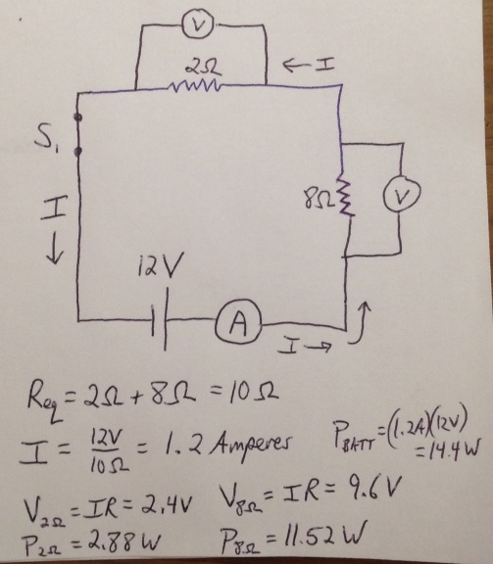
Answers will vary. Voltmeter must connect to points on opposite sides of resistor, and ammeter is drawn inserted in circuit on either side of battery.
R = XX Ω
R = XX Ω
R = XX Ω
R = XX Ω
R = XX Ω
Power of 14.4 Watts uses 14.4 Joules per sec.
(14.4 J/s )(7hr)(3600s/hr) = 363,000 J = 363 kJ
(Energy = Power ∙ time), often measured in kW∙hr
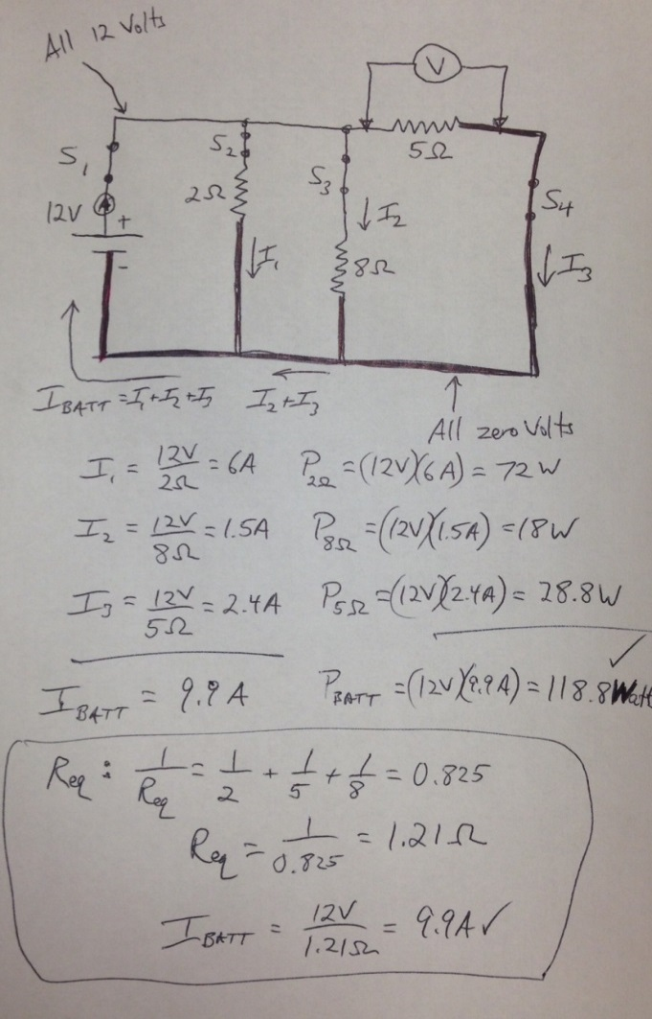
- Draw a circuit with the following: Three resistors, 2Ω, 8Ω, and 5Ω, connected in parallel, BUT NOT ACTUALLY PARALLEL, and attached to a 12-Volt battery. Draw one switch which turns off everything, and one switch for each resistor which turns off only that resistor. Draw an ammeter next to the battery, and a voltmeter across the resistor furthest from the battery.

  - Label all four different currents on the circuit. Calculate the power used by each resistor, and the power provided by the battery.
  - Calculate the equivalent resistance of the circuit. Confirm that it equals V/I through battery.

- Calculate the equivalent resistance for the following circuit, and the total power used. For more challenge, calculate the power used by each resistor.
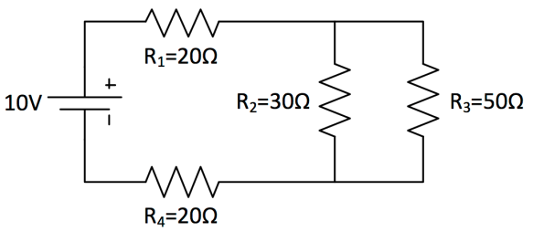
R_{eq} of 30Ω and 50Ω in parallel = 18.75Ω.
R_{eq} circuit = 20Ω+18.75Ω+20Ω = 58.75Ω.
I_{batt} = 10V/58.75Ω = 0.17 Amperes
P_{batt} = (0.17A)(10V) = 1.7 Watts

R1 and R4 have same resistance, and same current through them, so they must have the same voltage difference
V₁ = V₄ = IR = (0.17A)(20Ω) = 3.4V
R1 and R4 use a total of 6.8V, leaving 3.2V for the other pair of resistors.
I₂ = 0.107A I₃ = 0.064A
P₁ = P₄ = 0.579W
P₂ = 0.339W P₃ = 0.204
(Check that total power = P_{batt})

