Extra Practice Worksheet DAL 12/2/16 Name ________________________
Slopes and Equations of Parallel and Perpendicular Lines Date ___________ Period ___

You can check each of your answers by graphing them on Desmos or similar graphing program, either on a computer, tablet, or phone. Graph the given line, and graph your answer to see if it looks right.

I. Basics
1) What is the formula for slope, given two points (x₁, y₁) and (x₂, y₂)?

2) Parallel Lines have slopes which are _____________________

3) Perpendicular Lines have slopes which are _______________________ ________________________.

4) Give the opposite reciprocal of the following:

a) $m=\frac{5}{2}$ m⊥ = b) $m=-\frac{2}{3}$ m⊥ =

c) $m=-\frac{1}{8}$ m⊥ = d) $m=4$ m⊥ =

II. Slope intercept equation:____________________________

Given a point (x,y) and the slope (m), you plug in those numbers into the equation, and then solve for b.
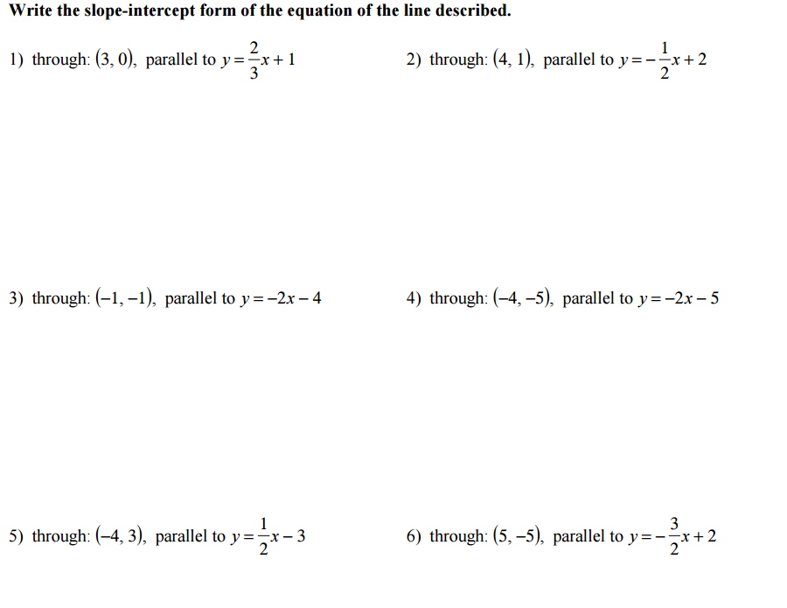

III. Calculate the slope of a segment between the given points.
Then, write the slope of a line which is perpendicular to the original segment. You may use graph paper if you wish, but should be able to do this only using the equation for slope.

1) (3,6) and (5,-4) 2) (-1,-7) and (4, 9)

3) (8,0) and (4,0) 4) (3,6) and (3,-5)

IV. Calculate the equation of a line which is perpendicular to a given segment, and passes through a given point.

1) Perpendicular to segment between (-4,2) and (6,4), and passes through (3, -7)

a) Find the slope of the segment.

b) Find the opposite reciprocal of the slope.

c) Substitute the perpendicular slope and given coordinates (3,-7) into the slope-intercept formula and solve for the y-intercept, b.

