Notes on Light Ch 13-14 4/20/15 Name_______________________ Date______
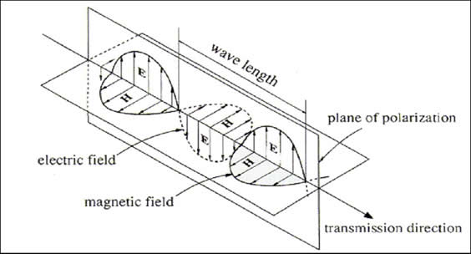
Light is an electromagnetic wave. Waves in water are made by something disturbing the water, and can make a duck on the water bob up and down. Electromagnetic waves are made by something disturbing the electric or magnetic field, and can make electrons bob up and down.
In the diagram to the right, the electric field is oscillating up and down, and the magnetic field is oscillating left and right.

If this wave hit an electron, it would make the electron vibrate up and down. The plane of polarization is oriented vertically, so there are no other electric field waves vibrating in other directions.

The Speed of Light in a vacuum is called “c”. It is the fastest speed anything in the universe can go!
c = 186,000 miles per second = 300,000,000 meters per second!
= roughly 1 million times faster than the speed of sound

Inverse Square Law: The intensity of light is inversely proportional to the distance from the light source. Example: if you go 2.4 times as far from a light source, then the intensity will go down by a factor of 2.6², or 6.76. One divided by 6.76 = .148 = 14.8%, so the light will be only about 15% as bright as it was at the original distance.

Intensity or Amplitude – we see as: BRIGHTNESS!! Frequency – we see as: COLOR!!

Above each type of wave, fill in the approximate range of frequencies. (e.g., “10⁴ – 10⁶ Hz”)

< 10⁹
Low Energy
HIGH
Energy
high frequency, short wavelength
low frequency, long wavelength
Radio Microwave TV Infrared Visible Ultraviolet X-ray Gamma Ray
“ROYGBIV”

In the space above, fill in approximate wavelength of each wave type (e.g., “nanometer” or “10⁻³ m”)

The table above is found in lots of books and web pages, and is very useful for learning the various types of light in the electromagnetic spectrum. It is misleading in that there is not actually any wave which looks like this! A light wave can be either radio or infrared or UV or some other color, but not all at once.

Also, "low" frequency is still ridiculously high. Radio waves from station 96.3 in Detroit have a frequency of 96.3 MHz, or 96.3 million cycles per second. Gamma waves have frequencies a trillion times higher than this!
Light waves (electromagnetic waves) can be:
emitted, or radiated = sent out from an object which is hot, or atoms which are “excited”
absorbed = taken in and turned into another form of energy, such as heat
reflected = bounced off a surface
transmitted = passed through a substance (medium)

Materials can be Transparent (clear), Translucent (cloudy or frosted), or Opaque (blocks light).

(Opaque things don't have to be black, they just have to keep light from going through.)
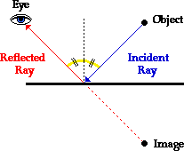

Reflection Bouncing of Waves off a Surface
Angle of Incidence = Angle of Reflection

These angles are measured from the dotted line, the “normal”, which is a line at a right angle to the surface,
at the point where the light ray hits.

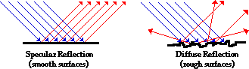
Diffuse reflection (not shiny): rays bounce off rough surfaces scattering in
many directions.

That specular reflection from
the mirror makes you look
spectacular!

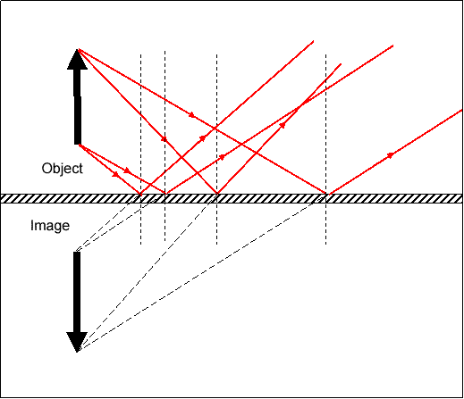
Mirrors:
Mirrors are flat or curved reflectors which have smooth surfaces, and reflect light in a regular smooth way so they can form images.
Every light ray follows the law of reflection as it hits the surface of a mirror, but the rays all hit at different places, at different angles, so must be traced separately.

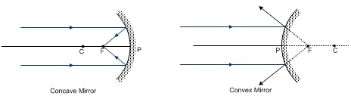

Human Vision: Our eyes sense all wavelengths in the “visible” section of the spectrum (duh, that’s why they call it visible!!), but we have three types of cone cells in our retinas that are particularly sensitive to the three primary colors – Red, Green, and Blue. Our brains can be tricked into thinking we see any color just by showing the correct combination of the three primary colors.

When two primary colors are combined, we perceive secondary colors. When all three primaries are combined, we perceive white light. There isn’t actually any light which is “white” – we just sense white when all the cells in our retina are sensing their colors. There is also no “black” – that is just the absence of light (and color).

For Humans: Primary Colors: Red Green Blue (Red)

combine pairs of top colors to make: Secondary Colors: Yellow Cyan Magenta

Polarized Light: Light normally has its electric field vibrating in all directions which are perpendicular to the direction of travel. In other words, light traveling north could have its e-field vibrating up-down, or east west, or any diagonal combination of those. Take a minute to actually point north, and oscillate your hand in these directions.
Light which is polarized, due to being emitted, reflected, or transmitted in a special way, only has its e-field oscillating in one direction. If this polarized light arrives at a special polarizing filter, it will either be passed through, if the filter is aligned the same way as the light, or blocked, if the filter is aligned at right angles. If the filter is aligned at an angle, only the “lined up” component will get through, so the transmitted light will be dimmer than the incident light.

Polarizing filters are useful in photography and many types of chemical analysis, in addition to making sunglasses which block glare (light reflected off snow, water, or wet roads).
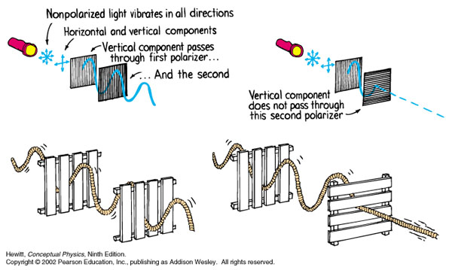

Refraction Bending of waves caused by a change in speed as they pass from one medium to another.

Index of Refraction: The factor by which a material slows down light. If a certain type of plastic makes light travel only half as fast as in a vacuum, then the index of refraction of that plastic is 2.00. A material with a high “n” will slow down light a lot, and therefore cause it to bend a lot.
Index of Refraction: $=\frac{c}{v}$ , or rearrange to $v=\frac{c}{n}$
n is the index of refraction,
c is the speed of light in a vacuum (2.998 x 10⁸ m/s)
v is the speed of light in the material

When light hits a different medium, if it slows down, it bends towards the normal; if it speeds up it bends away from the normal. Remember that the normal is the dotted line which is perpendicular to the boundary between the two media, and that the normal must be drawn through the spot where the wave hits that boundary

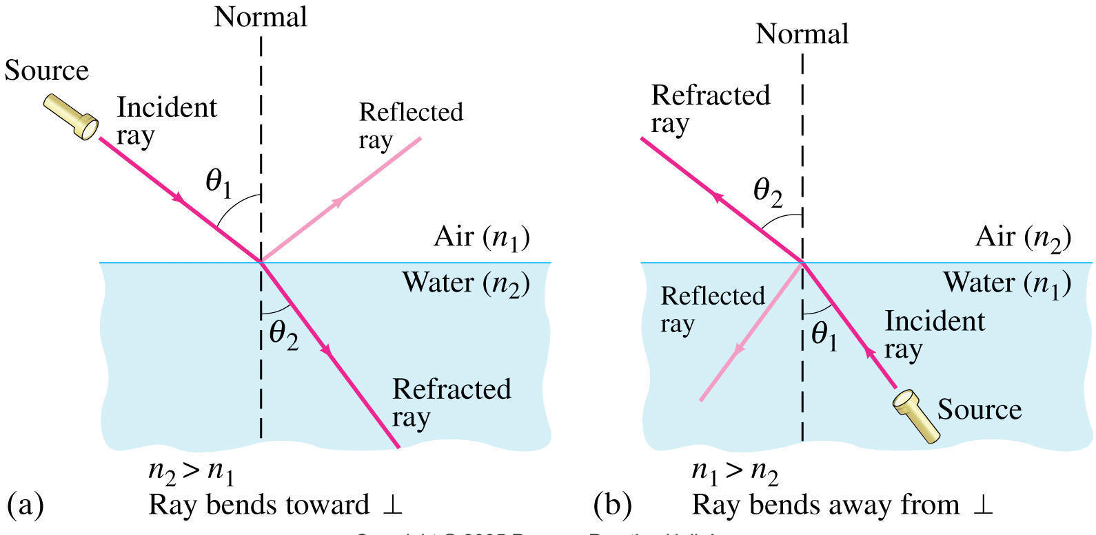

Snell’s Law: To calculate the actual angles from the normal, or to calculate the speed of light in the substance, use Snell’s Law:
$$n_{1}\sin{θ_{1}}=n_{2}\sin{θ_{2}}$$

If you have the angles, and one of the indices of refraction, then it is relatively easy to calculate the other index of refraction.
If you have both indices of refraction, and one angle, you can calculate the sine of the other angle, but you will need to use the arcsin or inverse sin on your calculator to actually get the angle.

Lenses: (curved pieces of glass, plastic, or other transparent material)
Convex Lenses make rays bend in (converge) Concave Lenses make rays diverge.

Lenses have focal points – parallel incident rays form image at focal points.

[What do we call a lens that is not convex or concave? A window.]

Images
When light rays from one object are made to focus and actually cross, they form a real image which can be projected onto a screen.
When light rays from one object are bent so they appear to have come from one place, they form a virtual image, which looks like an actual object in space.

Our corneas and lenses focus incoming light rays into a real image on the retina on the back of our eyeballs. This image is inverted, or upside down, but our brain adjusts to it so we perceive the world right side up.
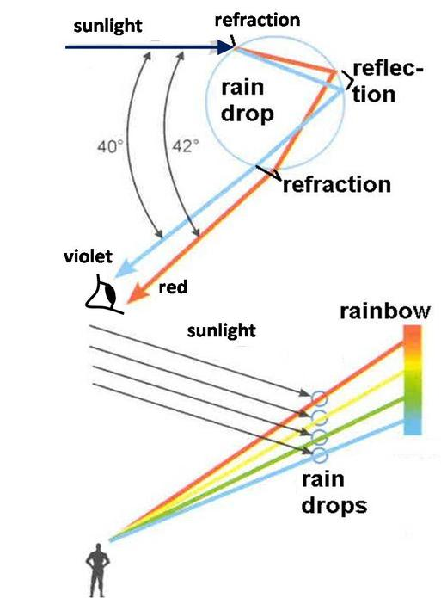

Dispersion
Different colors of light are not all slowed down the same amount in some materials. For example, when light passes from air into water, violet light slows down more than red light does.

This causes the some wavelengths to bend more than others, and get separated into different colors – a spectrum.

Dispersion is what causes white light to be separated into the whole visible spectrum in raindrops and prisms

Doppler Effect This works the same way for light as it does with other waves such as sound. As a source is approaching you, you will sense a higher frequency and shorter wavelength, which appears more blue than the actual source. As a source is moving away from you (as most stars and galaxies are) you will sense a lower frequency and longer wavelength (more red = redshift).

This is also how radar guns work, as the radio wave is bounced off a car, and shift frequency depending on how fast and in what direction a car is moving. The reflected wave then causes beats with the original wave, so the speed of the car can be calculated.

