The First Silk Roads, By Craig Benjamin, Professor, Grand Valley State University
Trade Routes Connect the Vast Continent of Afro-Eurasia
Beginning with early agrarian civilizations, societies started to connect into large networks of exchange, leading to levels of collective learning never seen before in human history.
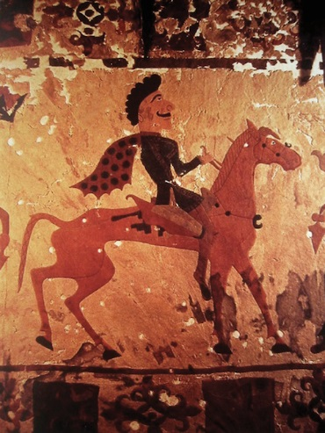
A Scythian/Pazyryk horseman, c. 300 BCE, State Hermitage Museum in St. Petersburg
Agrarian civilizations did not exist in isolation. As they grew and stretched their boundaries they joined up to form larger structures. This linking up of different civilizations was an important process because it ensured that collective learning reached further and embraced more people and greater diversity than ever before. Significant exchanges occurred in the Americas, in Australasia, and in the Pacific, but the most important exchange networks emerged in Afro-Eurasia. At this time these four zones were still so isolated from each other that humans living in one remained utterly ignorant of events in the others.
In Afro-Eurasia, all agrarian civilizations were linked together into a vast interconnected network by the beginning of the Common Era. This network involved not only the trading of material goods, but also the trading of social, religious, and philosophical ideas, languages, new technologies, and disease. The most important exchange system that existed anywhere during the Common Era is known today as the Silk Roads, but significant smaller connections developed much earlier between many of the agrarian civilizations.
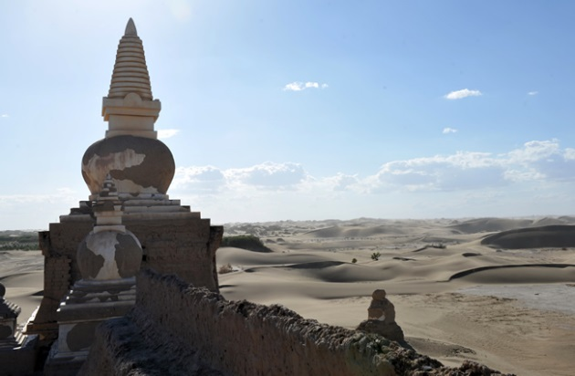
Heicheng in China’s Inner Mongolia Autonomous Region© Asigang/Xinhua Press/Corbis
Not all these connections were based on trade. Warfare is common to all agrarian civilizations, so conflict was also a powerful way of connecting civilizations. It was through warfare that the Romans eventually connected many of the peoples of Afro-Eurasia. Centuries later, Muslim armies quickly constructed a vast Islamic realm that stretched from Europe to the borders of the Tang dynasty’s empire, deep in central Asia. Although these military relationships were important in establishing connections, the most influential connections of the era were built through trade.
Trade was important from the beginning. As early as 2300 BCE, civilizations in Mesopotamia, Egypt, and the Indus Valley were involved in commercial relationships. The Silk Roads enabled these early small-scale exchanges to expand dramatically, leading to even more significant changes in human history, and to intensive collective learning.
The First Silk Roads Era (50 BCE–250 CE)
The first major period of Silk Roads trade occurred between c. 50 BCE and 250 CE, when exchanges took place between the Chinese, Indian, Kushan, Iranian, steppe-nomadic, and Mediterranean cultures. A second significant Silk Roads era operated from about 700 to 1200 CE, connecting China, India, Southeast Asia, the Islamic realm, and the Mediterranean into a vast web based on busy overland and maritime trade. The primary function of the Silk Roads during both periods was to facilitate commercial trade, but intellectual, social, and artistic ideas were also exchanged. Historians believe that it is these nonmaterial exchanges that have been of greatest significance to world history.
Large-scale exchanges became possible only after the small early agrarian civilizations were consolidated into huge and powerful empires. By the time of the first Silk Roads era just four ruling dynasties — those of the Roman, Parthian, Kushan, and Han empires — controlled much of the Eurasian landmass, from the China Sea to the Atlantic Ocean. Order and stability was established over a vast geopolitical environment, great road networks were constructed, advances were made in metallurgy and transport technology, agricultural production was intensified, and coinage appeared for the first time. By 50 BCE, conditions in Afro-Eurasia were much different than they had been before the consolidation of empires.
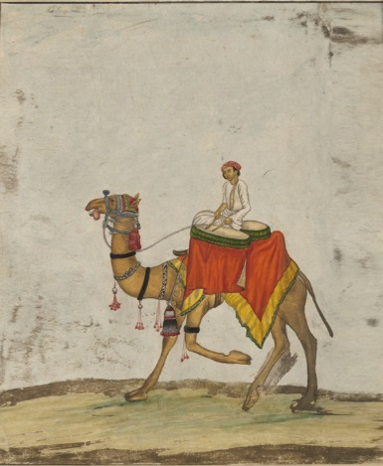
A camel and rider from a Mughal Empire ceremonial procession, public domain
Pastoral nomads (humans who form communities that live primarily from their domesticated animals like cattle, sheep, camels, or horses) were also important in these exchanges. Toward the end of the first millennium BCE, large and powerful pastoral nomadic communities appeared — the Scythians, the Xiongnu, and the Yuezhi. The ability of pastoral nomads to thrive in the harsh interior of Inner Asia helped facilitate the linking up of all the different civilizations and lifeways, as travelers depended on these people when the Silk Roads formed.
It was the decision by the Han Chinese in the first century BCE to interact with their western neighbors and engage in long-distance commerce that turned small-scale regional trade into a great trans-Afro-Eurasian exchange network. This occurred around the same time that Augustus came to power in Rome following a century of civil war. In the relatively peaceful era that ensued, the demand for foreign luxury goods in Rome exploded, leading to a huge expansion of both land-based trade routes connecting the Mediterranean with East Asia, and maritime routes connecting Roman Egypt to India.
The major Chinese export commodity in demand in Rome was silk, an elegant, sensual material formed by silkworms that was highly coveted by wealthy women. The Chinese carefully guarded the secret of silk, and border guards searched merchants to make sure they weren’t carrying any actual silkworms out of the country. The Romans also prized Han iron for its exceptional hardness, as well as spices from Arabia and India, such as nutmeg, cloves, cardamom, and pepper. From central Asia, India, and the Mediterranean region, the Chinese imported agricultural products (such as grapes), glassware, art objects, and horses.
The Silk Roads land routes stretched from China’s capital, Chang’an (in Shaanxi Province near Xi’an), through Central Asia and on to the Mediterranean. The animal that made Silk Roads trade possible was the Bactrian camel, which was incredibly well adapted to its environment. The humps on its back contain high quantities of fat (not water) to sustain it for long distances, and its long eyelashes and sealable nostrils guard against dust in the frequent sandstorms. The two broad toes on its feet have undivided soles, a natural adaptation to walking on sand. The bulk of overland Silk Roads trade was literally carried on the backs of these extraordinary animals.
Much Silk Roads trade also took place by sea, between Roman Egypt and the west coast of India. Sailors had discovered the “trade winds,” which blow reliably from the southwest in the summer, allowing heavily laden ships to sail across the Indian Ocean from the coast of Africa to India. The winds reverse in the winter so that the same ships carrying new cargo could make the return journey to Egypt. Whether by land or by sea, however, few traders ever made their way along the entire length of the Silk Roads. Typically, merchants from the major eastern and western agrarian civilizations took their goods as far as central Asia before passing them on to a series of middlemen, like the Kushans, the Sogdians, and the Parthians.
During the third century CE, the Silk Roads fell into disuse as both the Chinese and Roman empires withdrew from the network. Silk Roads trade was at least partly responsible for this, because it led to the spread of disastrous epidemic diseases. Smallpox, measles, and bubonic plagues devastated the populations at either end of the routes, where people had less resistance to each other’s diseases. As a result, the population of the Roman Empire fell from perhaps 60 million to 40 million by 400 CE, while that of China may have dropped from 60 million to 45 million by 600 CE.
These huge demographic losses, which happened at the same time as the decline of previously stable civilizations (the Parthian, Han, and Kushan empires all disintegrated between 220 and 250 CE, and the Roman Empire experienced a series of crises beginning in the early third century), meant that the political situation in many parts of Afro-Eurasia was no longer conducive to large-scale commercial exchange. However, with the establishment of the Islamic realm in the eighth and ninth centuries CE, and the emergence of the Tang dynasty in China at the same time, significant Silk Roads exchanges along both land and maritime routes were revived.
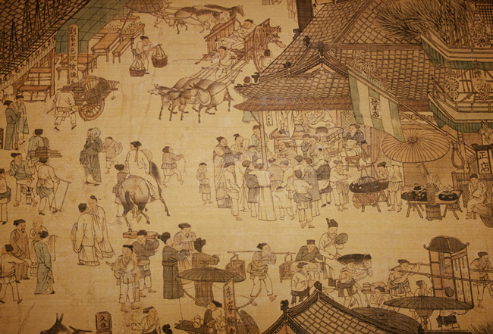
A painting of the Qingming Festival by Zhang Zeduan© Pierre Colombel/CORBIS
The Second Silk Roads Era (700–1200 CE)
Both the Tang dynasty (618–907 CE) and its successor, the Song (960–1279), presided over a vibrant market economy in China, in which agricultural and manufacturing specialization, population growth, urbanization, and technological innovation encouraged high levels of trade. New financial instruments (including printed paper money) were devised to facilitate large-scale commerce. At the same time, Arab merchants — benefiting from the stable and prosperous Abbasid administration in Baghdad (750–1228 CE) — began to engage with their Chinese counterparts in lucrative commercial enterprises, leading to a revival of the Silk Roads.
The trade goods exchanged across Afro-Eurasia during this second Silk Roads era, including ceramics, textiles, foods, spices, and high-value art, were impressive. But as was the case with the first era, religious exchanges were perhaps of even greater significance to world history. Even before the Tang came to power, many foreign religions had made their way into East Asia, including Christianity, Manichaeism, and Zoroastrianism. With the advent of Islam in the seventh century and the establishment of substantial Muslim merchant communities in the centuries that followed, mosques also began to appear in many Chinese cities. But of all the foreign belief systems that were accepted in China, it was Buddhism that made the most substantial inroads.
Exchange Shapes Culture
The Silk Roads are the supreme example of the interconnectedness of civilizations during the Era of Agrarian Civilizations. Along these often difficult routes, through some of the harshest geography on Earth, traveled merchants and adventurers, diplomats and missionaries, carrying their commodities and ideas enormous distances across the Afro-Eurasian world zone. Each category of exchange was important, and, as a result of this interaction, Afro-Eurasia has preserved a certain underlying unity, expressed in common technologies, artistic styles, cultures and religions, and even in disease and immunity patterns.
Other world zones also had their early exchange networks, but none on the scale of the Silk Roads. American trade networks happened over long distances, crossing diverse geographic regions — from the Andes through Mesoamerica and up into North America. But American networks were much smaller and less varied than those of the Silk Roads, probably because the jungles of the equatorial region acted as a barrier. Because of the Silk Roads, Afro-Eurasia was much larger in population, much more technologically dynamic, and also much more interlinked through trade and exchange than the other three world zones were. This is a particularly important distinction because, when the different zones finally collided after 1492, the societies of Afro-Eurasia were quickly able to dominate the rest of the world. And that in turn explains why the modern revolution that followed was destined to be led by Afro-Eurasian peoples, not those from the Americas.

