“Create Your Vision of the Future”:
Now that we are near the end of the course, I want you to use your educated imagination to envision what the world will be like exactly 100 years from today. Your vision of the future needs to be backed by the history you have learned in this course and the state of affairs today. Before we commence on our own vision, I want you to take notes on the visions of three distinguished individuals:
- Henry Louis Gates, Jr. (https://www.youtube.com/watch?v=un5wOmL3LBQ)

- Bill Gates: (https://www.youtube.com/watch?v=oxbSM2IwIBo)

- Sanjayan: (https://www.youtube.com/watch?v=h5P4hHAYPOI)

You can create your vision in writing form, using multimedia, or some other means you devise. I am open to the, “how”, but as for the, “what”, your world must include the following:
Map piece:
On your map specify the following items:
A. Population in areas of the world- Will there be any countries that increase their size? Any that no longer exists? Any that decrease in size? Specify where you think these changes are occurring and what caused these changes.
B. What diseases will be rampant and where will they cause the most damage? (Create a key to what diseases and their locations)
C. Key areas of importance- specify where and why.

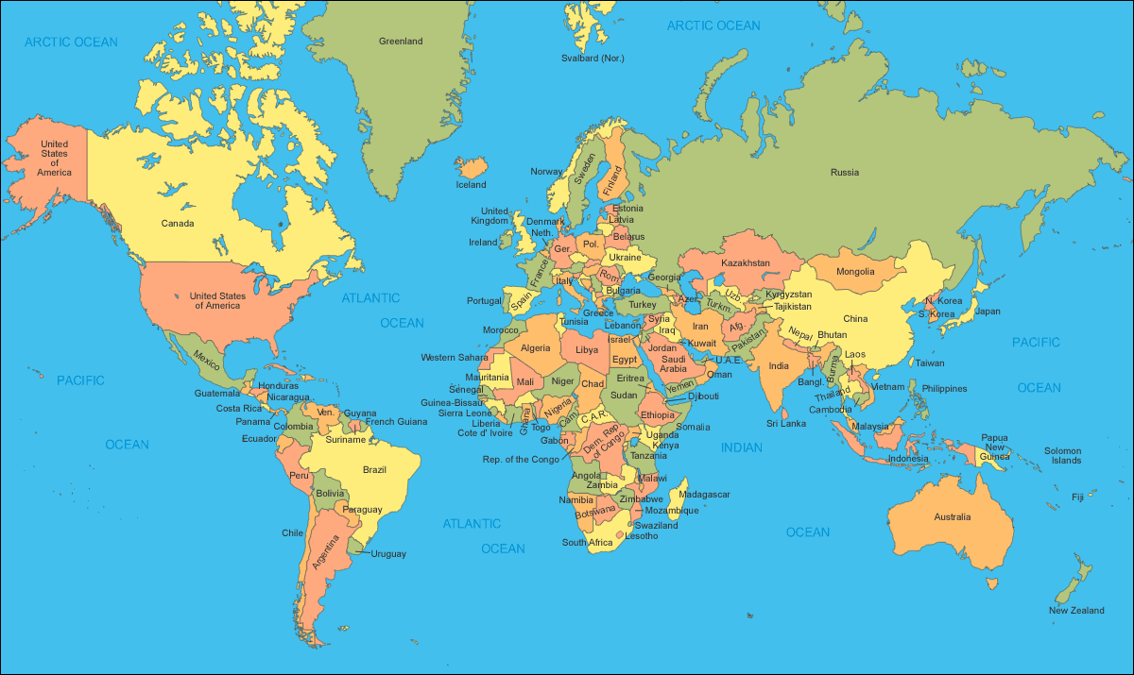

Written piece:
Write a paper that you will staple to your map that will explain the following in your vision:
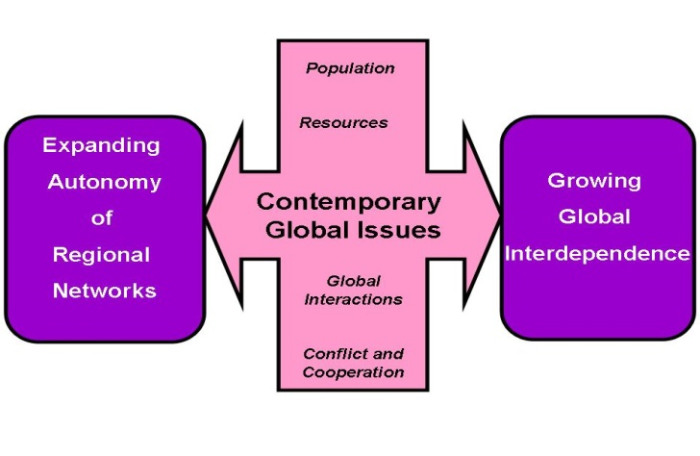
- What will be humanities solution to population issues? Will it Malthusian in nature? Will it require social engineering? Will we be able to adapt successfully to unprecedented numbers of people? How will human rights be affected?

- What resources will be at a premium 100 years from now?

- What will be the state of global interactions? What will the role of international organizations, such as the European Union, NATO, and the United Nations play?

- Will we live in a more cooperative world or one of increased conflict? What ethnic, regional, religious and economic issues will need to be remedied to create a more peaceful world?
And most importantly…..

- Explain your rationale to why you envision the world to be. What historical events and current events did you use to fortify your projection? Essentially, explain your thinking (epistemology)

