Name ________________________________ date __________ hour __________

CW 6: Atomic Emission Spectra
Complete the following as you progress through the PowerPoint.

- What is electromagnetic radiation?

- How does a spectrum form?

- Why is the spectrum formed by a helium lamp different than the spectrum formed by a white light bulb?

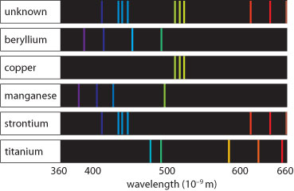
- Can you identify the element(s) present in the unknown? Justify your answer and explain how you came to it.

- Why did Bohr choose to study hydrogen?

- What happens to the distance between energy levels as they increase?

- Draw and label the Bohr model of the atom. Summarize the basics.

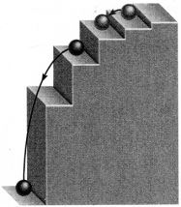

- Explain how the picture relates to atoms and the Bohr model.

- Compare the ground state and the excited state.

- Explain how electrons move between energy levels.

- Only certain frequencies of light are visible to the human eye. List all of the visible energy transitions found in hydrogen and the colors that correspond.

- Compare the energy transitions in the ultraviolet and infrared frequencies. Then circle the correct words in the sentence below.
The energy given off during an infrared transition is too (small/large) to be seen by the human eye, whereas the energy given off during an ultraviolet transition is too (small/large) to be seen by the human eye.

- What is a flame test? Explain.

Flame Test Pre-Lab

Video Link: http://www.youtube.com/watch?v=65aWaDGNfVE

- Watch the video.
- In your groups, write the purpose, procedure (step by step, numbered; spare no details!), and materials needed for the lab.
- NOTE: We will not do it exactly like in the video. Observe the materials we will use and adjust your procedure accordingly.

