The Lytic cycle
Once a virus has completed adsorption and entered the cell or injected its genes, it may go through the lytic or lysogenic cycle.

Virulent viruses go through the Lytic cycle while avirulent or temperate viruses go through the lysogenic cycle.

The Lytic cycle
- Adsorption to the host cell
- Infection of the host cell by the virus
- Virus destroys the host’s DNA and takes over the host machinery for self-replication. It uses the host’s energy to make proteins and copies of itself
- Viral particles are assembled into virions
- Viruses use Lysozyme to lyse the cell and release the virions or they may exit via budding (if they are enveloped viruses)
- Infection spreads to more cells
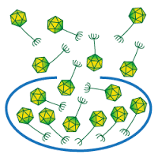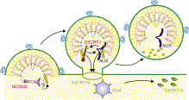

https://www.google.com/imgres?imgurl=http://phagesdb.org/media/glossary/pics/BurstSizeMod.png&imgrefurl=http://phagesdb.org/glossary/&h=250&w=250&tbnid=kU90RL-dBbxeKM:&docid=M27ChZuZTKMn0M&ei=FzPgVvSxIMr5jgThoYeYDg&tbm=isch&ved=0ahUKEwi0meec6LPLAhXKvIMKHeHQAeMQMwhDKBwwHA
© 2013 Elsevier Inc. Published by Elsevier Inc.http://www.cell.com/cell-host-microbe/abstract/S1931-3128(13)00294-1

