Class/Subject: Philosophy | Lesson 13: “Aesthetics as it applies to paintings”
Objective(s):  SWBAT use the criteria for aesthetics and apply in the evaluation of 25 of the some of the greatest works of fine art in human history. | Unit: Aesthetics
Philosophical Quote of the Day:  “The purpose of art is washing the dust of daily life off our souls”. - Pablo Picasso | Philosophical Song of the Day:  “When I Paint My Masterpiece”- Emmylou Harris  https://www.youtube.com/watch?v=rA4dsEWDtZI
Key Points of the Day:  • Critiquing art is a difficult pursuit and people see it in very different ways. However, the more you learn and experience, the better equipped you are to assert your aesthetic beliefs. | - Aesthetic criteria are useful tools to evaluate art, but it is difficult to gain consensus to what great art constitutes.
Journal Entry:  “What constitutes a great work of art? Which piece had the highest level of aesthetics? Which had the lowest? How are you justifying this opinion philosophically? | Supplemental Reading and Philosopher: What Is Art?  Book by Leo Tolstoy  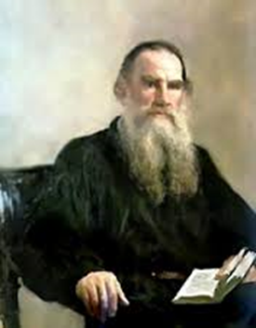  Leo Tolstoy is considered more of a writer, than philosopher, but philosophic principles were infused throughout his works. In the realm of art, Tolstoy rejected any definition of art based on a conception of beauty. Since we have no objective way of defining beauty, it merely becomes defined as what pleases us, which is different for each person. The only clear definition of art can lie in its function, which is the transmission of feeling. Art can then be judged on how well it transmits feelings (infectiousness) and on the value of the feelings transmitted (truth or goodness).

