Class/Subject: Philosophy | Lesson 4- “Soul Profile (Eastern/Western Philosophies)”
Objective(s):  SWBAT complete their soul profile, personal vision, and mission statements. SWBAT discern between Western and Eastern philosophies | Unit: “KNOW THYSELF”
Philosophical Quote of the Day:  “Many scientists think that philosophy has no place, so for me it's a sad time because the role of reflection, contemplation, meditation, self- inquiry, insight, intuition, imagination, creativity, free will, is in a way not given any importance, which is the domain of philosophers” –Deepak Chopra | Philosophical Song of the Day:  James Brown- “Soul Power” https://www.youtube.com/watch?v=l0OJUcxdL24
Key Points of the Day:  • This course is a Western philosophy course, but there is another subset of philosophy that is Eastern. The Western tradition is Greek and the Eastern stems from Hindu and Buddhist roots | - These questions are a more spiritual, eastern version of the western maxim to, “know thyself”.
Journal Entry:  “What are your Soul Profile, Personal Vision, and Mission Statements?” | Supplemental Reading and Philosopher: Deepak Chopra, The Soul of Leadership: Unlocking Your Potential for Greatness  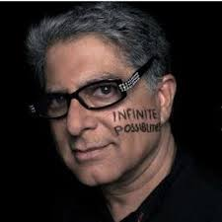  Deepak Chopra is an Indian-born American author and public speaker. He is an alternative medicine advocate and a promoter of popular forms of spirituality, who has been described by the New York Times as a "controversial New-Age guru".

