Is Density an Intensive or Extensive Property?
Your hypothesis -______________________________________________________________________
____________________________________________________________________________________
Let’s use Pennies to find out! (Mini-lab)
Density = mass (g)/volume (ml)
We will get the mass of the pennies using a triple beam balance and we will determine the volume of the pennies by recording how much water is displaced when pennies are added to a graduated cylinder with 20mls of water in it.
Procedure: Part 1 - MASS
1. Stack 5 pennies on top of each other and add the stack to the triple beam balance. Record the mass of the 5 pennies.
2. Stack another 5 pennies on top of each other and add them to the triple beam balance. The balance should now have 10 pennies on it. Record the mass of the 10 pennies.
Using common sense, how should the mass have changed? _____________________________
______________________________________________________________________________
3. Stack another 5 pennies on top of each other and add them to the triple beam balance. The balance should now have 15 pennies on it. Record the mass of the 15 pennies.
4. Stack another 5 pennies on top of each other and add them to the triple beam balance. The balance should now have 20 pennies on it. Record the mass of the 20 pennies.
5. Take a look at your numbers, do they make sense? Are you getting what you would LOGICALLY expect to get? Yes or no? ______________________

Procedure: Part 2 – VOLUME – remember to start with 20mls of water in the graduated cylinder. Also, measure volume from the bottom of the meniscus
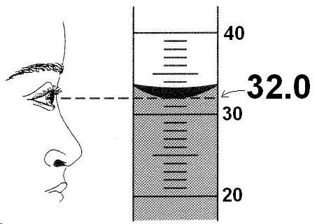
(the “U” shape) when the cylinder is at eye level.

1. Carefully drop the first stack of 5 pennies in the graduated cylinder. Calculate the displacement of water (i.e. started at 20mls and went up to 22mls so volume = 2mls). Record.
2. Add the second stack of 5 pennies to the same cylinder.
Calculate and record displacement (Your # -20mls)
3. Repeat this procedure two more times for the last two stacks of pennies. Record your data.
(Your # - 20mls)

Calculations and Data – Use your data and the formula above to calculate the density of the pennies. Show your work and your units below!

Density of 5 pennies-

Density of 10 pennies –

Density of 15 pennies -

Density of 20 pennies -

Conclusions and reflections

What does your data show? Is Density an intensive or extensive property? _____________________

Check to see what other groups are getting for data. Are there differences in results? ____________

What could be some reasons for the variations in answers among groups?

Research
Look on the internet – what should be the density of a penny (after 1982)? ____________________
How far off are you from this number? _____________________________
Why do you have to differentiate between pre and post 1982 pennies?

