Days 166-168: Contemporary Global Issues
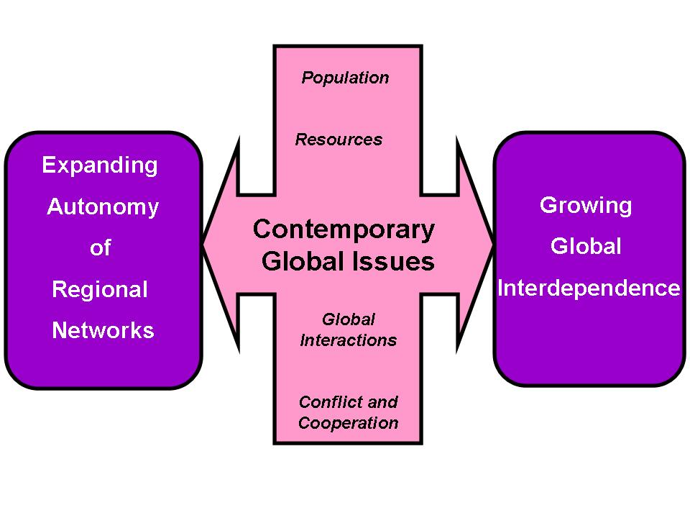
PART I: Interpret this visual’s meanings- Discuss as a class.
PART II: Research- You will be divided up into teams. Your team will research the contemporary global issue you were assigned. There are some links on the Moodle page that can help you.
A) Ethnic cleansing- What is the difference between this and genocide, if any? Use the breakup of Yugoslavia as a case study.
B) Fossil fuels/Global Warming- What are fossil fuels and how is the Greenhouse Effect changing the world? What alternative forms of energy are being used?
C) 21st Century Migrations- What major migrations are taking place today? Use Syria as a case study of the challenges such migrations present.
D) Natural resources- What things are considered natural resources? What nations have economic advantages based upon these? Use neodymium in China as a case study.
E) Terrorism- How many terrorist acts have been committed since 9/11/01? Who has perpetrated these acts? What steps are being taken to combat terrorism internationally?
F) Overpopulation- What is the world’s population? What challenges are we facing and will we face with the population growing? What was the Malthusian Theory of Population Growth and was his hypothesis correct?
G) The Information Age- Begin with August 9, 1995 when Netscape went public and end with today. How has technology proliferated since 1995 and who has access to technology internationally? How has it changed the world?
H) The Israeli-Palestinian Conflict- Chart the history of Israel from the Balfour Declaration to today. When did the nation of Israel form and how did it change the world. What policies should America have in relation to Israel.
PART III: Presentations- We will go in order the second day and your group is responsible to provide:
1. An explanation that classmates will understand. You will also use the correct scale that has the perfect amount of detail.
2. A visual for classmates to see.
PART IV: Notes- As an individual, you are responsible for keeping notes on your classmates’ presentations. Your grade will entail this graphic organizer and how well you contribute to your group.

