Lesson 4
Student Handout 4.1—New Identity in Japan: Resistance and Change During the first half of the nineteenth century, Japan was ruled by the Tokugawa shogunate (1600-1868). This period is called the Edo period because the Tokugawa
Capital was in Edo (modern Tokyo). The Tokugawa shogun was a dictator who ran a
central bureaucracy with alliances to regional daimyo, or great estate owners, and to the samurai, a class of professional knights in service to both daimyo and the shogunate. Japan continued to have an emperor but only with ceremonial functions. To preserve stability, society was formally divided into samurai, farmers, artisans, and merchants, and contact with the world beyond Japan was severely restricted. The Tokugawa shogunate initiated a number of changes, including the standardization of coins, a system of weights and measures, improvement of roads and canals, and implementation of detailed law codes. In part because of these policies, Japan’s internal economy grew impressively during much of the Tokugawa period.

Japanese cultural and intellectual life also flourished into the beginning of the nineteenth century. For example, the number of educational institutions increased, resulting in the highest rate of literacy outside of Europe by the middle of the century. Intellectual life in Japan also produced a number of debates between traditionalists and reformists, the former praising Japanese government and Shinto religion and the latter admiring Western science and literature.

Commerce and manufacturing expanded, developments that may have planted some early seeds of industrialization. Despite this expansion, however, the Tokugawa regime faced a number of financial problems. For one thing, it continued to rely on taxes on agriculture despite the fact that Japan’s commercial economy was producing more and more potentially-taxable revenue. In addition, the delicate political balance it tried to maintain with the daimyo and samurai required payment of large stipends in exchange for their loyalty. By the 1850s, economic growth had slowed and rural protests erupted among peasants, who were unhappy with financial conditions and landlord controls.

Despite these problems, Japan experienced an unprecedented period of peace and relative stability under the strict isolationist policy of the Tokugawa shogunate. Faced with the reality of European expansion, however, some Japanese became increasingly worried about the threat of outside forces. Then, in 1853, U.S. Commodore Matthew Perry sailed into Edo Bay with a small armed fleet, and he insisted that Japan open its ports to American trade. Nearly powerless against this show of naval superiority, Japan signed a formal treaty with the U.S. to open two commercial ports. Soon thereafter, the major European powers won similar rights.

Now faced with the collapse of its strict isolationist policy and humiliated by Perry’s forces, Japan entered into more than a decade of political turmoil. Some Japanese, like those intellectuals who had already become fascinated with Western culture, were completely ready to open their doors to European and American influence. Others, like

the daimyos, wanted to conserve Japanese traditions and their way of life. The samurai were divided, with some seeing the opportunity for more political power if the shogunate ended. In 1867, using American Civil War surplus weapons, a group of samurai defeated shogunate forces, convincing many of the military superiority of Europe’s modern weaponry.

In 1868, radicals seized the imperial palace and claimed “restoration” under the young emperor whose formal reign name was Meiji. A brief civil war followed, ending with the victory of Meiji forces. Hence began a period of Meiji rule, in which the government was centralized and power distributed among appointed district administrators. The Meiji government sent officials abroad to study Western economic and political institutions and technology and, impressed with what they found, instituted a number of reforms. The tax on agriculture was broadened and samurai stipends were decreased. Former samurai organized political parties; government bureaucracy was expanded and a constitution was issued.

The new Meiji army also modeled itself after Western standards, instituting full military conscription and officer training, and upgrading weapons. The government also set its sights on full industrialization, expanding railroads and promoting increased agriculture to support it. The government expanded technical training, education, and banking systems to make way for industrialization as well. By the beginning of the twentieth century, Japan had entered a complete and well-organized industrial revolution.

The Meiji government also provided a universal primary education, which stressed science and technology to further support increased industrialization. Education,
however, brought exposure to values different from traditional Japanese values. By 1880, the emperor decided that changes had gone too far. Therefore, the government set out on
a mission to provide an education replete with traditional Japanese morals and loyalty to the government and nation. Many Japanese were particularly eager, for example, to maintain the traditional inferiority of women. Also, the Meiji emperor and his conservative advisers placed government restrictions on Buddhism, giving new primacy to the native Japanese religion of Shintoism, which promoted strict order and national allegiance.

Still, Japanese culture and life became imbued with borrowings from the West, including fashion, hairstyles, and hygiene. Japan adopted the Western calendar and metric system. Although Japan retained many traditional values and institutions after contact with the West, at the beginning of the twentieth century it surely was different from early nineteenth-century Japan.
Sources: David S. Noss and John Boyer Noss, A History of the World's Religions (New York: Macmillan,
1994); Peter N. Stearns, Michael Adas, and Stuart B. Schwartz, World Civilizations: The Global
Experience (New York: Longman, 2001).

Japan

China

Korea

Nagasaki

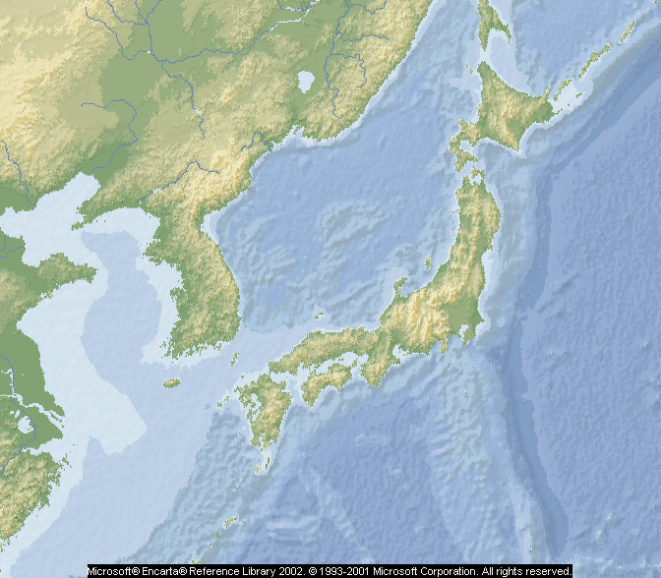Osaka
Edo
(Tokyo)

Lesson 4
Student Handout 4.3—Venn Diagram: Japan
New Identities: Aspects of
identity that were changed after significant contact with the West
Old Identities:
Aspects of Identity prior to significant contact with the West
Retained Identity:
Aspects of identity intact after significant contact with the West.

