Cone Activity – Multiple Levels

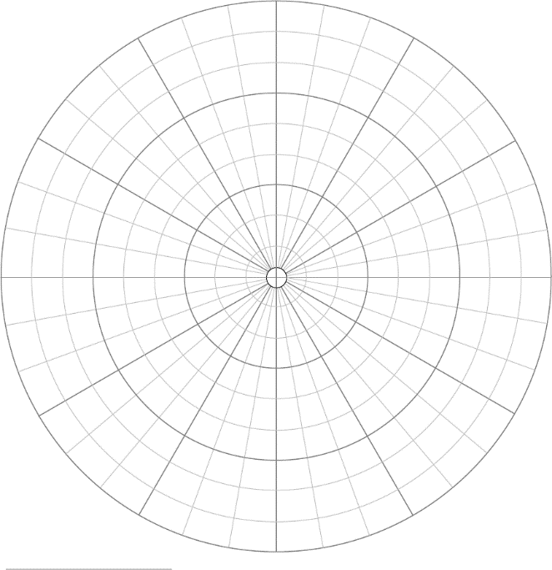
Level 1
- Get a piece of polar graph paper marked as shown.
- Cut out a full circle using the drawn curves. You may choose a circle other than the outer circle, if you wish. Mark one radius as “zero degrees”, and then move counterclockwise around the circle to select another radius more than 90° away. Mark the central angle θ, and label the angle.
- Precisely measure the radius of your chosen circle, and label it. Shade in the sector included in your central angle, using colored pencil or crayon. Also, use marker or crayon to color the arc along the edge.
- Calculate the arc length and the area of the sector. Show all formulas, substitution, calculations, and units.

Level 2
- Cut along one of the radii bordering the selected sector. Cut carefully, exactly to the center.
- Slide the uncolored portion (not in the sector) behind the colored portion to create a cone. Only the colored portion should be showing. Tape the loose edges on the inside and outside of the cone.
- Using the arc length you previously calculated, calculate the radius of the circular base of the cone. Show all equations, and include units.
- Using a ruler, measure the diameter of the base of the cone, and use that to confirm that your calculated value of the radius is correct.

Level 3
- Use the calculated radius and the slant height of the cone to calculate the height of the cone.
- Use the height and the radius to calculate the volume of the cone.
- [LATER!] Either waterproof the cone, or make an identical cone out of a plastic transparency sheet, or sacrifice your cone to mathematics, and fill the cone with your calculated volume of water to confirm that it actually holds the volume you calculated.

Level 4
- Calculate the angle the cone makes with horizontal when placed flat on a surface with the vertex pointing up.
- Draw and cut out a triangular cross section of the cone, and confirm that it fits perfectly in the cone.

Level 5
- Create a new cone which follows specific design criteria of your choosing. Choose a cone diameter and cone vertex angle, and calculate the needed slant height for the cone. Then figure out what radius circle and what central angle you will need to build that cone.

