WRITE YOUR OWN OBITUARY
Your obituary should have the following format:
1) NAME
2) PHOTO
3) QUOTE THAT SUMMARIZES YOU (HELPFUL DRILL FOR YOU SENIORS PREPARING FOR YOUR QUOTE AT GRADUATION)
4) SYNOPSIS OF YOUR TIME HERE (BEGINNING, END, WHO’S LEFT BEHIND?)
5) PROFESSIONAL ACCOMPLISHMENTS
6) PERSONAL ACCOMPLISHMENTS
7) INFORMATION ON YOUR SEND-OFF AND HOW YOU SEE YOUR FINAL CEREMONY GOING.
If this format doesn’t help you, I provided a template below of myself. Talking about death shouldn’t be all dark and macabre. Philosophically, the acknowledgement of death and how it is handled varies greatly. Over the next couple of days, we’ll explore how we feel about it.

Anthony Alfiero Salciccioli
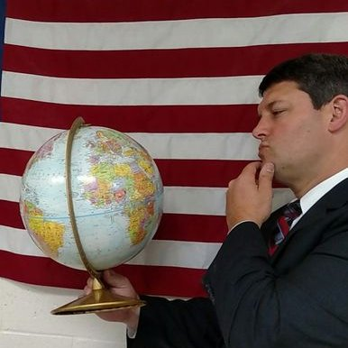
(August 12, 1974- October 15, 2052)

“The unexamined life is not worth living”- Socrates
Born in Southfield Michigan and died suddenly in Gagliano-Aterno, Italy hiking the trails of the Gran Sasso. He is survived by the love of his life, Heidi Ostheimer and three children, Sophia, Michael, and Laine. He is also survived by his beloved six grandchildren, Tony, Luther, Sugar, Ezekiel, Guadalupe, and Bri Bri. He is also survived by his brother Jonathan and sister Kathryn.
Salciccioli was a proud Michigan State Spartan, graduating in 1996 where he played prop on the rugby team. He received a second degree from the University of Michigan and a Master’s degree in Education from Marygrove College. Salciccioli taught social studies in Clarenceville public schools for 35 years, where he also coached for a number of years.
During his retirement, Salciccioli was involved in a variety of civic groups and tutored at-risk youths. He travelled extensively and and had an insatiable curiosity about the world, in particular, the social sciences. He loved spending time with this family, being a teacher, reading, travelling and taking long walks with his dogs.
Salciccioli will have a celebration of life at the Farmington Hills Hall located at 14597 11 Mile Road. All friends, coworkers, neighbors, and former students are welcome for good food, good drink, and good company. Donations are welcome and will go to offset the costs of the refreshments, with the extra money going to the Clarenceville High School Wrestling Club. In lieu of flowers, please contribute to this. There will be an open mic and blank books where it is encouraged stories will be spoken and written. It is asked there are no tears and all smile.

