The Middle Passage

Document Worksheet

Overarching Question: How were captives treated during their journey, otherwise known as, The Middle Passage.

Directions: Use this worksheet to help you analyze the documents.

Source A

This picture is of the Slave Ship Brookes. It was built to accommodate 451 persons but at times held over 600. A British parliament committee deciding on how to regulate the slave trade used the source. In 1788, the Plymouth Chapter of the Society for Effecting the Abolition of the Slave Trade published and distributed this diagram depicting the conditions on board the slave ship Brookes. Notice the difference between, “tight-packing”, and, “loose packing”.
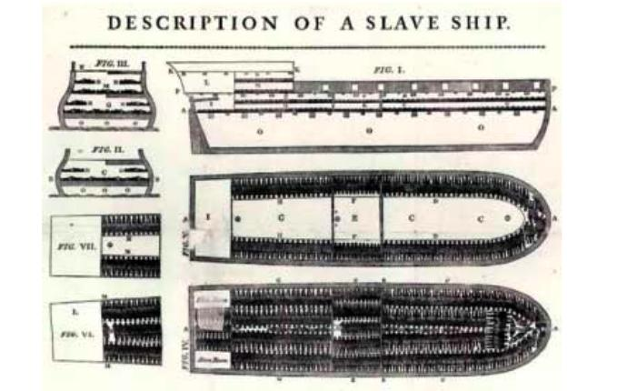

1. What is the main idea of this document? What is the illustrator trying to show you? (Summarize)

_____________________________________________________________________

_____________________________________________________________________

_____________________________________________________________________

_____________________________________________________________________

_____________________________________________________________________

_____________________________________________________________________

_____________________________________________________________________

_____________________________________________________________________

Source B

Thomas Phillips, a slave-ship captain, wrote an account of his activities in A Journal of a Voyage (1746)

I have been informed that some commanders have cut off the legs or arms of the most willful slaves, to terrify the rest, for they believe that, if they lose a member, they cannot return home again: I was advised by some of my officers to do the same, but I could not be persuaded to entertain the least thought of it, much less to put in practice such barbarity and cruelty to poor creatures who, excepting their want of Christianity and true religion (their misfortune more than fault), are as much the works of God's hands, and no doubt as dear to him as ourselves.

1. What is the main idea of this document? What is the author trying to tell you? Summarize your ideas.

_____________________________________________________________________

_____________________________________________________________________

_____________________________________________________________________

_____________________________________________________________________

_____________________________________________________________________

_____________________________________________________________________

_____________________________________________________________________

_____________________________________________________________________

_____________________________________________________________________

_____________________________________________________________________

Source C

Dr. Thomas Trotter, a physician working on the slave-ship, Brookes. When a House of Commons (British Parliament) committee was investigating the slave trade in 1790, they interviewed Trotter. This is how he replied when he was asked if the "slaves had room to turn themselves.”

No. The slaves that are out of irons are locked "spoonways"" and locked to one another. It is the duty of the first mate to see them stowed in this manner every morning; those which do not get quickly into their places are compelled by the cat and, such was the situation when stowed in this manner, and when the ship had much motion at sea, they were often miserably bruised against the deck or against each other. I have seen their breasts heaving and observed them draw their breath, with all those laborious and anxious efforts for life which we observe in expiring animals subjected by experiment to bad air of various kinds.

1. What is the main idea of this document? What is the author trying to tell you? Summarize your ideas.

_____________________________________________________________________

_____________________________________________________________________

_____________________________________________________________________

_____________________________________________________________________

_____________________________________________________________________

_____________________________________________________________________

_____________________________________________________________________

______________________________________________________________________

Source D

Zamba Zembola, was the son of a king of a small community in the Congo, When he was in his early twenties he was invited by a Captain to accompany him to America on his slave ship. After arriving in America, he was kidnapped and sold as a slave). He later wrote and published his autobiography in 1849, The Life and Adventures of Zamba an African Slave.

After being about 15 days out to sea a heavy squall struck the ship. The poor slaves below, altogether unprepared for such an occurrence, were mostly thrown to the side, where they lay heaped on the top of each other; their fetters rendered many of them helpless, and before they could be arranged in their proper places, and relieved from their pressure on each other, it was found that 15 of them were smothered or crushed to death. The captain seemed considerably vexed; but the only grievance to him was the sudden loss of some five or six thousand dollars.

1. What is the main idea of this document? What is the author trying to tell you? Summarize your ideas.

_____________________________________________________________________

_____________________________________________________________________

_____________________________________________________________________

_____________________________________________________________________

_____________________________________________________________________

_____________________________________________________________________

_____________________________________________________________________

_____________________________________________________________________

_____________________________________________________________________

Source E
Olaudah Equiano, was captured and sold as a slave. He later earned his freedom, and wrote his memoir which was published in 1789, The Interesting Narrative of the Life of Olaudah Equiano, or Gustavus Vassa, the African.

I was soon put down under the decks, and there I received such a greeting in my nostrils as I had never experienced in my life; so that, with the loathsomeness of the stench, and crying together, I became so sick and low that I was not able to eat, nor had I the least desire to taste anything. I now wished for the last friend, death, to relieve me; but soon, to my grief, two of the white men offered me eatables; and, on my refusing to eat, one of them held me fast by the hands, and laid me across, I think, the windlass, and tied my feet, while the other flogged me severely…..The closeness of the place, and the heat of the climate, added to the number in the ship, which was so crowded that each had scarcely room to turn himself, almost suffocated us. The air soon became unfit for respiration, from a variety of loathsome smells, and brought on a sickness among the slaves, of which many died. The wretched situation was again aggravated by the chains, now unsupportable, and the filth of the necessary tubs, into which the children often fell, and were almost suffocated. The shrieks of the women, and the groans of the dying, rendered the whole scene of horror almost inconceivable.

1. What is the main idea of this document? What is the author trying to tell you? Summarize your ideas.

_____________________________________________________________________

_____________________________________________________________________

_____________________________________________________________________

_____________________________________________________________________

_____________________________________________________________________

Source F

Ottobah Cugoano, a slave, wrote in his Narrative of the Enslavement of a Native of Africa in 1787,

“…And when we found ourselves at last taken away, death was more preferable than life; and a plan was concerted amongst us, that we might burn and blow up the ship, and to perish all together in the flames: but we were betrayed by one of our own countrywomen, who slept with some of the headmen of the ship, for it was common for the dirty filthy sailors to take the African women and lie upon their bodies; but the men were chained and pent up in holes…”

1. What is the main idea of this document? What is the author trying to tell you? Summarize your ideas.

_____________________________________________________________________

_____________________________________________________________________

_____________________________________________________________________

_____________________________________________________________________

_____________________________________________________________________

_____________________________________________________________________

_____________________________________________________________________

PUTTING IT ALL TOGETHER: WHAT COMMON THEMES EMERGED FROM THESE PRIMARY SOURCES? How were captives treated during their journey, otherwise known as, The Middle Passage?

