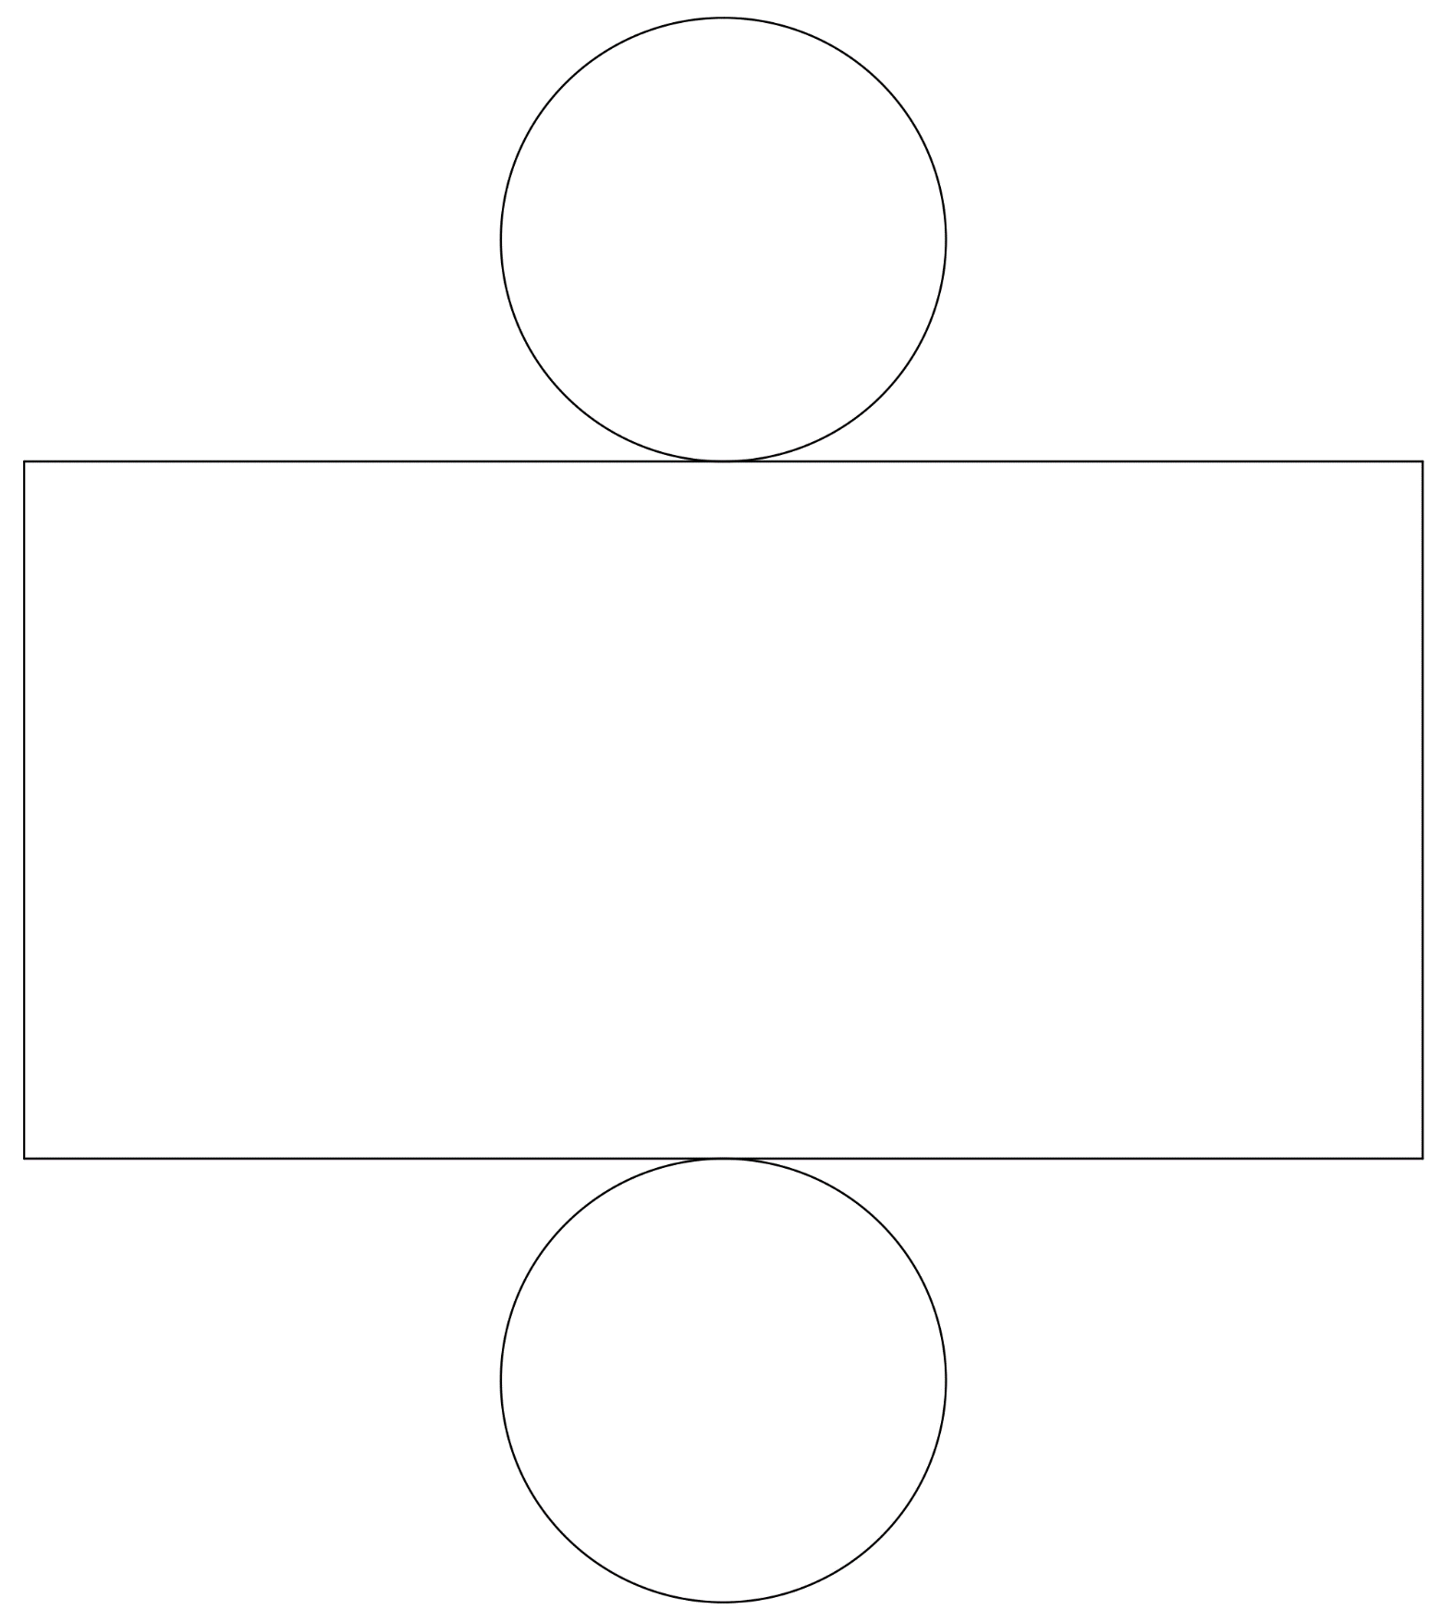
- Measure, as precisely as you can, the diameter of the circles, and the width and height of the rectangle.
- Check to make sure the width of the rectangle equals the circumference of the circle.
- Calculate the surface area and volume of the cylinder, including correct units.
- If you wish, you can cut out and assemble the cylinder to make it easier to visualize.

