Day 160: End of the Cold War Web Form
On your large paper recreated this web form with the following events listed below:
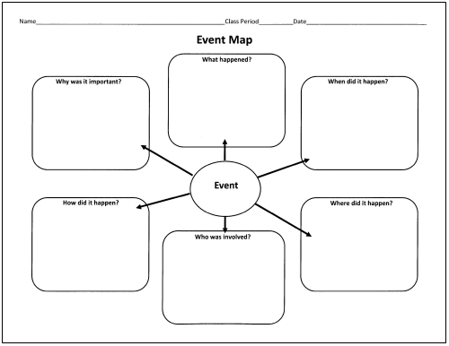
- Solidarity Movement in Poland (Lech Walesa)

- Glasnost and Perestroika (Mikhail Gorbachev)

- The Split of Czechoslovakia (Václav Havel)

- The Berlin Wall Falling (November 9, 1989)

