Chemical formulas and nomenclature – Charts, Tables etc.

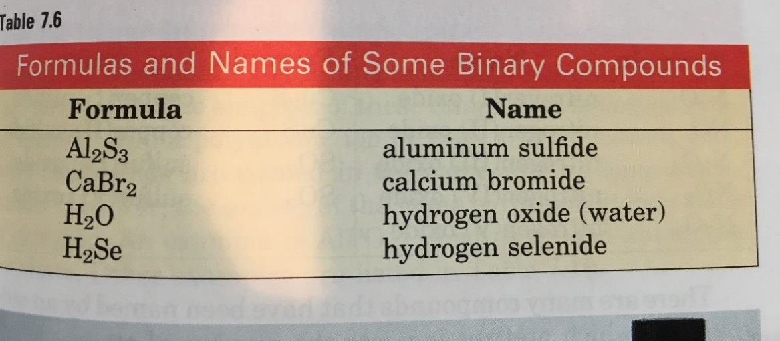Binary Ionic compounds

Potassium Fluoride

Lithium Bromide

KF

LiBr

Binary Molecular Compounds

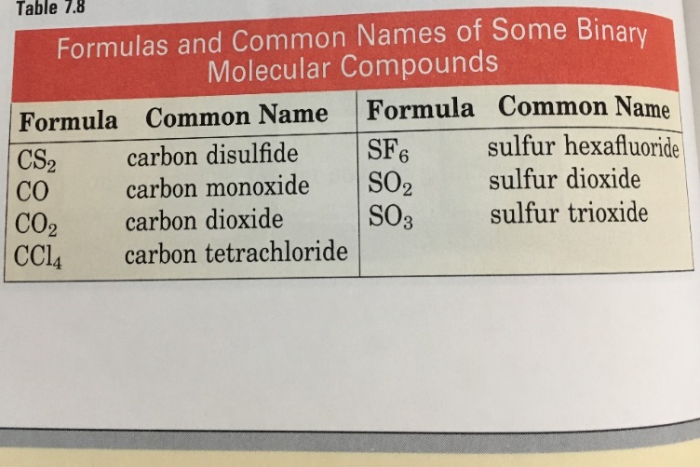

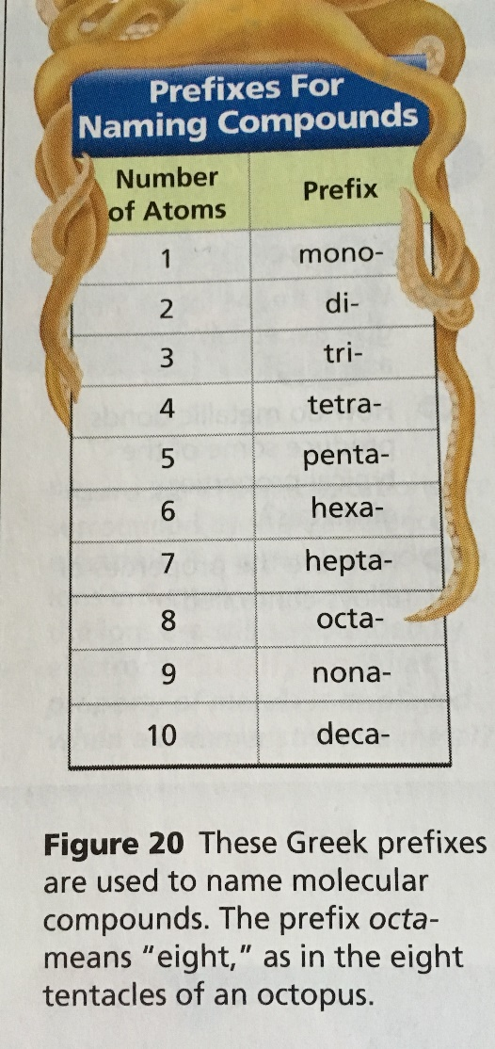

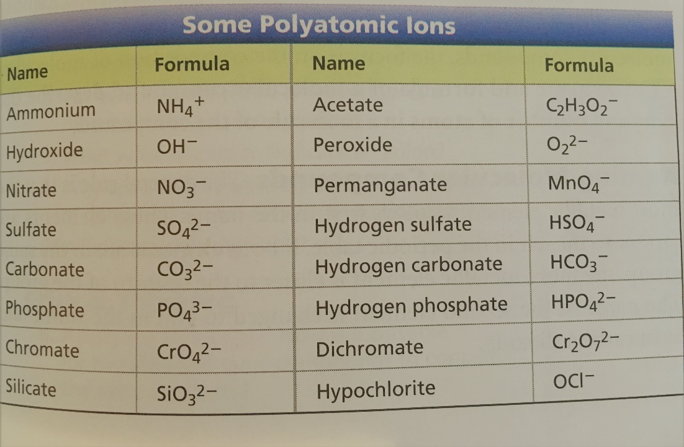Polyatomic Ions

**Ions with “ite” ending have one less oxygen atom than the “ate” ion.**

For example Nitrate is NO3- while nitrite would be NO2-

Use the table to write the chemical formula for these ions:

Phosphite = ________________

Sulfite = ___________________

Carbonite = _________________

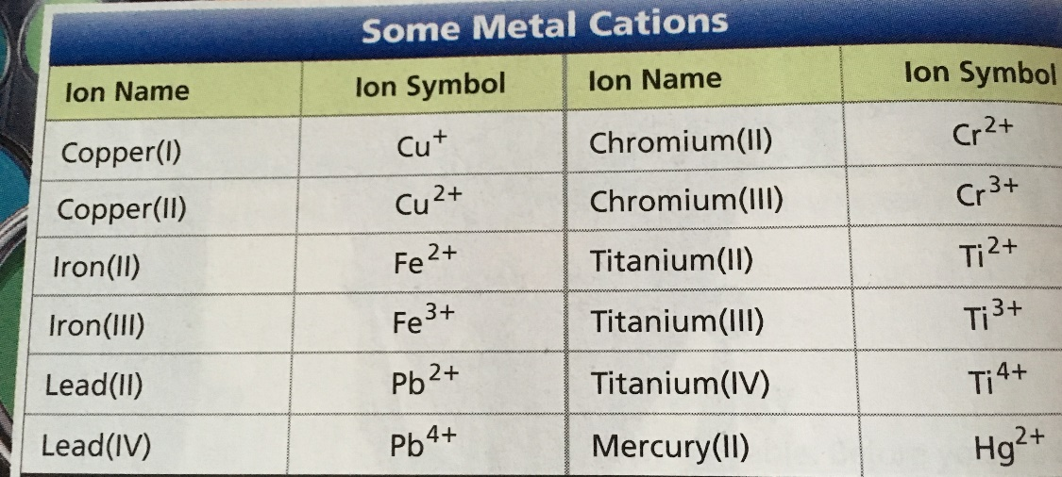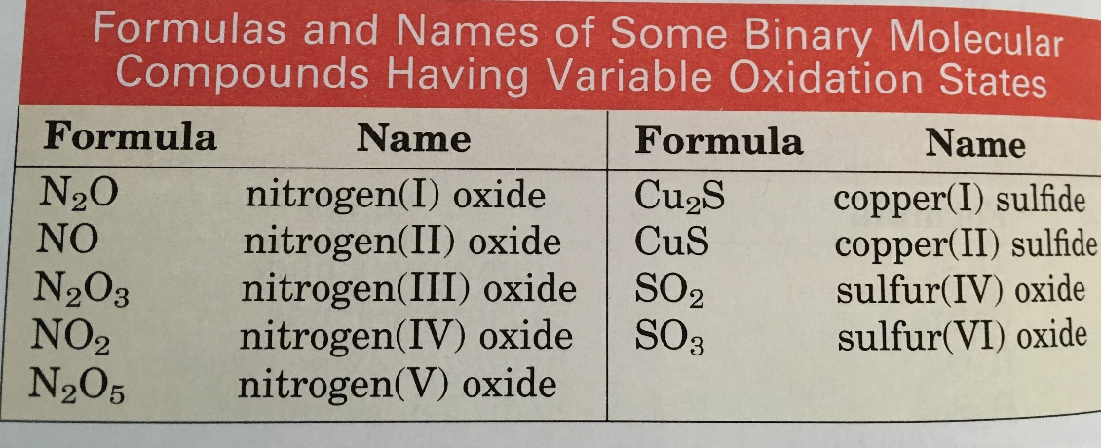

Compounds with varied oxidation states