Class/Subject: Philosophy | Lesson 21: “Moral Relativism and Moral Absolutes”
Objective(s):  SWBAT identify moral and cultural relativism and establish a criterion to what is relative as opposed to unethical. SWBAT as a class will attempt to establish moral absolutes, if that is feasible. | Unit: Ethics
Philosophical Quote of the Day:  "Quod ali cibus est aliis fuat acre venenum" (what is food for one man may be bitter poison to others).- Lucretius | Philosophical Song of the Day:  “Only Shades of Gray” by: The Monkees https://www.youtube.com/watch?v=x2zlnfOUK3s
Key Points of the Day:  Moral Relativism (or Ethical Relativism) is the position that moral or ethical propositions do not reflect objective and/or universal moral truths, but instead make claims relative to social, cultural, historical or personal circumstances. It does not deny outright the truth-value or justification of moral statements. It may be described by the common aphorism: “When in Rome, do as the Romans do”. | Moral Relativists point out that humans are not omniscient, and history is replete with examples of individuals and societies acting in the name of an infallible truth later demonstrated to be more than fallible, so we should be very wary of basing important ethical decisions on a supposed absolute claim. Absolutes also tend to inhibit experimentation and foreclose possible fields of inquiry which might lead to progress in many fields, as well as stifling the human spirit and quest for meaning. In addition, the short term proves itself vastly superior in the ethical decision-making process than the relatively unknown long-term.
Journal Entry:  “What are examples of moral and cultural relativism? Also, are there any absolute standards of right and wrong, if so, how do we identify them? | Supplemental Reading: “Moral Relativism (BIG IDEAS//small books)” by Steven Lukes  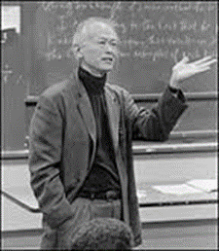  Dr. David Wong is a contemporary American philosopher who is best known for his study of the nature and extent of moral differences and similarities across and within societies and how these differences and similarities bear on questions about the objectivity and universality of morality. As a prolific writer and polymath, Aristotle radically transformed most, if not all, areas of knowledge he touched. I consider him the most important philosopher to Western Civilization.

