Name ___________________________________________ Date ____________ Hour ____

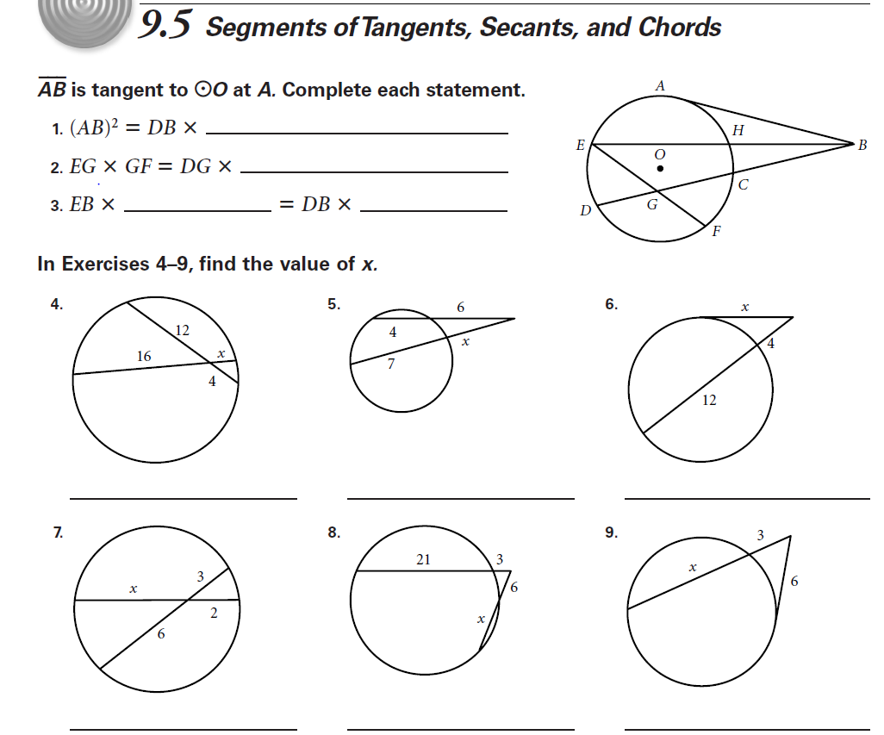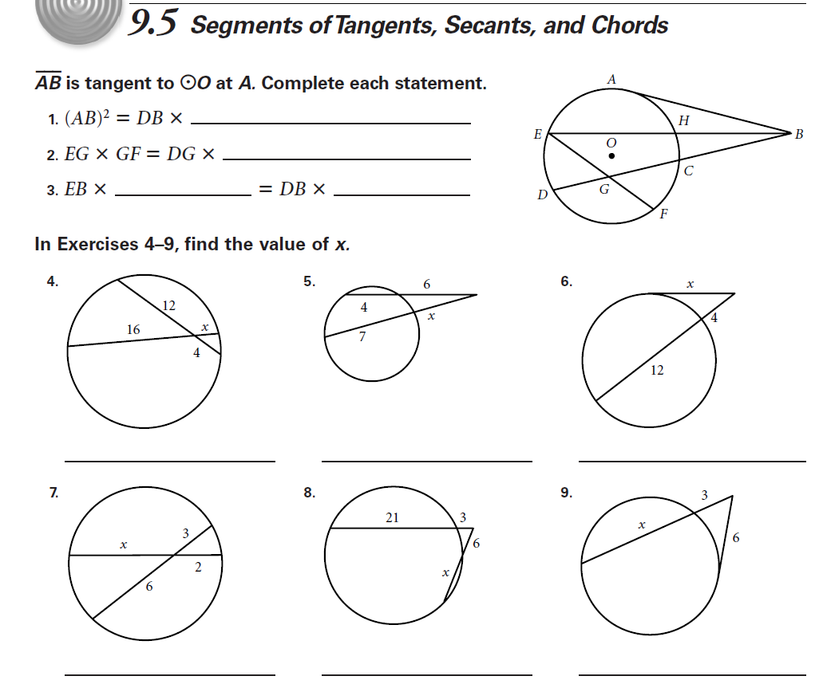Notes: