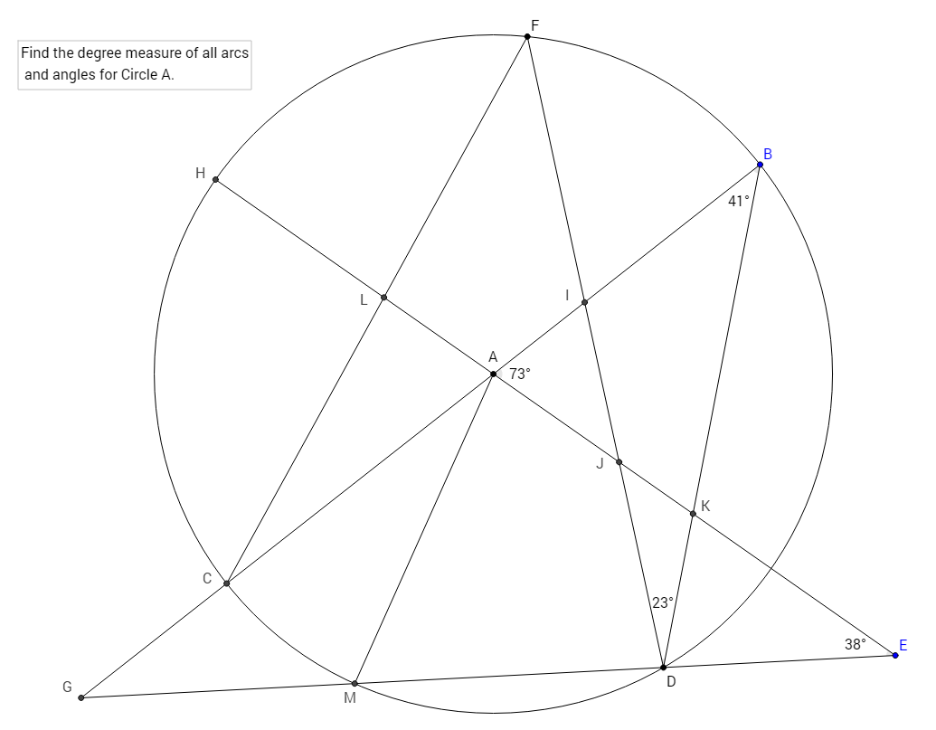

Use vertical angles, linear pairs, triangle sum theorem, central angle = minor arc, inscribed angle = ½(intercepted arc), and connection between large arc, small arc, and secant angle.