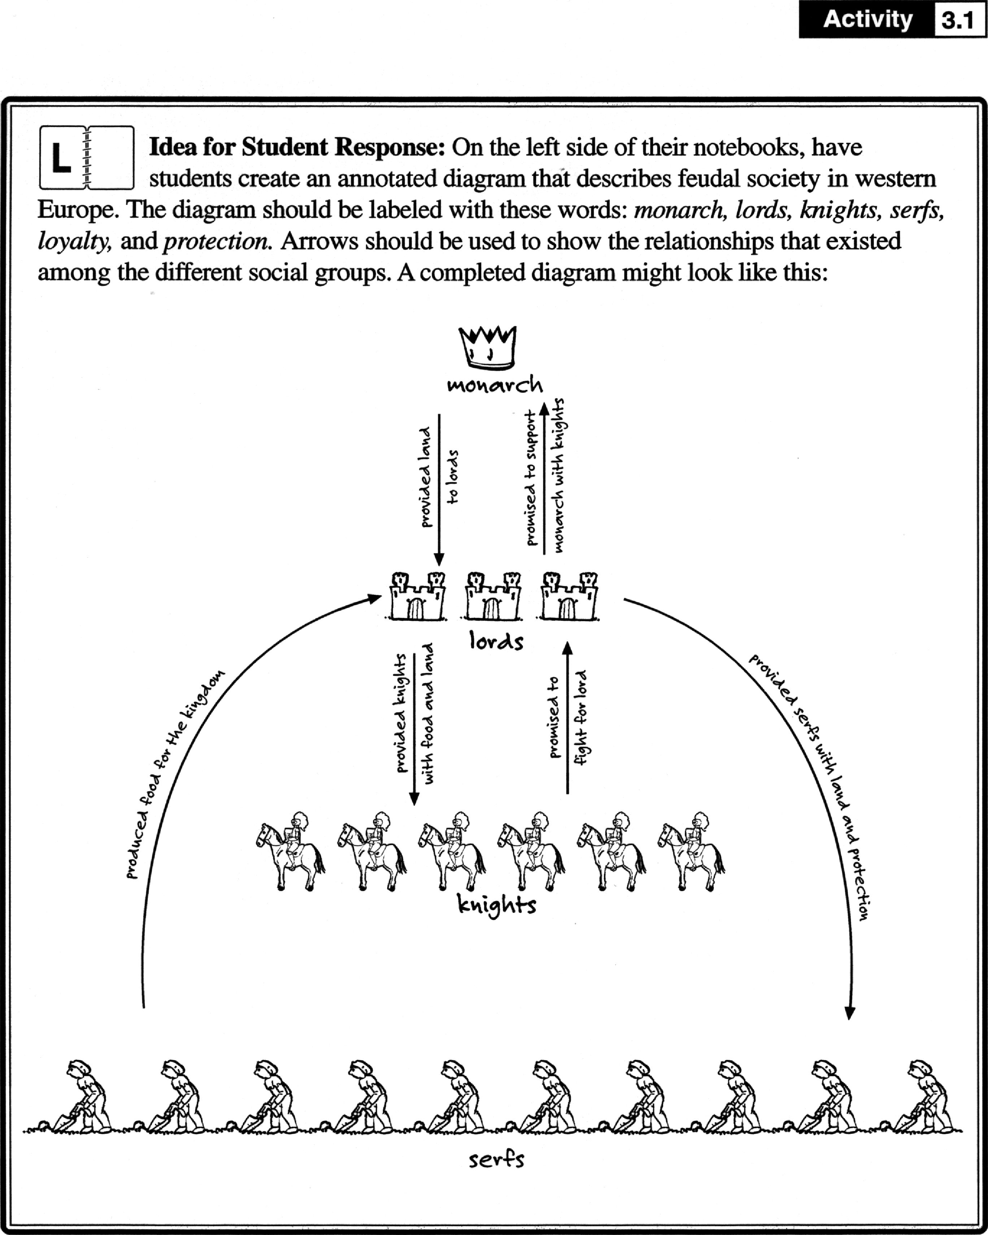

**DAY**

**42**

**Monarch**

•

**WH-7-1, Activity 3.1, Page 6**