Class/Subject: Philosophy | Lesson 27- “Medical Ethics”
Objective(s):  SWBAT to identify what a medical ethical issue is and then devise their own philosophical opinions to what constitutes ethics in this field. | Unit- “ETHICS”
Philosophical Quote of the Day:  Whenever a doctor cannot do good, he must be kept from doing harm.- Hippocrates | Philosophical Video of the Day:  “One”- Metallica https://www.youtube.com/watch?v=WM8bTdBs-cw
Key Points of the Day:  - The medical field is one of the major employers in the United States. Those who enter the field are sworn to a code of ethics. However, there are issues that are ambiguous in terms of ethics. | - Be able to formulate an ethical assessment of the issues listed on the worksheet in class and justify your philosophical assertions.  - What was the gist of Nurse Ostheimer’s talk? How do ethics apply to her occupational decisions?
Journal Entry:  “Based upon your discussions in small and large groups assert your ethical positions on the issues presented.” Also, provide a synopsis of Nurse Ostheimer’s talk”. | Featured philosopher and supplemental reading:  “Classic Works in Medical Ethics: Core Philosophical Readings” by Gregory Pence  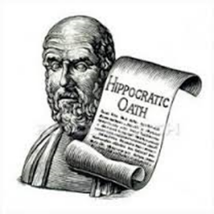  Hippocrates of Kos, was a Greek physician of the Age of Pericles, and is considered one of the most outstanding figures in the history of medicine.

