Name:____________________________________ Date:_______ Hour:_______

**Physics Notes: Chapter 16 ELECTRIC CHARGE AND STATIC ELECTRICITY** 2/24/15

**16.1 Electric Charge**

Electrical energy is associated with electric charges. An electric charge is a property that causes subatomic particles such as _______________ and _________________ to attract or repel each other. Two types of electric charges called positive and negative. Protons have a ___________________ charge and _______________________ have a negative charge.

In an __________, the positively charged ________________ is surrounded by a cloud of negatively charged ______________________. The number of __________________ equals the number of electrons which results in a __________________ atom.

If an atom has unequal numbers of protons and electrons, it will have a net _____________. Since protons are trapped in the nucleus and do not move, an atom must _________ or _________ electrons in order to become charged. If it gains electrons, it becomes ______________________ charged. If an atom loses electrons, it becomes ____________________ charged.

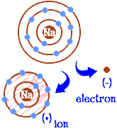

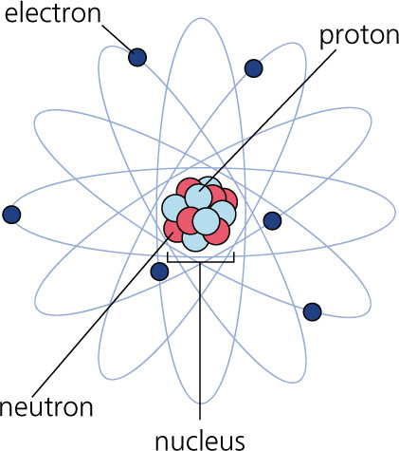

**Measurement of Charge**

In 1909, Robert Millikan did an experiment in which he carefully measured tiny charges on oil droplets suspended in midair. He discovered that there was a minimum charge, or a *fundamental charge*, and that the charges on the droplets were all multiples of this minimum charge. This charge is called “e” and is the amount of charge of an electron or a proton.

The SI unit of electric charge is the __________________ (C),. An electron or proton carries a very small charge, 1.602 x 10-19 C. It would take _________________________ electrons or protons to add up to a single Coulomb of charge.

**Static Electricity and Charging**

Static electricity is the study of the distribution of electric charges, including how charge is _________________________ between objects. Static means “not moving”; electric charge moving through wires is called “current electricity”. Net charges can be built up by friction, by __________________, and by induction. Even though there is a charge transfer, the _______________ charge is the __________ before and after the transfer. This is known as the _____________________________ _____ ______________________.

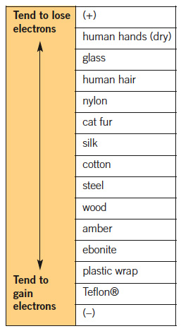**Charging by Friction**

An example of charging by friction would be rubbing a balloon on your head. How is a net charge produced? The latex balloon _______________ electrons __________ than your hair does, so the balloon picks up electrons and becomes _____________________charged. Because your hair ____________ electrons, it becomes ______________ charged. Opposite charges _______________ , so your hair and the balloon are attracted to each other.

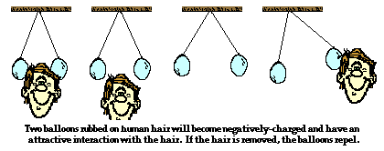

Two balloons rubbed on hair will become negatively charged and will be attracted to the hair, which is positive.

If the balloons are hung next to each other, they repel because they both have a negative charge.

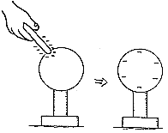**Charging by Contact**

___________________ something that has a charge can transfer the charge to you or from you to it. For example, if you touch a negatively charged rod to a metal ball, then then charge will distribute so the ball receives some of the negative charge (extra electrons). The rod will still be negative, but less so.

**Charging by Induction**

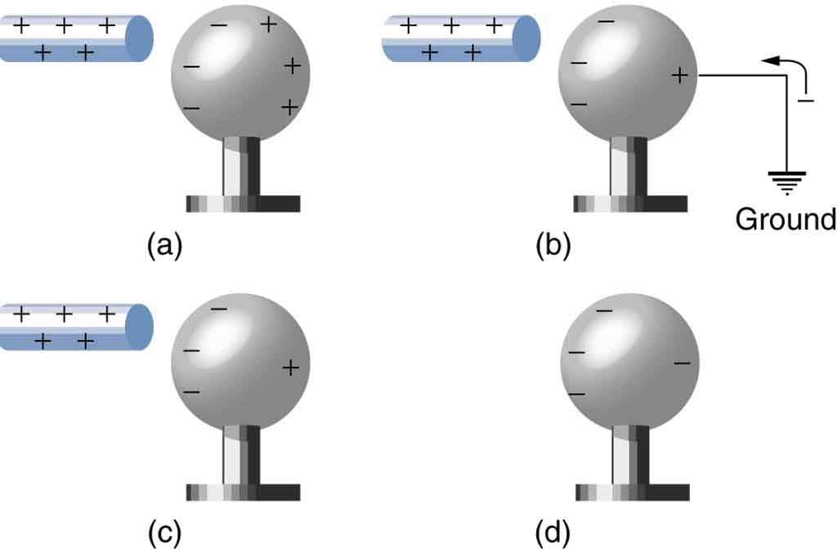 As you walk across a carpet, you pick up extra _____________________, and have a negative charge. If you were to reach for a metal doorknob, electrons from your hand would repel electrons in the doorknob, leaving a __________________ charge on the part of the doorknob closest to your hand touched it. This transfer of charge without contact between materials is called _______________________.

In the diagram (a) to the right, the positively charged rod induces a separation of charge, by pulling ___________ to the near side. In (b), connecting the sphere to the ground allows electrons to come up to balance the positive charge on the right. The electrons are then trapped when the sphere is disconnected from ground.

Notice that through induction, the *positive* rod is able to give the sphere a *negative* charge, without ever touching the sphere!

**Polarization through induction.**

When a charged object is brought near a neutral object, it can induce a separation of charge. The balloon in the diagram is negatively charged, and will cause _______________________ in the wall to slightly to the ________________.

* -

- - -

- - -

-

The protons will stay put because they are ____________________ in the _________________________. This results in the wall being slightly polarized, which means one side is more positive and one side is more negative.

DRAW THE CHARGES IN THE WALL.

**16.2 Electric Forces**

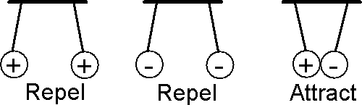 Opposite charges _____________ each other. Like charges repel each other. Neutral charges are not attracted or repelled to either type of charge.

Neutral objects, though, can be polarized, with more negative charge on one side, and positive on another, so they can still be attracted to charged objects.

Electric forces can attract or repel. The electric force between two objects depends on the amount of electric ____________________, as well as the __________________between objects. As the objects get further from each other, the force decreases. If you double the distance, the force decreases to one fourth of what it was. If you triple the distance, the force decreases to one ninth of what it was. (22 = 4, and 32=9) This is similar to the gravitational force between objects. For example, a space shuttle is ________ affected by the Earth’s gravitational pull in outer space compared to the surface.

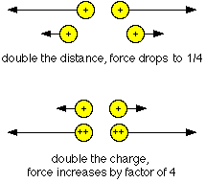

Double the distance, force drops to 25%

Double each charge, force gets 4 times as strong

Gravitational forces seem strong, but electric forces inside an atom are much stronger. If you charge a couple of pennies with a thousandth of a Coulomb, and put one 1 meter above the other, the electrical force between them would be hundreds of times greater than the weight of the pennies, and would shoot the top penny up into the air.

**Coulomb’s Law**

The force between two charges depends on the strength of the charges and r, the distance between their centers. k = 8.99 x 109 N∙m2/C2

*The force is attractive if the sign is negative (opposite charges)*

*and repulsive if the sign is positive (like charges).*

1) Calculate the electrical force between two objects which are 2.94m apart, and have

charges of +1.40 x 10-4C, and +3.50 x 10-4 Coulombs. Is the force attractive or repulsive?

2a) Calculate the force between two objects which are 36.2 cm apart, and have

charges of +1.40 x 10-3C, and -2.50 x 10-2 Coulombs. (Pay attention to the units!)

b) If 1N equals 0.225 pounds, how many pounds of force would be pulling these objects together?

**Static Discharge**

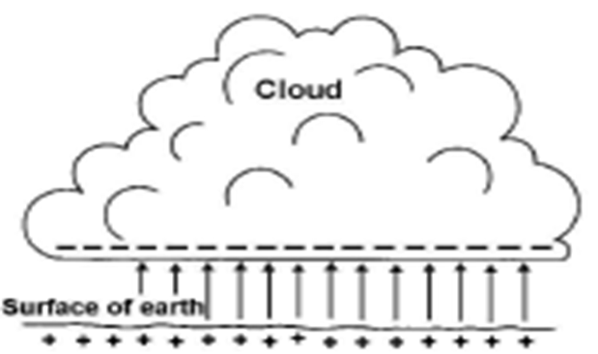 Have you ever gotten a ______________ from a doorknob or other object? That spark that you feel is a static discharge. Static discharge occurs when a ______________________ for charges to travel suddenly forms. The ________ between you and the doorknob is the pathway. This shock can happen when you are _____________ to another object and occurs less from farther away.

__________________________ is a more dramatic form of static discharge. How does this occur? Charge can build up in a storm cloud from _________________ between moving air masses. ______________________ charge in the ______________ part of the cloud induces a _________________ charge in the _______________ below the cloud. As the amount of charge in the cloud ________________, the force of attraction between charges in the cloud and charges in the ground ______________________. (Remember, stronger electric forces increase attraction or repulsion between charges.) Eventually the ________becomes charged, forming a ______________________ for electrons to travel from the cloud to the ground.

**16.3 Electric Fields**

The ________________ that an electric charge has on other charges in the _____________ around it is the charge’s ______________________________. The ___________________ of an electric field depends on the _________________ of charge that produces the field and the __________________ from the charge. In other words, small charge produces a ______________ electric field. Electric fields can be represented with lines as shown below. Notice that the electric field of a positive charge points ___________________ and the electric field of a negative charge points __________________.

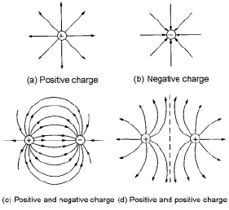[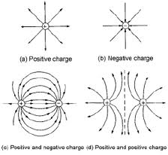](http://www.google.com/imgres?imgurl=http://www.mea.or.th/internet/understanding_emf_web/emf_eng/imagebook_eng/05_charge%20and%20electric%20field%20line_s.png&imgrefurl=http://www.mea.or.th/internet/understanding_emf_web/emf_eng/webpage_eng/page01_eng.htm&usg=__wqeRcrh3YtL10obKc96w9fS1VNo=&h=258&w=281&sz=30&hl=en&start=0&zoom=1&tbnid=juFTKc_aD3UcZM:&tbnh=126&tbnw=137&prev=/images?q=electric+field&hl=en&biw=1362&bih=534&gbv=2&tbs=isch:1&itbs=1&iact=hc&vpx=960&vpy=199&dur=2512&hovh=206&hovw=224&tx=133&ty=116&ei=E1fTTMbYFMK88gbLv83TDg&oei=E1fTTMbYFMK88gbLv83TDg&esq=1&page=1&ndsp=21&ved=1t:429,r:12)

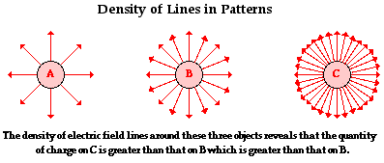

The density of electric field lines around these three objects reveals that the quantity of charge on C is greater than that on B which is greater than that on A. Also, as distance from the charge increases, the density of the lines decreases, representing a weaker field. The electric field is *inversely proportional to the square of the distance.*

The strength of a gravitational field indicates how much a certain mass will weigh. Earth’s gravitational field is 9.81 Newtons per kilogram at the surface, and gets weaker as you get farther from the earth’s center.

Electric fields are measured in Newtons per Coulomb, and give the force on each unit charge.

F=qE

1. Calculate the electric field at a distance of 1.34 m from a point charge of +1.87 mC

2. What would be the size and direction of the force on a test charge of 7.81 nC at that point?

**Questions**

1. When does an object have a net charge?_____________________________________________________

________________________________________________________________________________.

2. If an atom gains 2 electrons, what is its net charge?_________________ If an atom loses 3 electrons, what is its net charge?__________________

3. What is an electric field?________________________________________________________

_______________________________________________________________________________

_______________________________________________________________________________

4. What two factors can affect the strength of an electric field?

a)

b)

5. In what three ways can charge be transferred?

a)

b)

c)

6. Is it likely that static discharge would occur if you were 10 feet from a doorknob?_____

What must be formed in order for static discharge to occur?_________________________

7. What is the relationship between the strength of electric force and the amount of charge?

What is the relationship between electric force and the distance between charges?

8. When a balloon is rubbed on dry hair, what net charge does it gain?______________ What net charge does the dry hair gain?___________________

Name:___KEY__________________ Date:_______ Hour:_______

**Physics Notes: Chapter 16 ELECTRIC CHARGE AND STATIC ELECTRICITY** 2/24/15

**16.1 Electric Charge**

Electrical energy is associated with electric charges. An electric charge is a property that causes subatomic particles such as __protons__ and __electrons___ to attract or repel each other. Two types of electric charges called positive and negative. Protons have a __positive__ charge and _______electrons__________ have a negative charge.

In an __atom____, the positively charged __nucleus_____ is surrounded by a cloud of negatively charged _____electrons_____. The number of _____protons__ equals the number of electrons which results in a ___neutral__ atom.

If an atom has unequal numbers of protons and electrons, it will have a net __charge___. Since protons are trapped in the nucleus and do not move, an atom must _gain___ or _lose__ electrons in order to become charged. If it gains electrons, it becomes ______negatively_________ charged. If an atom loses electrons, it becomes ______positively______ charged.





**Measurement of Charge**

In 1909, Robert Millikan did an experiment in which he carefully measured tiny charges on oil droplets suspended in midair. He discovered that there was a minimum charge, or a *fundamental charge*, and that the charges on the droplets were all multiples of this minimum charge. This charge is called “e” and is the amount of charge of an electron or a proton.

The SI unit of electric charge is the __Coulomb____ (C). An electron or proton carries a very small charge, 1.602 x 10-19 C. It would take ____6.24 x 1018___________________ electrons or protons to add up to a single Coulomb of charge.

**Static Electricity and Charging**

Static electricity is the study of the distribution of electric charges, including how charge is ________transferred__________ between objects. Static means “not moving”; electric charge moving through wires is called “current electricity”. Net charges can be built up by friction, by __contact______, and by induction. Even though there is a charge transfer, the ______total_______ charge is the ____same___ before and after the transfer. This is known as the __conservation of charge__________ ______________________.

**Charging by Friction**

An example of charging by friction would be rubbing a balloon on your head. How is a net charge produced? The latex balloon __attracts___ electrons __more___ than your hair does, so the balloon picks up electrons and becomes ________negatively____charged. Because your hair __loses___ electrons, it becomes ___positively___ charged. Opposite charges __attract_______ , so your hair and the balloon are attracted to each other.



Two balloons rubbed on hair will become negatively charged and will be attracted to the hair, which is positive.

If the balloons are hung next to each other, they repel because they both have a negative charge.

**Charging by Contact**

___Touching______ something that has a charge can transfer the charge to you or from you to it. For example, if you touch a negatively charged rod to a metal ball, then then charge will distribute so the ball receives some of the negative charge (extra electrons). The rod will still be negative, but less so.

**Charging by Induction**

 As you walk across a carpet, you pick up extra ____electrons_____, and have a negative charge. If you were to reach for a metal doorknob, electrons from your hand would repel electrons in the doorknob, leaving a _____positive____ charge on the part of the doorknob closest to your hand touched it. This transfer of charge without contact between materials is called ___charging by induction__________.

In the diagram (a) to the right, the positively charged rod induces a separation of charge, by pulling _electrons____ to the near side. In (b), connecting the sphere to the ground allows electrons to come up to balance the positive charge on the right. The electrons are then trapped when the sphere is disconnected from ground.

Notice that through induction, the *positive* rod is able to give the sphere a *negative* charge, without ever touching the sphere!

**Polarization through induction.**

When a charged object is brought near a neutral object, it can induce a separation of charge. The balloon in the diagram is negatively charged, and will cause _______electrons_____ in the wall to slightly to the _____right_____.

+ - +-

+ - -

+ - +-

-+ - +

+ + -

- + -+

* -

- - -

- - -

-

The protons will stay put because they are _____trapped_______ in the _________nucleus__________. This results in the wall being slightly polarized, which means one side is more positive and one side is more negative.

DRAW THE CHARGES IN THE WALL.

More positive close to the balloon, more negative away from balloon.

Total number of positives and negatives are EQUAL!

**16.2 Electric Forces**

 Opposite charges __attract__ each other. Like charges repel each other. Neutral charges are not attracted or repelled to either type of charge.

Neutral objects, though, can be polarized, with more negative charge on one side, and positive on another, so they can still be attracted to charged objects.

Electric forces can attract or repel. The electric force between two objects depends on the amount of electric ___charge_________, as well as the ___distance___ between objects. As the objects get further from each other, the force decreases. If you double the distance, the force decreases to one fourth of what it was. If you triple the distance, the force decreases to one ninth of what it was. (22 = 4, and 32=9) This is similar to the gravitational force between objects. For example, a space shuttle is __less_ affected by the Earth’s gravitational pull in outer space compared to the surface.



Double the distance, force drops to 25%

Double each charge, force gets 4 times as strong

Gravitational forces seem strong, but electric forces inside an atom are much stronger. If you charge a couple of pennies with a thousandth of a Coulomb, and put one 1 meter above the other, the electrical force between them would be hundreds of times greater than the weight of the pennies, and would shoot the top penny up into the air.

**Coulomb’s Law**

The force between two charges depends on the strength of the charges and r, the distance between their centers. k = 8.99 x 109 N∙m2/C2

*The force is attractive if the sign of the force is negative (opposite charges)*

*and repulsive if the sign is positive (like charges).*

1) Calculate the electrical force between two objects which are 2.94m apart, and have

charges of +1.40 x 10-4C, and +3.50 x 10-4 Coulombs. Is the force attractive or repulsive?

Force = 51.0 Newtons, repulsive (like charges)

2a) Calculate the force between two objects which are 36.2 cm apart, and have

charges of +1.40 x 10-3C, and -2.50 x 10-2 Coulombs. (Pay attention to the units!)

F = -2.40 x 106 N (attractive)

b) If 1N equals 0.225 pounds, how many pounds of force would be pulling these objects together?

F = 540,000 pounds!

**Static Discharge**

 Have you ever gotten a __shock_____ from a doorknob or other object? That spark that you feel is a static discharge. Static discharge occurs when a __pathway________ for charges to travel suddenly forms. The _spark_ between you and the doorknob is the pathway. This spark can happen when you are ___close____ to another object and but is less likely when you are farther away.

___Lightning_____ is a more dramatic form of static discharge. How does this occur? Charge can build up in a storm cloud from ___friction___ between moving air masses. _______Negative___ charge in the ____lower___ part of the cloud induces a ___positive______ charge in the __ground______ below the cloud. As the amount of charge in the cloud ___increase__, the force of attraction between charges in the cloud and charges in the ground ___increase______. (Remember, stronger electric forces increase attraction or repulsion between charges.) Eventually the __air___ becomes ionized, forming a ____pathway___ for electrons to travel from the cloud to the ground.

**16.3 Electric Fields**

The strength of a gravitational field indicates how much a certain mass will weigh. Earth’s gravitational field is 9.81 Newtons per kilogram at the surface, and gets weaker as you get farther from the earth’s center. A bigger mass is affected more by the gravitational field, and has a bigger force (weight).

The __effect__ that an electric charge has on other charges in the __space_____ around it is the charge’s __electric field_____. The _____strength____ of an electric field depends on the ____amount____ of charge that produces the field and the ____distance_____ from the charge. In other words, small charge produces a __small_____ electric field. Electric fields can be represented with lines as shown below. Notice that the electric field of a positive charge points ____outward_______ and the electric field of a negative charge points ____inward_______. The lines show the force on a proton!

[](http://www.google.com/imgres?imgurl=http://www.mea.or.th/internet/understanding_emf_web/emf_eng/imagebook_eng/05_charge%20and%20electric%20field%20line_s.png&imgrefurl=http://www.mea.or.th/internet/understanding_emf_web/emf_eng/webpage_eng/page01_eng.htm&usg=__wqeRcrh3YtL10obKc96w9fS1VNo=&h=258&w=281&sz=30&hl=en&start=0&zoom=1&tbnid=juFTKc_aD3UcZM:&tbnh=126&tbnw=137&prev=/images?q=electric+field&hl=en&biw=1362&bih=534&gbv=2&tbs=isch:1&itbs=1&iact=hc&vpx=960&vpy=199&dur=2512&hovh=206&hovw=224&tx=133&ty=116&ei=E1fTTMbYFMK88gbLv83TDg&oei=E1fTTMbYFMK88gbLv83TDg&esq=1&page=1&ndsp=21&ved=1t:429,r:12)



The density of electric field lines around these three objects reveals that the quantity of charge on C is greater than that on B which is greater than that on A. Also, as distance from the charge increases, the density of the lines decreases, representing a weaker field. The electric field is *inversely proportional to the square of the distance.*

The strength of a gravitational field indicates how much a certain mass will weigh. Earth’s gravitational field is 9.81 Newtons per kilogram at the surface, and gets weaker as you get farther from the earth’s center. A bigger mass is affected more by the gravitational field, and has a bigger force (weight),

Electric fields are measured in Newtons per Coulomb, and give the force on each unit charge.

F=qE

1. Calculate the electric field at a distance of 1.34 m from a point charge of +1.87 mC

2. What would be the size and direction of the force on a test charge of 7.81 nC at that point?

**Questions**

1. When does an object have a net charge?_____________________________________________________

________________________________________________________________________________.

2. If an atom gains 2 electrons, what is its net charge?_________________ If an atom loses 3 electrons, what is its net charge?__________________

3. What is an electric field?________________________________________________________

_______________________________________________________________________________

_______________________________________________________________________________

4. What two factors can affect the strength of an electric field?

a)

b)

5. In what three ways can charge be transferred?

a)

b)

c)

6. Is it likely that static discharge would occur if you were 10 feet from a doorknob?_____

What must be formed in order for static discharge to occur?_________________________

7. What is the relationship between the strength of electric force and the amount of charge?

What is the relationship between electric force and the distance between charges?

8. When a balloon is rubbed on dry hair, what net charge does it gain?______________ What net charge does the dry hair gain?___________________