**Physics B Review Sheet – Optics Name _______________________ Hour__ Date _________**

1) Match two of these terms with each of the diagrams below:

Converging Mirror      Convex Mirror Converging Lens Diverging Mirror  
Diverging Lens   Concave Lens       Convex Lens Concave Mirror

_____________________ _____________________ _____________________ _____________________

_____________________ _____________________ _____________________ _____________________

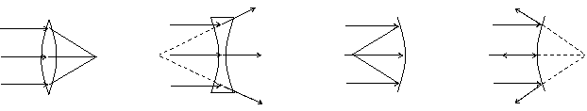

2) Define focal point for a convex lens.

3) Describe how tell whether an image is real or virtual.

4) Describe why plane mirrors can’t form a real image.

5) Label the two different types of telescopes, and name the indicated parts.

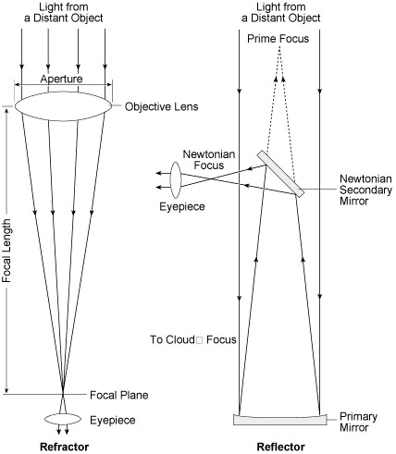

________________________ telescope

________________________ telescope

6) What are two benefits of reflecting telescopes compared to refracting telescopes?

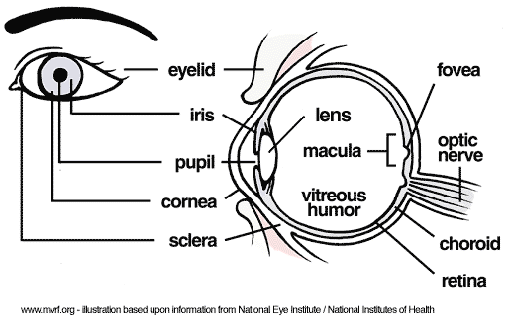7) Name the parts of the human eye which perform the following functions:

|  |  |
| --- | --- |
| Function | Part of Eye |
| Control amount of light entering |  |
| Focus the light |  |
| Detect light |  |
| Hold all the pieces together |  |
| Explain: How do you change from focusing on a near object to focusing on a distant object? |  |

8) Describe the problem with the eye to the right. Describe what type of vision correction would help, and how.

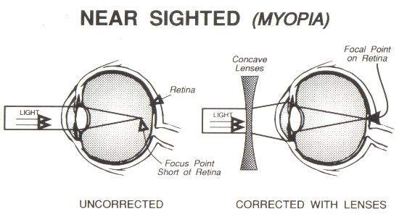

9) Explain this diagram. Refer to the letters and try to use precise optics terms.

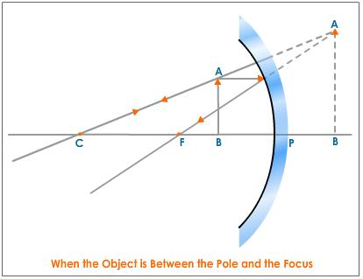

A’

B’

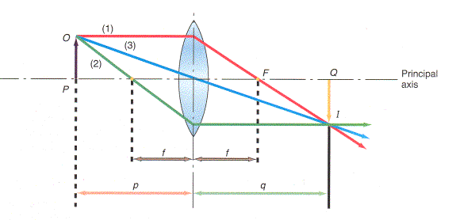10) Explain this diagram as precisely as you can. Describe the image using specific terminology.

11)

a) Use Snell’s Law to calculate the index of refraction of a piece of plastic if a laser beam which is 54.0 degrees from the normal travels from air into the plastic, and ends up 38.6 degrees from the normal inside the plastic.

b) Sketch a diagram and calculate the angle of incidence for a ray of light which travels from water (n=1.33) into a diamond, and ends up traveling at an angle of 62 degrees from the surface of the diamond (n=2.52).

12) On a separate page, calculate the missing values for each of the following lenses:

a) Image Distance = 43.1 cm Object distance = 82.5 cm f=?

b) f=21.0 cm Object distance = 31.5 cm Image distance = ? Magnification = ?

c) f=11.8 cm Object distance = 7.20 cm Image distance =? Magnification = ?

Explain the odd results from c by sketching a diagram.

13) Calculate the critical angle for a laser beam which traveling through a glass fiber in a water tank. The index of refraction of the glass is 1.71, and the index of refraction of water is 1.33. Remember that the critical angle (of incidence) is the angle which would result in a ray being refracted at 90° from the normal, which is along the boundary between the media.

Sketch a diagram of the situation and rays described.