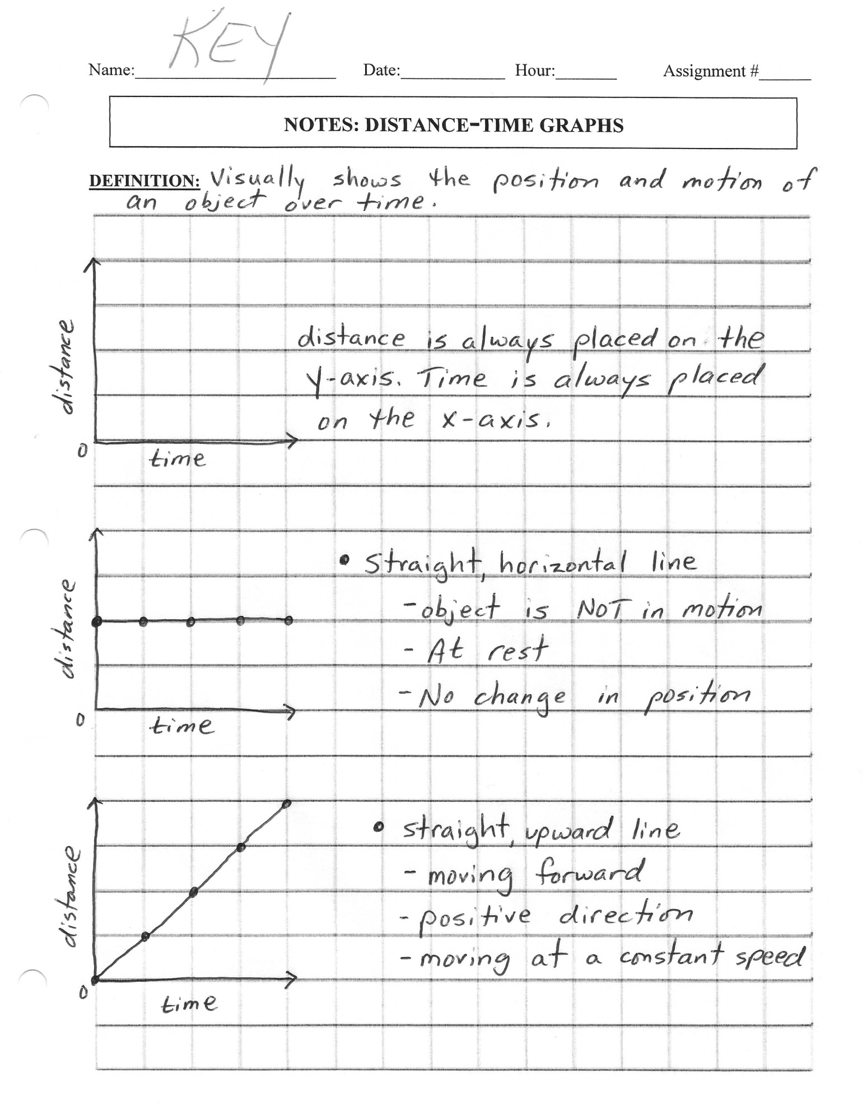

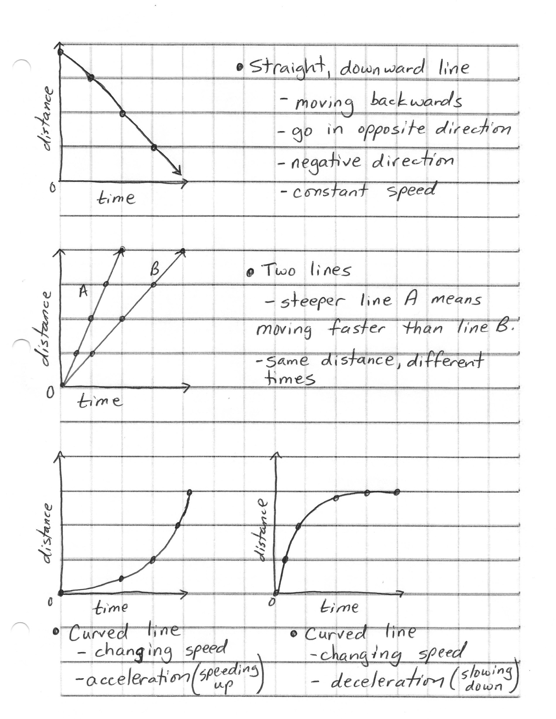

Name:_______________________ Date:____________ Hour:_______ Assignment #______

**NOTES: DISTANCE-TIME GRAPHS**

**DEFINITION:**





Name:__________________________ Date:_________ Hour:_______ Assignment #______

**Understanding Distance-Time Graphs**

Answer the questions based on distance-time graphs.

1. An airplane is descending to land at the airport. During its descent it had to fly in circles until the

landing was cleared of other planes. **Explain what is occurring during each of the segments using the plane’s descriptions of motion.**

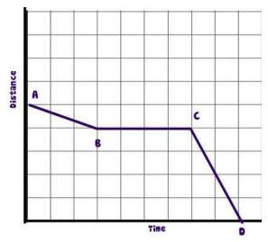

AB

BC

CD

2. John left his home and walked 3 blocks to his school, as shown in the accompanying graph.

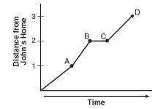

What is one possible interpretation of the section of the graph from

point B to point C?

(1) John arrived at school and stayed throughout the day.

(2) John waited before crossing a busy street.

(3) John returned home to get his mathematics homework.

(4) John reached the top of a hill and began walking on level ground.

3. Jen left her house and drove to school in the morning, as shown in the accompanying graph. On her drive

to school she realized that she forgot her bookbag and had to return home before driving back to school

for a 3 hour class. Explain what is happening during each part of the graph below

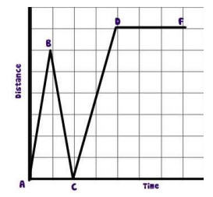

AB

BC

CD

DE

4. The accompanying graph shows Marie’s distance from home (A) to work (F) at various times during

her drive.

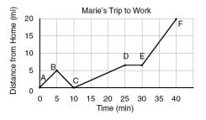

a) Marie left her briefcase at home and had to return

to get it. State which point represents when she

turned back around to go home. __________

Explain how you know.

b) Marie also had to wait at the railroad tracks for a

train to pass. How long did she wait? ____________

Explain how you arrived at that conclusion.

5. A bug travels up a tree, from the ground, over a 30-second interval. It travels fast at first and then slows

down. It stops for 10 seconds, then proceeds slowly, speeding up as it goes.

Which sketch best illustrates the bug’s distance (d) from the ground over the 30-second interval (t)? ________

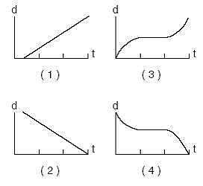

**The graph to the right shows how three**



**runners ran a 100-meter race.**

6. Which runner won the race?

Explain how you know.

7. Which runner stopped for a rest?

Explain how you know.

How long was the stop? ___________

8. How far had Bob traveled after 10 secs? ___________

9) Which of the graphs shows that one of runners started 10 yards further ahead of the other? _______

**Explain how you know.**

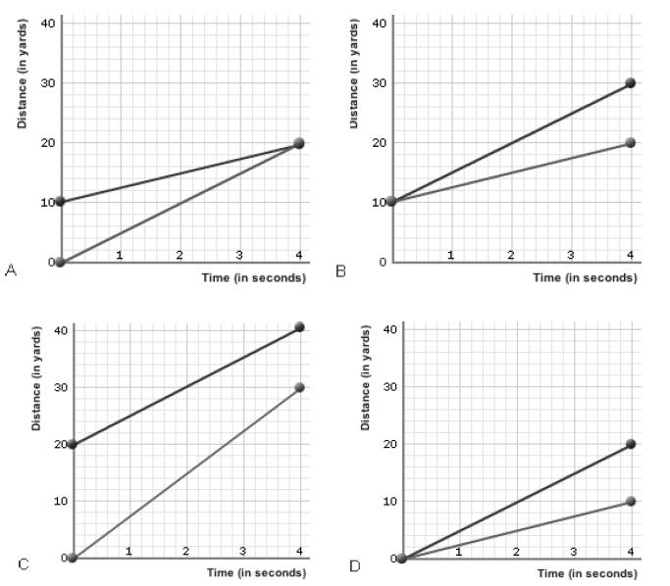

**In**

10) In which of the following graphs below are both runners moving at the same speed?___________

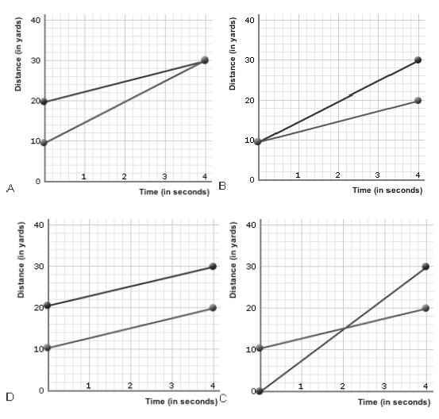

**Explain how you know.**

11) The distance-time graphs below represent the motion of a car. Tell which graph belongs with each description.

**Explain how you know!**

**Descriptions:**

a. The car is stopped.

b. The car is traveling at a constant speed forward.

c. The speed of the car is decreasing.

d. The car is coming back.

