# **Waves and Sound Practice Worksheet Name \_\_\_\_\_\_\_\_\_\_\_\_\_\_\_\_\_\_\_\_\_\_\_\_\_\_ Date \_\_\_\_\_\_\_\_\_**

**Physics B**

1) Precisely measure the amplitude and wavelength of the wave below. Label them with arrows.

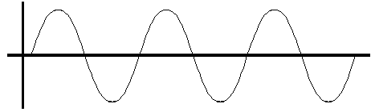Wavelength = \_\_\_\_\_\_\_\_\_

Amplitude = \_\_\_\_\_\_\_\_\_

# of wavelengths = \_\_\_\_\_

2) On the graph below, draw another wave which has the same wavelength, but half the amplitude.



3) On the graph below, draw a wave which has the same amplitude, but a twice the frequency



4) On the graph below, draw a wave which would cancel the wave below, showing complete destructive interference.



5) In the picture to the right, a wave source is moving to the right. Measure the wavelengths recorded by observer A, on the left, and observer B, on the right.

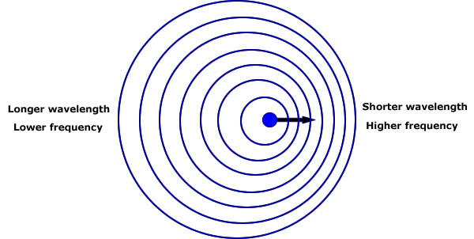

A

B

Do this by measuring 5 wavelengths and dividing by 5 to get a precise average.

|  |  |  |
| --- | --- | --- |
|  | A | B |
| 5 wavelengths (cm) |  |  |
| λ = wavelength (cm) |  |  |
| f = v / λ  (Hz) |  |  |

**Given:**

**Wave velocity = 20 cm/s**

6) The diagram above shows the cause of the Doppler Effect. If a wave source is moving towards an observer, that observer senses a \_\_\_\_\_\_\_\_\_\_\_\_\_\_\_\_\_\_\_\_ wavelength, and a \_\_\_\_\_\_\_\_\_\_\_\_\_\_\_\_\_\_\_ frequency. So observer B would hear a sound which was at a \_\_\_\_\_\_\_\_\_\_\_\_\_\_\_\_ \_\_\_\_\_\_\_\_\_\_\_\_\_\_\_ than the actual sound.

Observer A sees the source moving away, and would hear a sound which had a \_\_\_\_\_\_\_\_\_\_\_\_\_\_\_\_\_\_\_ wavelength, and had a \_\_\_\_\_\_\_\_\_\_\_\_\_\_\_\_ frequency, which sounds like a \_\_\_\_\_\_\_\_\_\_\_\_ \_\_\_\_\_\_\_\_\_\_.

## A

## SUM

## B

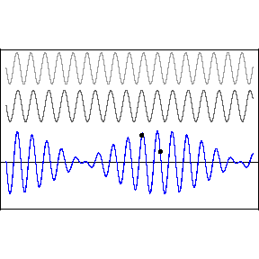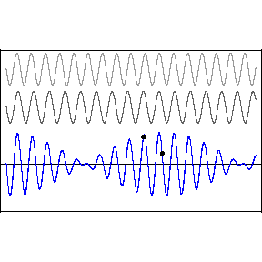

7) The diagram to the right shows two sine waves, A and B, which have slightly different frequencies. A listener hears the Sum of the two waves, shown at the bottom.

**Above diagram A, write “C” at each place where waves A and B are in phase**, and create constructive interference, and **write “D” at each place where the waves are opposite**, or out of \_\_\_\_\_\_\_\_\_\_\_\_\_\_\_ and create \_\_\_\_\_\_\_\_\_\_\_\_\_\_\_\_\_\_\_\_\_\_ interference.

If these were sound waves, you would hear \_\_\_\_\_\_\_\_\_\_\_\_\_\_, as the combined waves had a higher and lower amplitude. “Waah, waah, waah, waah…”

***More challenging problems:***

8) A certain spring is stretched to a tension of 42 N so waves travel at a speed of 12.4 meters per second. If the spring is 5.6 meters long, what are the wavelengths and frequencies of the first 3 harmonics?

f = \left( \frac{c + v_r}{c + v_{s}} \right) f_0 \,

9) The Doppler effect causes a shift in the observed frequency when the observer and the wave emitter are moving relative to each other.

The formula to the right gives the observed frequency, where

* f is the observed frequency
* f0 is the emitted, or original, frequency
* c is the velocity of waves in the medium
* v­r is the velocity of the receiver relative to the medium; positive if the receiver is moving towards the source.
* vs is the velocity of the source relative to the medium; positive if the source is moving away from the receiver.

The frequency is decreased if either is moving away from the other.

a) The speed of sound at a racetrack is 343 m/s. Show that a car driving at 86.2 m/s towards an observer, emitting a sound at 512 Hz, will be observed to have an apparent frequency of 683 Hz.

b) How fast would that car have to be driving to shift the frequency up by a full octave?

10) A child has a “whirlytube” which is an open tube which makes whistling sounds when it passes through the air quickly. It has an effective length of 78cm, including the end correction. What are the first four frequencies that should resonate in that pipe?

(Remember that a displacement antinode should occur at the open end.)

*We have this toy in the room. Find out what notes it plays, and see how close the frequencies are to the calculated frequencies!*