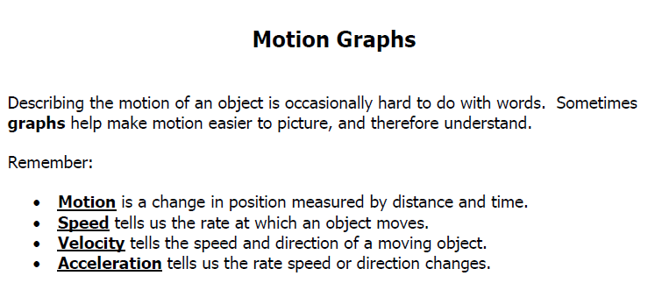

**\*\*\*\*\*\*COPY THESE NOTES ONTO YOUR OWN PAPER**

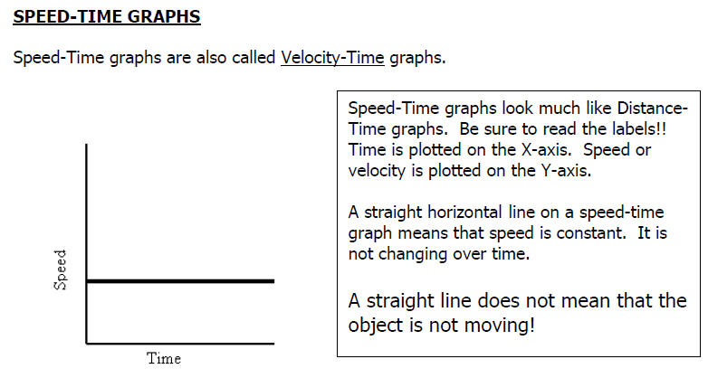

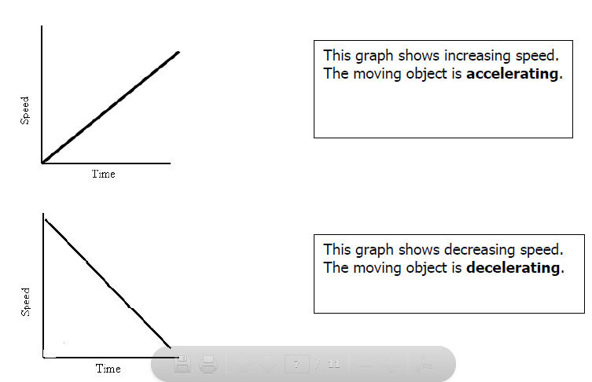

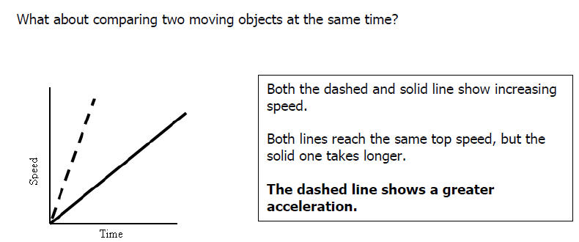

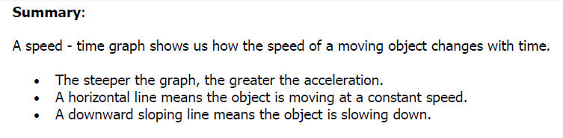

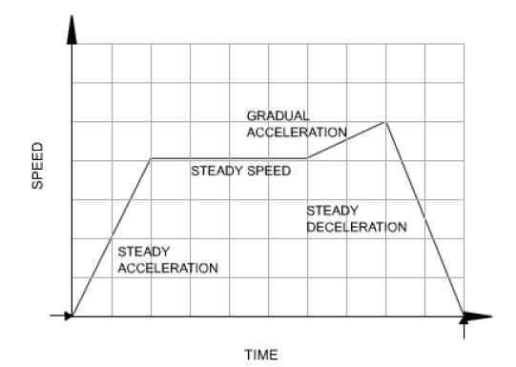

Name:________________________ Date:__________ Hour:_______ Assignment #______

**UNDERSTANDING SPEED-TIME GRAPHS**

Answer the questions based on the speed-time graphs shown.

1) The speed-time graphs below represent the motion of a car. Tell which graph belongs with each description. **Explain how you know!**

**Descriptions:**

a. The car is stopped.

b. The car is traveling at a constant speed.

c. The car is accelerating.

d. The car is slowing down.









2)

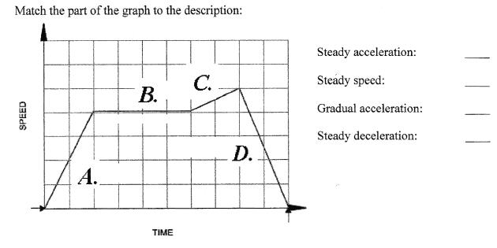

**3) The graph below shows how the speed of a bus changes during part of a journey.**



**Choose the correct words from the following list to describe the motion during each segment of the journey to fill in the blanks. Some will be used more than once.**

• accelerating • decelerating • constant speed • at rest

**Segment O-A** The bus is ________________________. Its speed changes from 0 to 10 m/s in 5 sec.

**Segment A-B** The bus is moving at a _______________________________of 10m/s for 5 seconds.

**Segment B-C** The bus is ______________________________. It is slowing down from 10 m/s to rest in 3 seconds.

**Segment C-D** The bus is ____________________________. It has stopped.

**Segment D-E** The bus is ____________________________. It is gradually increasing in speed.

**Segment E-F** The bus is moving at a ________________________________ of 5m/s for 4 seconds.

**4) Use the graph to the right to answer the following descriptions.**

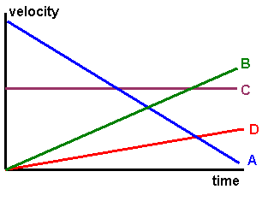

a. Which line(s) shows constant acceleration? ______________

b. Which line(s) shows deceleration (negative acceleration)?

____________. **How do you know?**

c. Which line(s) shows a constant speed (no acceleration)?

___________. **How do you know?**

d. Which line, B or C, has greater acceleration? ________