Class/Subject: Philosophy | Lesson 8- “Cognitive Biases”
Objective(s):  SWBAT identify cognitive biases and various attributions in their own thinking and in examples they’ve seen. SWBAT define and give examples of the 20 cognitive biases on the chart provided to them. | Unit: Epistemology
Philosophical Quote of the Day:  “It is an acknowledged fact that we perceive errors in the work of others more readily than in our own.” –Leonardo da Vinci | Philosophical Song of the Day:  “Cognitive Bias Song”- Brad Wray https://www.youtube.com/watch?v=3RsbmjNLQkc
Key Points of the Day:

When we think epistemologically, as philosopher we must be able to identify our biases and those of others we dialogue with. This is related to the historical concept of historical bias and various psychological/sociological concepts.

Journal Entry:  Do two things today: 1) Find a real world example to each of these biases and then ask yourself, which biases do you have? How does one lessen or eliminate these biases? | Supplemental Reading: “Psychology of Reasoning”- Peter Cathcart Wason  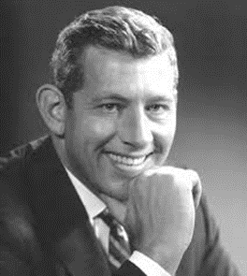  Peter Cathcart Wason was a cognitive psychologist at University College, London who pioneered the Psychology of Reason. He progressed explanations as to why people make certain consistent mistakes in logical reasoning.

