Chinese Citizens Kind Of Grateful To Not Have Access to All of Internet
NEWS • World • China • Internet • News • ISSUE 51•09 • Mar 3, 2015
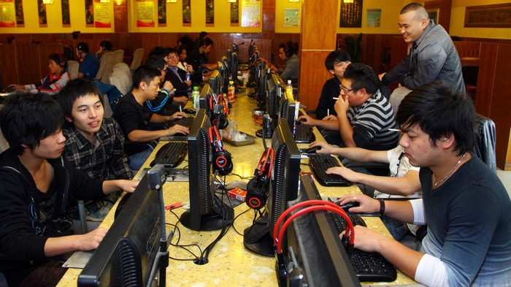
Chinese residents say it’s almost certainly in their best interest that the government limits their access to viral video aggregators and shareable images featuring inspirational quotes.
BEIJING— Asserting that their government’s policy of strict censorship was not completely detrimental, China’s 1.4 billion citizens admitted this week that they are actually kind of grateful to not have access to the entire internet.
Members of the Chinese populace pointed to endless social media updates, native advertising disguised as legitimate editorial content, and sound-producing banner ads as just a few features of the internet that they don’t particularly mind having blocked, with citizens telling reporters that, all things considered, the regulations that wall off the bulk of the world wide web have actually proven beneficial to their lives.
“When you consider exactly what the government is preventing us from accessing, you realize that this type of censorship has some real positive value,” said Beijing resident Ha Jin, noting that while the Ministry of State Security severely limits the political and cultural information available to them, this same agency also thankfully prohibits China’s internet users from ever reading an article containing several endlessly looping GIFs of sitcom actors rolling their eyes or giving each other high-fives. “Sure, our government is so repressive that we’re only allowed to view websites that adhere to Communist Party principles. But that also means we don’t see over-filtered photos of food truck tacos or videos of high school students asking celebrities to accompany them to prom, and we never will.”
“Truth be told, I can live with that,” he continued.
According to a nationwide poll, 73 percent of China’s population favors the government’s policy of blocking certain words and images it considers subversive from appearing in citizens’ search engine results, noting that the banned material could potentially include any number of meme photographs featuring user-generated text or listicles of ugly holiday sweaters.
An additional 85 percent of respondents voiced their support of the Communist Party’s efforts to curtail access to most social media sites, explaining that, while such regulations could be considered overly broad and heavy-handed, this censorship at least ensures citizens don’t ever log into their online account to find numerous invitations to play Bubble Witch Saga.
Furthermore, a full 98 percent of the Chinese people stated that the Golden Shield Project firewall that blacks out a significant portion of web content originating from outside China “isn’t all that bad,” as it effectively filters out all television show recaps, online poker games, crowdfunding campaigns for friends’ indie long-form documentary projects, Twitter, and racially charged discussion threads beneath webcam videos, sports articles, and billions of other pieces of online content.
“Our government scrubs the internet of everything it considers remotely objectionable, and when I stop to really consider what that means, I’m perfectly fine with it,” said Shenzhen resident Bao Ling, whose online activity is heavily monitored by her nation’s cybersecurity analysts, and who has not once been invited by a microwave popcorn company’s pop-up ad to “join the conversation” about their brand. “Sometimes I wonder what it would be like to have unrestricted use of email and be able to read a pro-democracy blog without one of our state-controlled internet service providers immediately taking it offline. But that would also mean sifting through countless spam messages advertising work-from-home opportunities and navigating vast scrollable catalogues of celebrity nip slips. That’s not a trade-off I want to make.”
Additionally, numerous citizens expressed their gratitude that Chinese authorities systematically prevent them from accessing Western news websites, noting that the same media outlets that might reference the Tiananmen Square massacre or the recent protests in Hong Kong would likely also include in-depth coverage of the latest viral wedding proposal video and mid-level celebrities’ recent style makeovers.
In fact, many of the Chinese citizens surveyed expressed sympathy for people in other countries who were exposed to the entirety of the internet without constraint, particularly the residents of the United States and other Western nations who must routinely contend with 3,000-word think pieces about superhero movies, blurry concert footage recorded on a cell phone, and online comments consisting largely of the phrase “butthurt” on a daily basis.
“When you consider what full access to the internet would really entail, we’re actually sort of lucky that our government does everything possible to keep us in the dark,” Bao said. “Of course, having unfettered freedom of expression and the ability to utilize online resources to collaborate with others on a large scale would be incredible, but I really don’t want any of those capabilities if it would mean I’d regularly have to sit through a 30-second laundry detergent commercial in order to watch some office’s poorly filmed parody of Pharrell’s ‘Happy’ music video, or have a complete stranger repeatedly belittle my figure and threaten my family on an online message board. It’s just not worth it.”
Added Bao, “To be perfectly honest, when I think about how I’d actually like to be spending my time, I think the government could stand to crack down on our internet access a little more.”

