Desmos Graphing Project – Shed and Doghouse Name _______________________________ Date ___
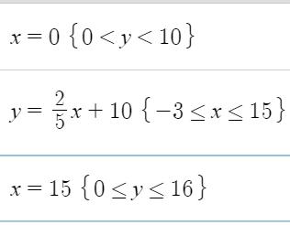
- Go to Desmos.com, and select Start Graphing
- Read the directions as you type the equations shown to the right, to create a drawing of a simple shed.
- After you type an equation, you can add in restrictions to the graph, which are shown in curly brackets {restrictions}.
- When you type a / symbol, the program will automatically create a fraction. Use the mouse or the right arrow key to make the cursor move out of the denominator, to the right.
- If you type the less than (<) symbol and then an equal sign, the program will automatically make a “less than or equal” symbol.
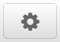
- To change the colors or style of the line segments, click the edit list gear, and then click the colored dot to the left of each function.
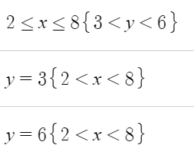
- To make the program fill in an area, you can graph an inequality. See what happens when you change the symbol between a less than, an equal sign, and a less than or equal sign. If you are actually reading the instructions, clap your hands two times.
- To add in a top line, graph the horizontal line y = 3, but limit it to the width of the “window” on the shed.
- Instead of retyping everything, you can highlight, copy (Cntrl-C) and paste (Cntrl-V), and then change what you need to.
- Using the same format you used to graph the window, graph a door on the shed.

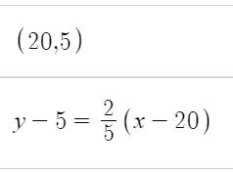
- Graph the point (20,5)

- Graph a line (point-slope form) through that point. Note that it has the same slope as the roof, but starts from a different location.
- Use curly brackets and an inequality to restrict the line to a segment between x = 19 and x = 25.

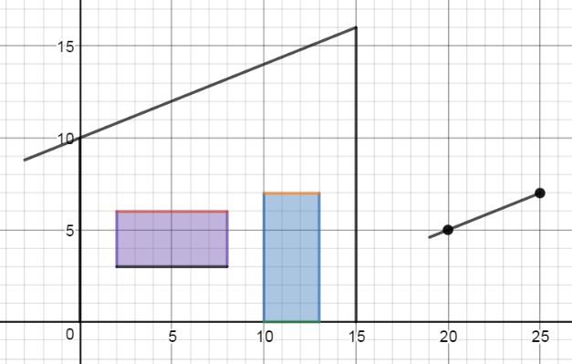
- Calculate the y-value of the point on that line segment that has the x value x = 25. (Plug in x = 25, and solve for y.) Plot that point.
- Graph the line segments for the walls of the doghouse, and make a door.

(continue on next page)

Homework:
(YOU WILL PROBABLY NEED EXTRA PAPER, UNLESS YOU WRITE IN TINY 6-POINT FONT)
- Choose three points which have x and y values between -10 and +10. No points can have matching x or y values to any other point. At least one point should have at least 1 negative coordinate.
- List the coordinates you choose, and plot and label the points.

Points: T( , ) U( , ) V( , )

- Calculate the slope of each segment.

- Calculate the length of each segment. (Distance between endpoints – use the formula!)

5. Write the point-slope equations of the lines which go through each pair of points. (These three lines will form the sides of a triangle.)

6. Graph the points and lines on Desmos. If your lines do not go through the points, try to figure out what is wrong. Do they at least have the correct slope? Once you get the lines to go through the points, use {restrictions} to restrict the lines to segments between the points.
Be sure to save your work with a logical title, like, “Triangle Segments given three points”

