Name Date Hour ___

3.2

Practice A

In Exercises 1 and 2, find  Tell which theorem you used in each case.

1. 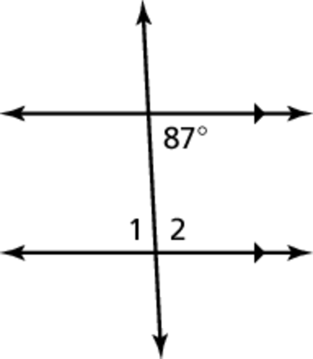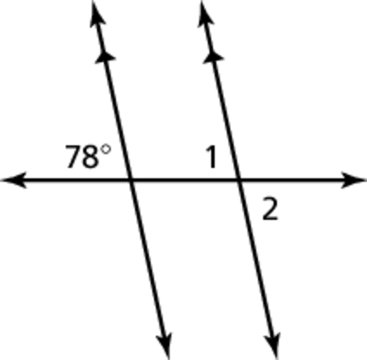 2.

In Exercise 3 find the value of *x*. Show your steps.

3.

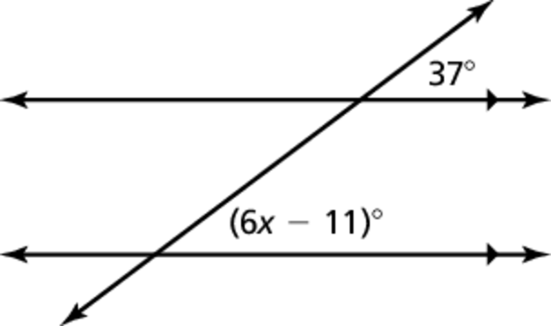

In Exercises 4 and 5, find  Explain your reasoning.

4. 5. 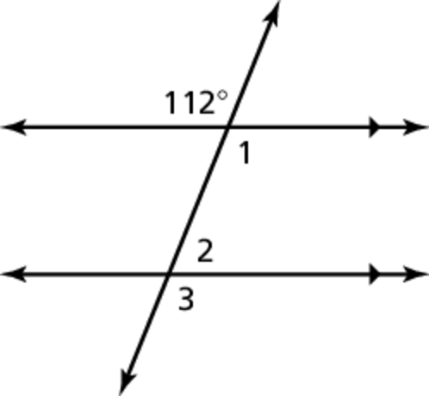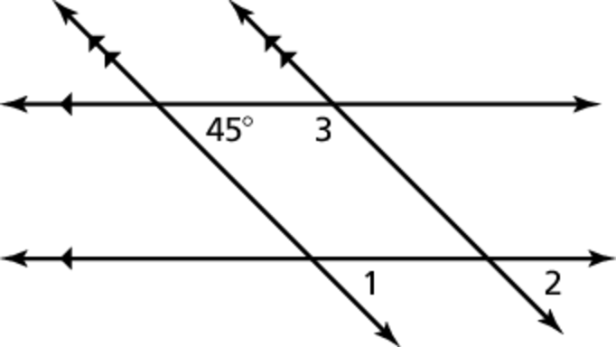

.

Name Date Hour ___

Practice B

3.2

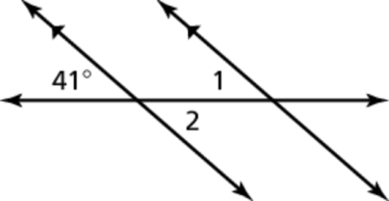In Exercises 1 and 2, find  Tell which theorems you used in each case.

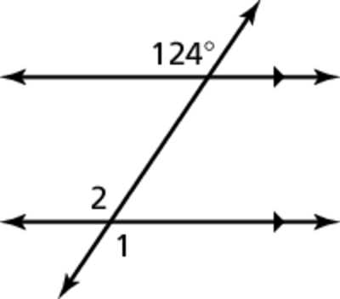 1. 2.

In Exercises 3 and 4, find the value of *x*. Show your steps.

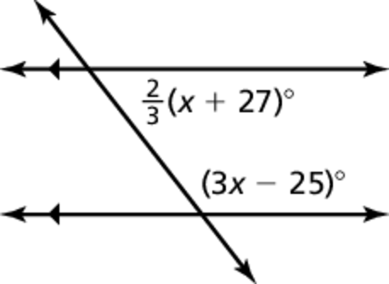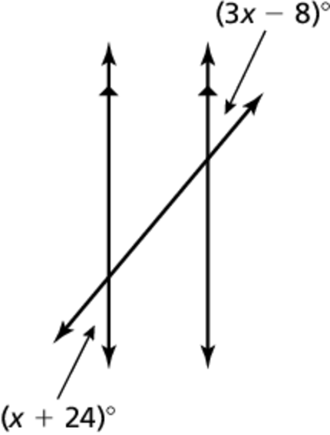 3. 4.

In Exercises 5 and 6, find  Explain your reasoning.

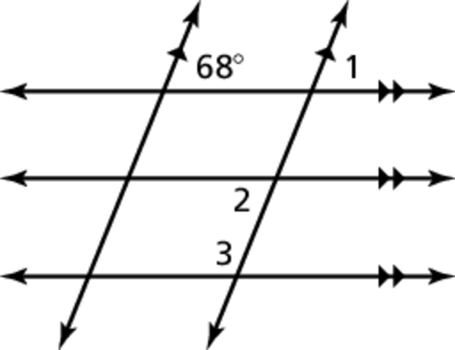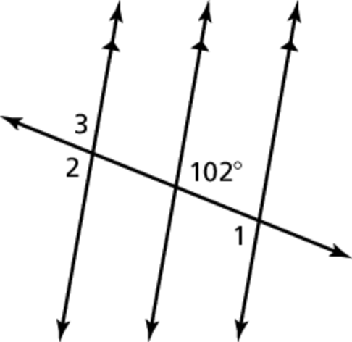 5. 6.