Genocide Trading Cards
Trading cards are small and usually are created for athletes. Therefore, efficiency of information is paramount. Each card provides a picture, team affiliation and key statistics.
For example:
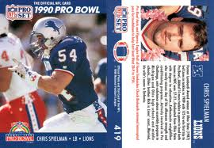
We are not creating cards for athletes. We are creating cards for historical figures. There are two teams, “Team Hero”, and “Team Evil”. You will see that human beings run the gamut from bravery and empathy to cruelty and callousness. Place the individuals listed below into the two teams and provide a solid synopsis on the life of these people.
Using the computer and/or your art skills create cards for the following individuals that provide a concise explanation of the person and what they did, much like a sport card does.
- Talaat Pasha
- Ambassador Henry Morgenthau
- Armin Wegner
- Adolf Hitler
- Oskar Schindler
- Nicholas Winton
- Josef Stalin
- Mao Zedong

Be creative and attempt to provide the most information in the smallest amount of space as possible.

