Free-Body Diagrams – ROCK! 11/3/14 Name:
Date:
Free-body diagrams are pictures of the force vectors on an object. The vectors are drawn at the proper direction, and scaled so longer vectors represent bigger forces. Draw accurate free-body diagrams showing all the forces acting on the rock, and no other forces. Use ruler and a pencil so that if you make a mistake, you can correct it. Label the forces using the following symbols: [ALWAYS START BY DRAWING WEIGHT, THE FORCE OF GRAVITY!]
Fg = weight of the rock F_{A} = applied force (a push, for example) T = tension (pulling force)
F_{N} = normal force, F_{f} = friction (acts parallel to surface where two objects touch)
(Remember that the Normal Force is perpendicular to the surface pushing on the rock.)
1. At rest. (example)  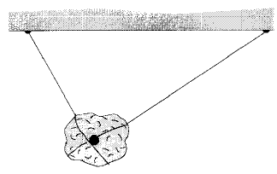  T₂  Fg  T₁ | 2. At rest.  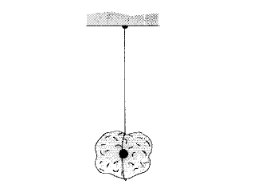 | 3. At rest.  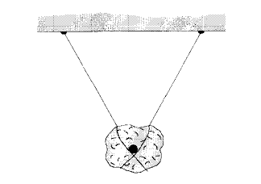
4. At rest.  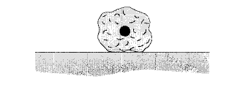 | 5. Sliding at constant velocity.  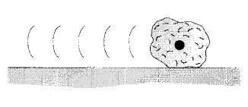 | 6. Slowing because of friction.
7. At rest (friction is preventing  sliding)  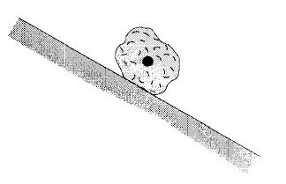 | 8. Slipping and accelerating.  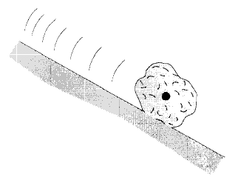 | 9. Falling without friction  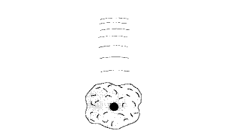
10. Falling at constant (terminal)  velocity.  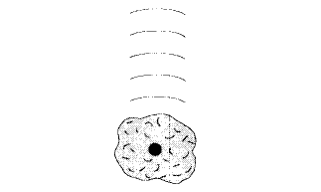 | 11. At rest.  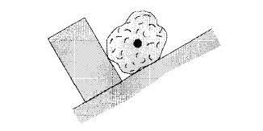 | 12. At rest.  