**NAME:**

# ANCIENT INDIA

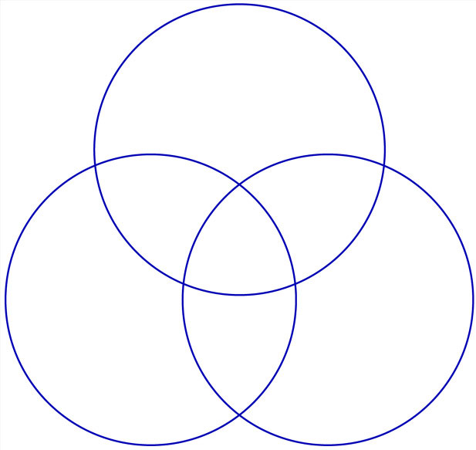

# GUPTA

# KUSHAN

# MAURYAN