Name Date Hour ___

3.3 Practice A

In Exercises 1 and 2, find the value of *x* that makes s parallel to t. Show the equation you use.

1. 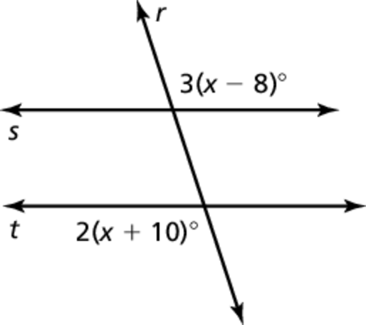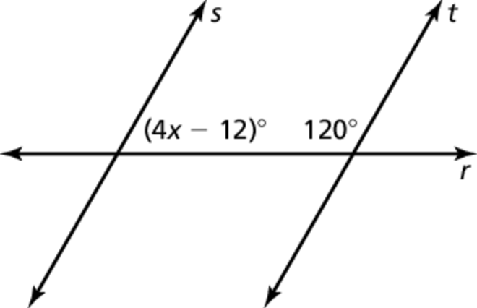2.

In Exercises 3 and 4, decide whether there is enough information to prove that p║q. If so, state the theorem you would use.

3. 4. 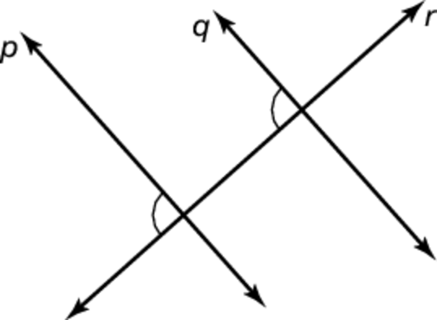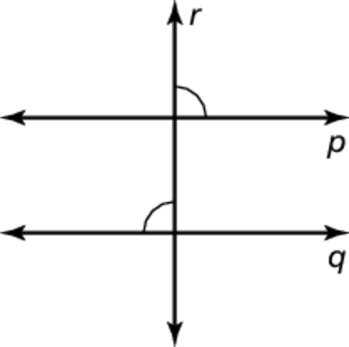

Thm: ____________________________ Thm: __________________________

5. Describe and correct the error 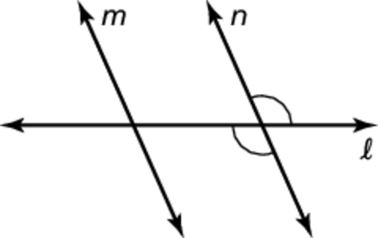  
in the reasoning.

**Conclusion:** m ║n

6. **Given:**  are supplementary 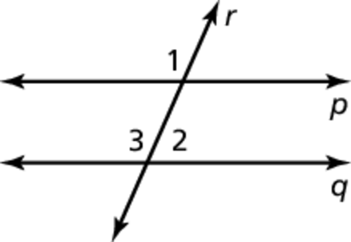

**Prove:** p║q

Name Date Hour __

3.3 Practice B

In Exercises 1 and 2, find the value of *x* that makes s║t. Show the equation you use.

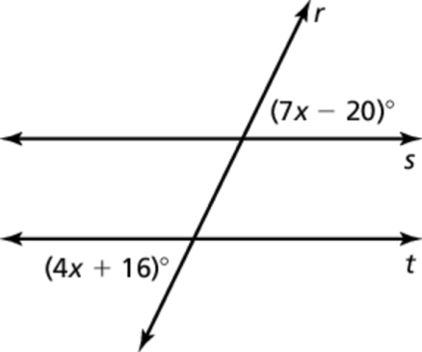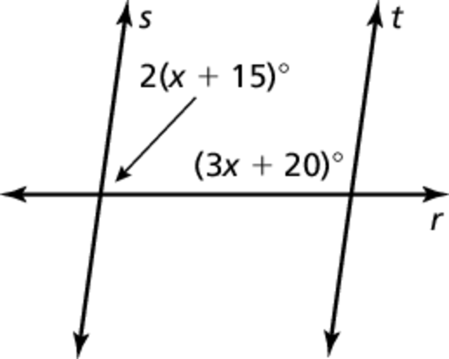 1. 2.

In Exercises 3 and 4, state the theorem you would use to prove that p║q

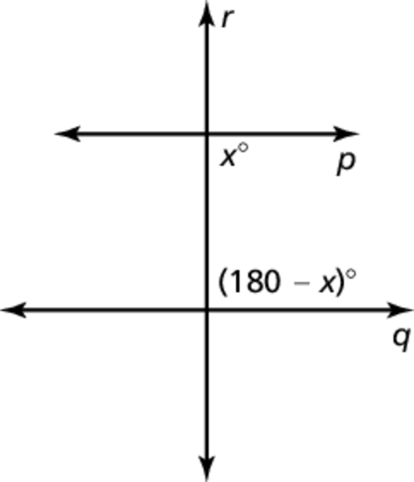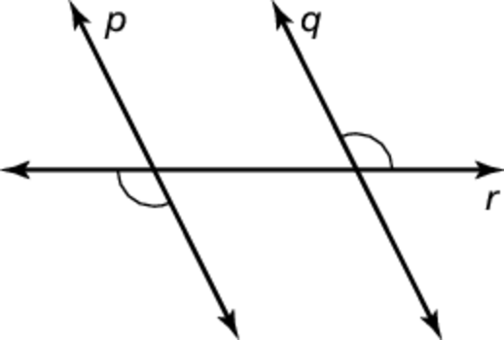 3. 4.

Thm: ____________________________ Thm: __________________________

5. Use the diagram to find the values of *x*, *y*, and *z* that make p║q and q║r. **Show math**.

