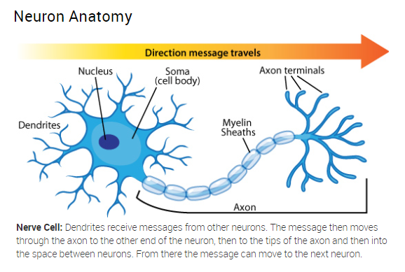
Nodes of Ranvier between myelin
https://askabiologist.asu.edu/neuron-anatomy

