Copy the boldface line into a new Word document. DAL 2016-04-18
Insert your data and save as “YOUR NAME Dilations on Geogebra” to your own folder or Drive.
Dilations On Geogebra Name: Date: Hour:
READ. THE. DIRECTIONS.
- Use your internet browser to open the geogebra.org site.
- Sign in to Geogebra using one of the options provided.
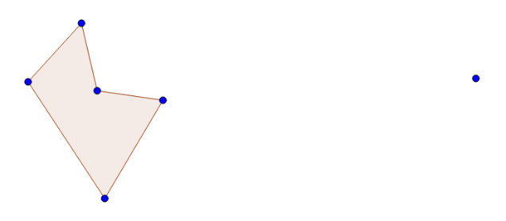
- Click Start Geogebra > Geometry
- Use the polygon tool to draw a polygon with 4 to 8 sides. Do not draw a regular polygon.
- Create a new point, far outside the polygon. This point will be used as your center of dilation.
- Select Dilate from Point from the Transformations menu. Follow the instructions in the black box at the bottom of the screen. Select a dilation factor which is between 0 and 1.
- If the image and preimage overlap a lot, use the move arrow to move the center of dilation, or move points on the preimage.
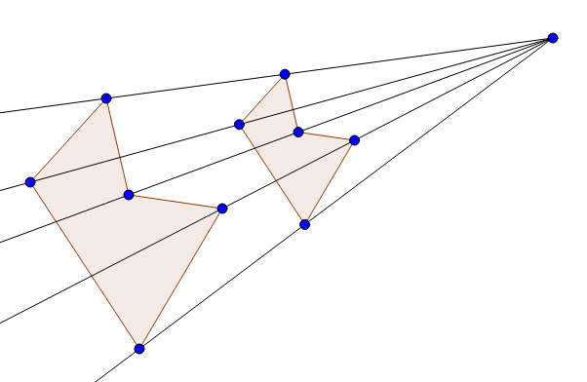
- Create rays from the center of dilation through every point on the preimage. Note that they should also pass through corresponding points on the image.
- Drag the center of dilation to see what happens.
- The snipping tool is found in All Programs>Accessories, from the Windows Start button. It can be right-dragged down to the bottom taskbar. Use the snipping tool to copy and paste the figure you created into your word document. You may need to:
  - right click and crop out extra white space
  - shrink the image to fit on the page
  - left click on image, and select “Tight” wrapping so words will fit around the image
- Undo (delete) all the rays you created.
- Use the measure tools to measure at least two sides and two interior angles on the preimage. Measure the corresponding sides and angles on the image.
- Move the labels so they do not overlap the points or other labels. To get labels to appear, right click on an object, and select Show Label.
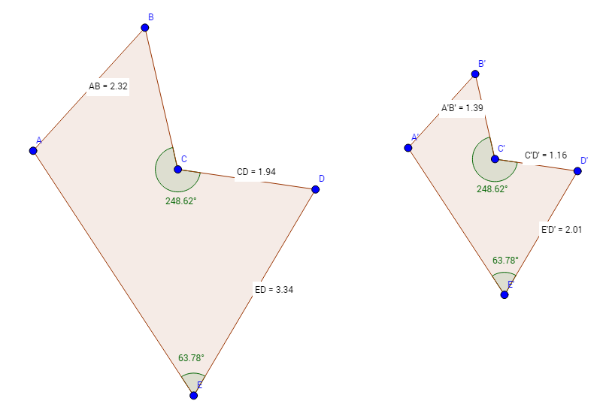
- Use the snipping tool again to copy your diagram, with measurements, as shown to the right.
- Save your geogebra work, using a logical name.
e.g., “NAME Dilations Geometry April 18 2016”
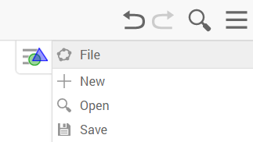

- Write a paragraph or two describing the dilation factor and how it relates to the figures. Be sure to explain:
  - what the center of dilation is
  - what the scale factor is
  - how the scale factor numerically relates to the segment lengths
  - what stayed the same
  - Extra Credit: show that the angles add up to the proper number based on the interior angle formula

- Print your document. Be sure to preview it to make sure it fits on the page, without a lot of wasted extra space. And, (duh) make sure you followed the directions at the beginning, and typed your name.

