DESMOS Circle Graphing Assignment Ooh, look! Lots of Options!
When you accomplish tasks, show them to your teacher for credit.
Standard:
- Use Desmos to graph a circle which has its center at the origin, (0,0), and has a radius of 4.
- Plot the point (10,5). Then graph a circle which has its center at (10,5), and is tangent to the x axis.
- Graph a circle which has a diameter of 6, and has its center at (0,7).
- There is only one circle which has a diameter which runs from (-6, -4) to (16,12).
  - Calculate the coordinates of the center of the circle, (h,k), and plot the center.
  - Calculate the radius, which is the distance from the center to one end of the diameter.
  - Graph the equation of the circle using your center and radius.
  - Graph a radius by graphing a horizontal straight line at y=k. Limit this to a radius by adding $\left\{h≤x≤h+r\right\}$, substituting in your values for h and r. (Handy tip: type SQRT to make the square root symbol appear.)
- Estimate the center and radius of the largest circle which will fit inside the large circle, but below and to the right of the other circles on the diagram. Write down the equation, and then see how close you were. This is “Price is Right” style, so the person who comes closest without touching wins.
Estimated equation:___________________________________
Advanced
- Use the variable feature in Desmos to create slider bars and draggable points. Type (h,k) into one of the formula bars, and click on “Add Sliders”. You can now move the point by dragging the sliders, or by dragging the point on the graph. You can use other letters to create other variables when you need them, so you don’t have to keep typing to change the numbers in an equation.
- Calculate the equation of a circle which has a diameter stretching from (3, 4) to (15, 10). Hint: First calculate the midpoint between the given points.
- In a video game, your character is located at the coordinates (13,11), on a square grid that extends from the origin to (20,20). (Measured in miles.) Your character is surrounded by zombies, so you need to blow up as much of the board as possible without killing your character. Give the coordinates of the center of each bomb location, and what radius you will set for each explosion.
- Create something fun!
Hint: Try graphing y = x². Now add the following after the equation: $\left\{-2≤x≤2\right\}$ This limits the graph to only those x values.
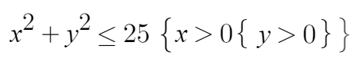
Check out:

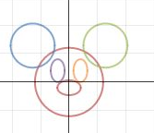
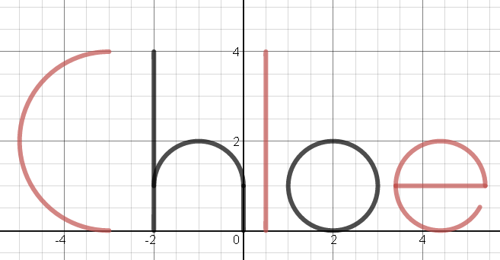
Desmos Challenge:

  - Create two draggable points, (a,b) and (c,d).
  - Use Desmos to calculate and plot the midpoint.
  - Write an equation for the distance between the points, and divide that by 2 to calculate the radius r.
  - Plot a circle with the center at the midpoint, and the radius r. It should just lie between the dragged points.

- Create multiple circles which touch each other. Try to graph 3 pennies all touching each other, or four pennies arranged in a square touching each other, with a smaller circle wedged inside. You will need to use special right triangles to calculate the radii. Don’t just guess and check!

- Graph the following line and circle. To graph the radius, you can limit the domain by typing something like $\left\{-2≤x≤2\right\}$ after the equation of the line. After you graph this line and circle, figure out the center and radius of another circle which will be tangent to the given line, and graph that circle.
