Class/Subject: Philosophy | Lesson 25- “Ethics in History”
Objective(s): SWBAT create criteria of ethics for historical figures. Then use it to evaluate several key historical figures. | Unit- “ETHICS”
Philosophical Quote of the Day:  “A man without ethics is a wild beast loosed upon this world”. -Albert Camus | Philosophical Song of the Day:  “Meta-Historical” by: KRS-One: https://www.youtube.com/watch?v=Q0jbOUc9Tjs
Key Points of the Day:

- Historical Figures had to make ethical choices that led to outcomes that affected many. It is an impossibility to separate historical figure’s philosophies from their place in history.

Journal Entry:  “What list did you compile for both U.S. and World History and what was your rationale behind them?”  . | Featured philosopher and  supplemental Reading: “Caligula” by: Albert Camus  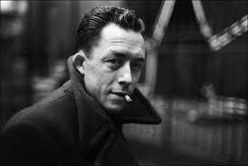  Albert Camus was a French philosopher, author, and journalist. His views contributed to the rise of the philosophy known as Absurdism.

