Intro to Chords, Secants, and Tangents Name __________________________________ Date ______ Hr. __
1. a) Draw, label, and measure at least one diameter, one radius, and one chord. Label all endpoints with letters.
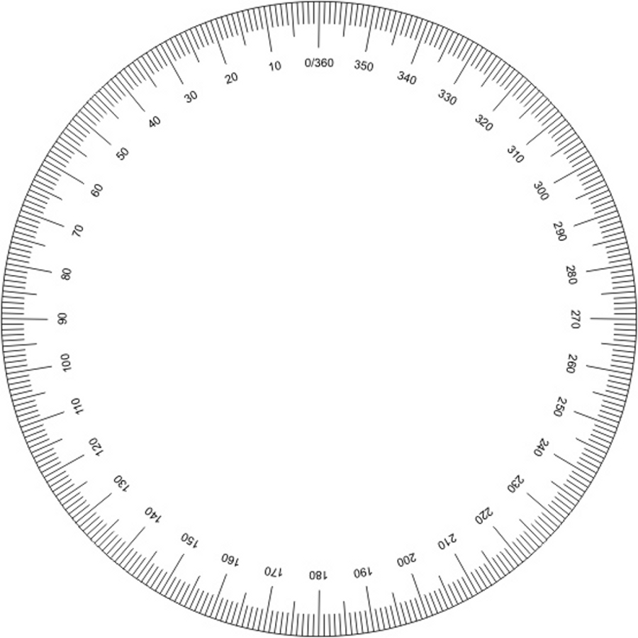
Lengths (with proper names):
.

b) Color or highlight the minor arc of the chord. (The short way around the circle from point to point.)

2. Draw two secants through the circle, which both pass through point K, and are different distances from the center. Mark the four points where the secants cross the circle.
K .

.

Using the marked angles on the protractor, find the angle measure of the two arcs which lie between the secants, on the near side and far side of the circle.

Arc close to K = _____°
Arc far from K = ______°
Difference between near and far arcs: _____°
Measure of Angle K: _____°
3. Plot a point somewhere to the left of the circle, and label it M. Draw two tangents, from M, which barely touch the edge of the circle. (Hold the ruler as close as you can to the circle without touching, and you will be able to more easily locate the point on the circle closest to the ruler.)
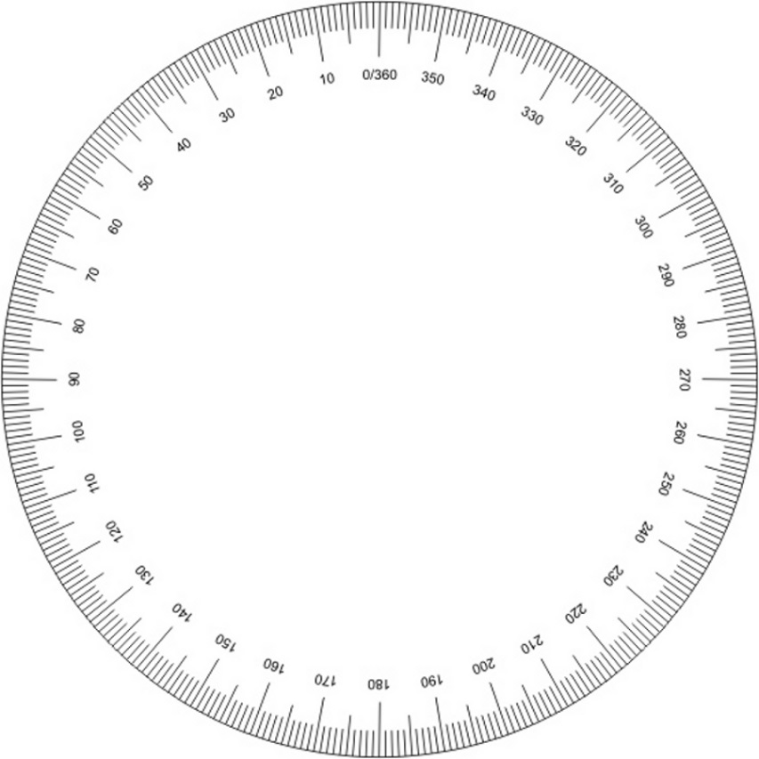
Label the points where the tangents touch (the “points of tangency”) J and Z.
.

Label the distances from point M to the points of tangency, and calculate the arc (how many degrees) between the points of tangency.
MJ = ______ cm
MZ = ______ cm

minor arc JZ = _____°
m∠M = _____°

4. Create and label two points which are 118° apart on the circle. Draw radii from the points to the center, which should also be labeled. Draw a chord between the points, and measure the chord length, using it to label the chord.
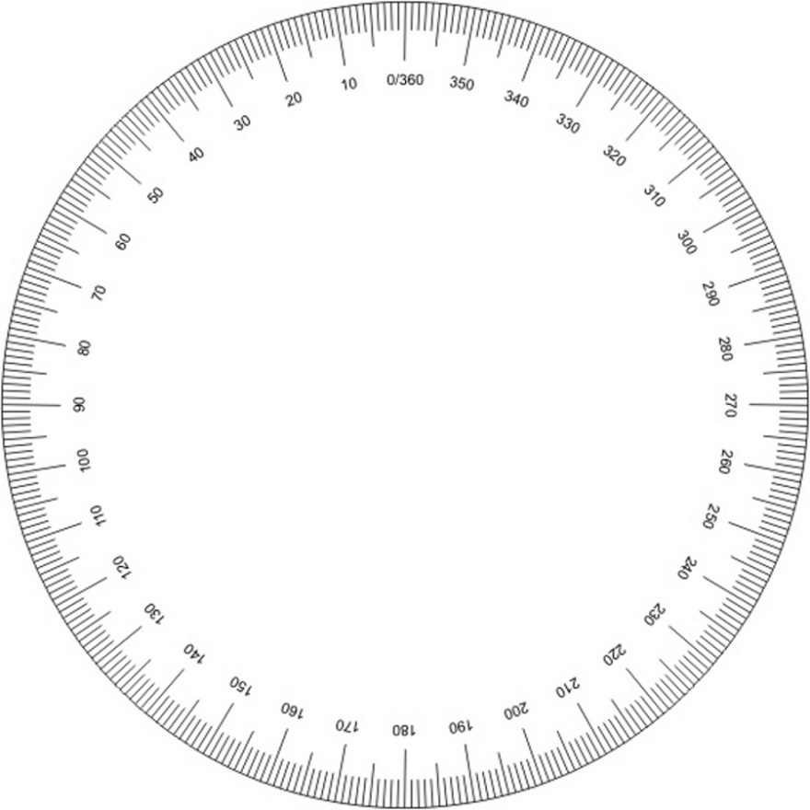
Now create two different points which are 118° apart, draw two more radii, and another chord, and measure the chord length, and label that chord.
.

a)What do you notice about the chords?
b) Before measuring the chords, what theorem could be used to show that the two triangles you drew are congruent?

c) How do you know both triangles must be isosceles?

d) What four angles must all be congruent?
Intro to Chords, Secants, and Tangents Name _____KEY_____________ Date ______ Hr. __
1. a) Draw, label, and measure at least one diameter, one radius, and one chord which is not a diameter. Label all endpoints with letters.
Lengths (with proper names):
.

Names will vary
Diameter = 10.4 cm Radius = 5.2 cm
chord lengths will vary

b) Color or highlight the minor arc of the chord. (The short way around the circle from point to point.)
Arc should be highlighted.

2. Draw two secants through the circle, which both pass through point K, and are different distances from the center. Mark the four points where the secants cross the circle.
B

K .

.

Using the marked angles on the protractor, find the angle measure of the two arcs which lie between the secants, on the near side and far side of the circle. POSSIBLE ANSWER:
A

Arc close to K = _27° (=181°- 154°)
D

Arc far from K = _77° (from 333° to 50°)
= from 333° to 360° and from 0 to 50°
Difference between near and far arcs: 50°
C

Measure of Angle K: 25°
3. Plot a point somewhere to the left of the circle, and label it M. Draw two tangents, from M, which barely touch the edge of the circle. (Hold the ruler as close as you can to the circle without touching, and you will be able to more easily locate the point on the circle closest to the ruler.)
Label the points where the tangents touch (the “points of tangency”) J and Z.
.

Label the distances from point M to the points of tangency, and calculate the arc (how many degrees) between the points of tangency.
MJ = ______ cm
MZ = ______ cm

minor arc JZ = _____°
m∠M = _____°

4. Create and label two points which are 118° apart on the circle. Draw radii from the points to the center, which should also be labeled. Draw a chord between the points, and measure the chord length, using it to label the chord.
Now create two different points which are 118° apart, draw two more radii, and another chord, and measure the chord length, and label that chord.
.

a)What do you notice about the chords?
b) Before measuring the chords, what theorem could be used to show that the two triangles you drew are congruent?

c) How do you know both triangles must be isosceles?

d) What four angles must all be congruent?

