Class/Subject: Philosophy | Lesson 46: “Philosophy of Humor”
Objective(s):  SWBAT evaluate what is funny. Although most people can express what makes them laugh, the origins and causes of humor are grounded in Metaphysics. SWBAT explore forms of humor and create a composite of types of humor. | Unit- “METAPHYSICS”
Philosophical Quote of the Day:  "A well-developed sense of humor is the pole that adds balance to your steps as you walk the tightrope of life”- William Arthur Ward | Philosophical Video of the Day:  “What makes things funny” by: Peter McGraw (Definitely a lot of aesthetics in this, but humor I would argue resides in both metaphysics and aesthetics) https://www.youtube.com/watch?v=ysSgG5V-R3U
Key Points of the Day:  Although most people value humor, philosophers have said little about it, and what they have said is largely critical. Three traditional theories of laughter and humor are examined, along with the theory that humor evolved from mock-aggressive play in apes. Understanding humor as play helps counter the traditional objections to it and reveals some of its benefits, including those it shares with philosophy itself. | Philosophers and other social scientists have quantified types of humor and reasons why people find things funny. We will explore these as a class.
Journal Entry:  “What is humor, how is humor created?” What do you consider the highest forms of humor, what do you consider the lowest forms? | Featured Philosopher and Supplemental Reading:  Herbert Spencer- “On the Physiology of Laughter”  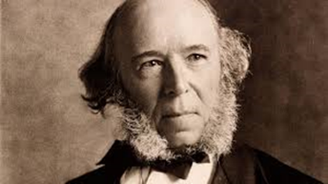  Herbert Spencer was an English philosopher, biologist, anthropologist, sociologist, and prominent classical liberal political theorist of the Victorian era. He explored the philosophical underpinnings of humor, in addition to many other philosophical works.

