Class/Subject: Philosophy | Lesson 37: “Three Logic Paradoxes”
Objective(s):  SWBAT create questions related to three paradoxes. SWBAT evaluate these questions and make connections to these paradoxes. | Unit- “LOGIC”
Philosophical Quotes of the Day:  “Philosophy is a battle against the bewitchment of our intelligence by means of language.”  -Ludwig Wittgenstein | Philosophical Video of the Day:  Mr. Spock’s Logic: https://www.youtube.com/watch?v=5_APSczipvo
Key Points of the Day:  - The prisoner's dilemma is a canonical example of a game analyzed in game theory that shows why two purely "rational" individuals might not cooperate, even if it appears that it is in their best interests to do so.  - Sorites paradoxes are a class of paradoxical arguments also known as little-by-little arguments. The name "sorites" derives from the Greek word soros, meaning "pile" or "heap." Sorites paradoxes are exemplified by the problem that a single grain of wheat does not comprise a heap, nor do two grains of wheat, three grains of wheat, etc. However, at some point, the collection of grains becomes large enough to be called a heap, but there is apparently no definite point where this occurs. | - Buridan’s Ass is the name give to an apparent paradox related to the free will paradox; although there is some debate amongst philosophers as to whether it actually is a paradox The paradox is named after the French priest and philosopher Jean Buridan. It refers to a hypothetical situation where a donkey finds itself exactly halfway between two equally big and delicious bales of hay. There is no way of distinguishing between these two bales – they appear to be identical. Because the donkey lacks a reason or cause to choose one over the other, it cannot decide which one to eat, and so starves to death. This tale is usually taken as demonstrating that there is no free will. The corollary to this argument is that if the donkey eats one of the bales of hay, then the donkey is making a choice. If the donkey is making a choice, then it must have free will, because there is no causal mechanism to make it choose one bale over another. And if donkeys have free will, then so must humans.
Journal Entry:  What questions and issues emerge from the Prisoner’s Dilemma, The Sorites Paradox and Buridan’s Donkey? What are your thoughts on the philosophical value of each of them? | Featured philosopher and supplemental reading: “Wittgenstein: A Very Short Introduction” by: A. C. Grayling  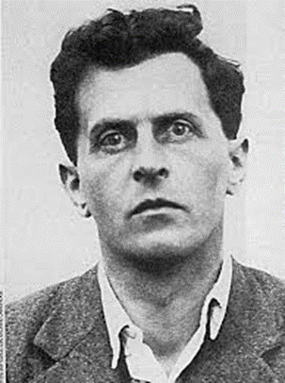  Ludwig Josef Johann Wittgenstein was an Austrian-British philosopher who worked primarily in logic, the philosophy of mathematics, the philosophy of mind, and the philosophy of language.

