Main Tests for drugs:
(See “Color Tests” packet of information for more detail regarding what these tests are etc.)

First a screening test is done to exclude possibilities. These tests are generally quick and relatively cheap. A confirmation test must then be performed to confirm exactly what drug it is. These tests often involve using high tech lab equipment.

- Color tests – mix the drug with some reagents and look for the color change. Need to know what color indicates a positive test result and which reagent to mix with each drug.
- Identification of Marijuana by microscopic analysis – look for short hairs having the shape of bear paws on the upper side of the leaf. These are called cystolithic hairs on leaves etc.
- Microcrystalline test
- Chromatography
- Spectrophotometry
- Mass Spectrometry

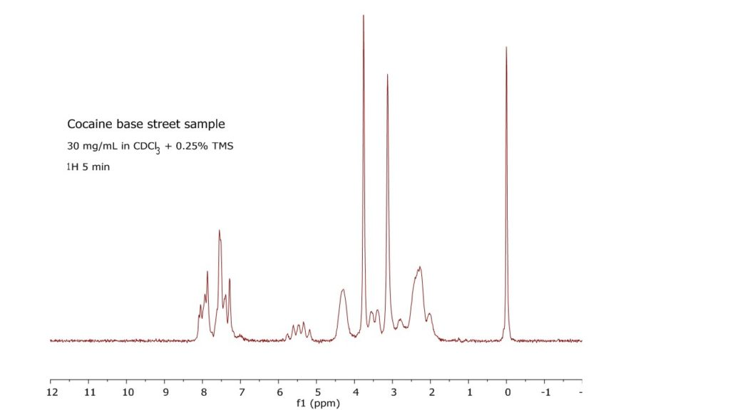
The best machine/test for drugs combines Chromatography and Mass Spectrometry. The GC/MS machine will do gas chromatography and mass spectrometry to confirm drugs and poisons in your samples.
