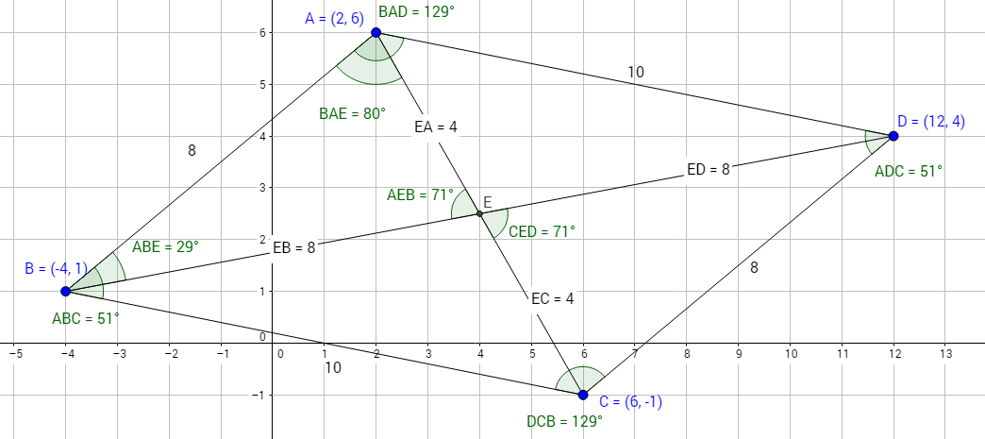
What were they really trying to say? Name _______________________________
These student statements are incorrect or unclear. Restate what the students were trying to say, using clear language and proper geometry terms.
1. “All the lines are parallel.”
2. “All the angles are 360.”
3. “The adjacent angles are the same.”
4. “The triangle is 180.”
5. “C is parallel to D.”
6. “Line AB is the same as line CD.”

